Kings Peak™

The Natural Choice for Your Home™



KNG150/199INW
Indoor Tankless Natural Gas Water Heater
INSTALLATION, USE, AND CARE MANUAL

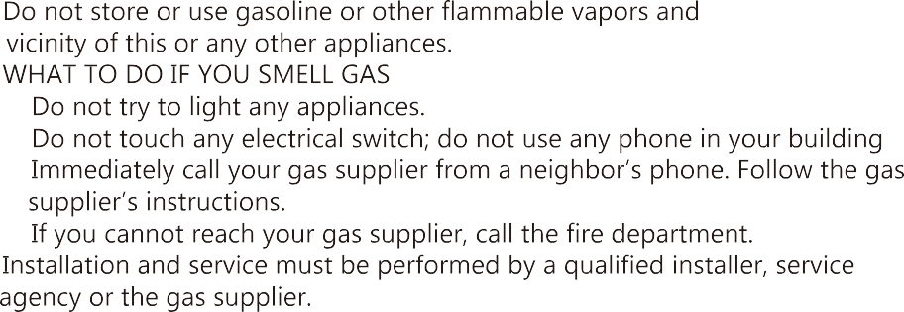




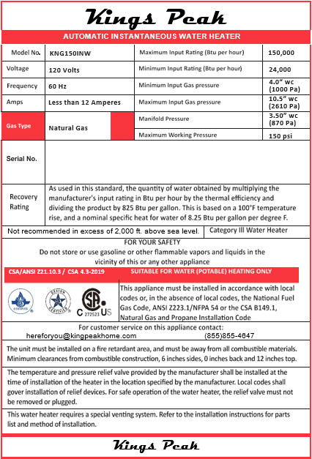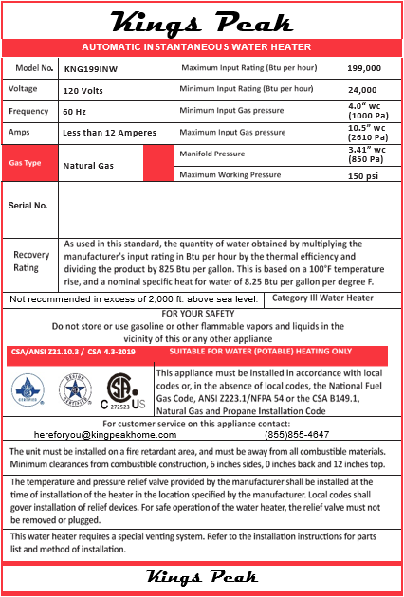

Always ready for the challenge!

Thank you for purchasing your new Kings Peak tankless water heater. We believe in creating world-class product solutions that minimize the use and consumption of non-renewable resources while maximizing your comfort at home.

We highly suggest you take the time to read through all of the safety and installation procedures in this manual before having your new water heater installed.
We are here for you via-
email: hereforyou@kingspeakhome.com - or – call: toll-free at (855)855-4647

 Read this manual:
You will find many helpful hints on how to properly use and maintain your water heater properly. А little preventive care can save you time and money over the life of your water heater. Here you will find many answers to common problems in the TROUBLESHOOTING TIPS (on Page 33). If you review the charts on Pages 33 and 34, you may not need to call for service, although we are always hereforyou@kingspeakhome.com
⚠️Read the safety information:
То ensure your safety and the safety of others, we have included important safety warnings throughout this manual.
AII safety messages will follow the safety alert symbol and the words:

"CAUTION", "DANGER", "WARNING" or "NOTICE".
These words mean:
⚠️DANGER
An imminently hazardous situation that will result in death or significant injury and/or damage to property if this instruction is ignored or not followed appropriately.
⚠️WARNING
А potentially hazardous situation that could result in death or serious injury and/or damage to property if this instruction is ignored or not followed appropriately.
⚠️CAUTION
А potentially hazardous situation that may result in moderate injury and/or damage to property if this instruction is ignored or not followed appropriately.

NOTICE
Attention is called to observe а specified procedure or maintain а specific condition.

It is imperative that all persons who are expected to install, operate, or adjust this water heater read these instructions carefully so they may understand how to perform these operations. If you don't understand these instructions or any terms within it, STOP, and seek professional advice.
Any questions regarding the operation, maintenance, service, or warranty of this water heater should be directed to the seller from whom it was purchased. If additional information is required, email hereforyou@kingspeakhome.com or visit our website www.KingsPeakHome.com
⚠️Do not destroy or throw away this manual. Please read carefully and keep in а safe place for future reference.
⚠️ Recognize this symbol as an indication of Important Safety Information!
⚠️ California Proposition 65 Warning: This product contains chemicals known to the State of California to cause cancer, birth defects or other reproductive harm.
⚠️WARNING
This water heater may not be suitable for use in manufactured homes or mobile homes. Please check local code restrictions pertaining to permanent/fixed installations in manufactured and mobile homes in your area.
⚠️WARNING
If the information in these instructions is not followed exactly, а fire or explosion may result causing property damage, personal injury, or death.
⚠️FOR YOUR SAFETY
Improper installation, adjustment, alteration, service, or maintenance may cause property damage, personal injury, or even death. Refer to this manual. Installation and service must be performed by а qualified installer, service agency, or the gas supplier.

⚠️DANGER
DO NOT store or use gasoline or other flammable vapors or liquids or other combustible materials in the vicinity of this or any other appliance. Doing so may result in an explosion or fire.

WHAT ТО DO IF YOU SMELL GAS
- DO NOT try to turn ON, ignite/light, or operate any appliances.
- DO NOT touch any electrical switch; do not use any phone in your building.
IMMEDIATELY CALL YOUR GAS SUPPLIER FROM А NEIGHBOR'S PHONE.
FOLLOW THE GAS SUPPLIER'S INSTRUCTIONS.
IF YOU CANNOT REACH YOUR GAS SUPPLIER, CALL THE FIRE DEPARTMENT.
- DO NOT return to your home until authorized by the gas supplier or fire department.

 FOR YOUR RECORDS
Please Note: To file а product warranty claim, original proof of purchase is required.
Manufactured for:
Salt Lake Iron & Steel Ltd. Co.
65 E Columbus Ct. Salt Lake City, UT 84103

Kings Peak

Contents of this manual:

Warnings & Welcome 1-4
Safety information 5-8
Installation Instructions……………………….….…………………………….….9-27
Operating Instructions 28-29
Routine Preventative Maintenance 30-32
Trouble Shooting & Service Parts 33-36
Limited Product Warranty 37-38

IMPORTANT SAFEТY INFORMATION

READ ALL INSTRUCTIONS BEFORE USING
Be sure to read and understand the entire Installation, Use, and Care Manual before attempting to install or operate this water heater. It may save you time and money. Pay particular attention to the Safety Instructions. Failure to follow these instructions and/or warnings could result in serious bodily injury or death. Should you have problems understanding the instructions in this manual, or have any questions, STOP, and get help from а qualified service technician, or the local gas utility.

⚠️DANGER
PROPERLY INSTALL THE WATER HEATER
Failure to properly install the water heater as outlined in the Installation Instructions in this manual may result in unsafe operation of the water heater. То avoid the risk of fire, explosion, or asphyxiation from carbon monoxide, never operate this water heater unless it is installed properly and has an adequate air supply and ventilation for proper operation. Be sure to inspect the flue terminal for proper installation at initial start-up and at least annually thereafter.

⚠️DANGER
Gasoline, as well as other flammable materials and liquids (adhesives, solvents, paint thinners, etc.), and the vapors they produce are extremely dangerous. DO NOT handle, use, or store gasoline or other flammable or combustible materials anywhere near or in the vicinity of а water heater or any other appliance. Be sure to read and follow the labels on the water heater, as well as the warnings printed in this manual. Failure to do so can result in property damage, bodily injury, or death.

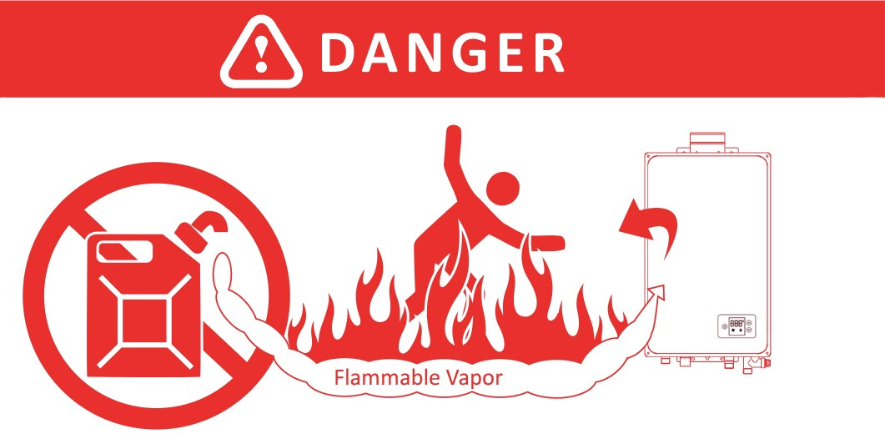
 Vapors from flammable Water heater has а main burner flame. liquids will explode and catch fire The main burner flame:
causing death or severe burns 1. Can come on at any time and Do not use or store flammable products 2. Will ignite flammable vapors.
such as gasoline, solvents, or adhesives
in the same room or area near the water heater

Keep flammable products: |  | Vapors:
1. Far away from heater |  | 1. Cannot be seen.
2. In approved containers |  | 2. Are heavier than air.
3. Tightly closed |  | 3. Go а long way across a floor.
4. Out of children's reach |  | 4. May be carried from other rooms to the main burner flame by air currents.

Installation:
Do not install water heater where flammable products will be stored or used unless the main burner flame is at least 18" inches above the floor. This will reduce, but not eliminate, the risk of vapors being ignited by the main burner flame.
Read and follow water heater warnings and instructions. If the user manual is missing, contact the retailer or manufacturer.

⚠️DANGER
WATER TEMPERATURE SETTING
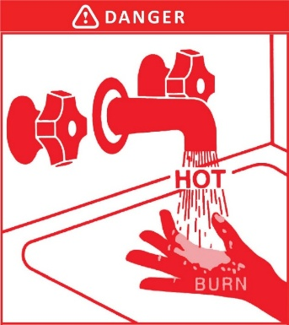
Safety and energy conservation are factors to be considered when selecting the water temperature setting. Water temperatures above 125° F can cause severe burns or death from scalding. The thermostat is adjusted to 110° F when shipped from our factory. Be sure to read and follow the warnings outlined on the label pictured below.
Water temperature over 125°F сап cause severe burns instantly or death from scalds. Children, disabled, and the elderly are at highest risk of being scalded. See instruction manual before setting temperature at water heater. Feel water before bathing or showering. Temperature limiting valves are available, see manual.

Time/Temperature Relationship in Scalds
Water Temperature | Time То Produce а Serious Burn
120° F | More than 5 minutes
125° F | 1½ to 2 minutes
130° F | About 30 seconds
135° F | About 10 seconds
140° F | Less than 5 seconds
145° F | Less than 3 seconds
150° F | About 1½ seconds
155° F | About 1 second
Table courtesy of Shriners Burn Institute

The chart shown above may be used as а guide in determining the proper water temperature for your home.

⚠️DANGER
Households with higher risk individuals such as small children, disabled, or elderly persons may require а 120°F or lower temperature setting to prevent contact with "HOT" water.
Maximum water temperature occurs while burner is in operation. То find water temperature being delivered at the faucet, turn on а hot water faucet, place а thermometer in the water stream, and read the thermometer after 30 seconds of the thermometer being exposed to the water stream.
The temperature of the water at the outlet of the water heater сап be regulated by setting the temperature on the display located on the front panel. The unit was set at 110° F before it was shipped from our factory.
NOТICE
When this water heater is supplying general purpose hot water requirements for use by higher risk individuals, а thermostatically controlled mixing valve for reducing point of use water temperature is recommended to reduce the risk of scald injury. Contact а licensed plumber or the local plumbing authority for further information.
NOТICE
We recommend operating temperatures between 115°F and 125°F depending on your household needs.
USING NATURAL GAS
⚠️ DANGER
Natural gas has odorants added to aid in detecting а gas leak. Some people may not physically be able to smell or recognize these odorants. If you are unsure or unfamiliar with the smell of natural gas, ask the gas supplier.
Other conditions, such as "odorants fade", which causes the odorant to diminish in intensity, сап also hide or camouflage а gas leak. Always check with commercial leak detectors or soapy water.

NOTICE
Gas detectors are recommended in natural gas applications and their installation should be in accordance with the detector manufacturer's recommendations and/or local laws, rules, or regulations.
- Water heaters utilizing natural gas as a fuel are different from propane fuel models. А natural gas water heater will not function safely on propane gas and vice versa.
- No attempt should ever be made to convert the water heater from natural gas to propane gas. То avoid possible equipment damage, personal injury, or fire, do not connect the water heater to а fuel type not in accordance with the unit’s data plate. Propane for propane units and natural gas for natural gas units. These units are not certified for any other fuel type.
- Before attempting to light the water heater, make sure to look and smell for gas leaks. Use а soapy solution to check all gas fittings and connections. Bubbling at а connection indicates а leak that must be corrected. When smelling to detect а gas leak, be sure to sniff near the floor.
- It is recommended that more than one method, such as soapy solution, gas detectors, etc., be used to detect leaks in gas applications.
⚠️ DANGER
If а gas leak is present or suspected:
  - DO NOT attempt to find the cause yourself.
  - DO NOT try to turn ON, start/light, or operate any appliances.
  - DO NOT touch any electrical switch.
  - DO NOT use any phone in your building.
  - Leave the house immediately and make sure your family and pets leave also.
  - Leave the doors open for ventilation and contact the gas supplier, а qualified service agency, or the fire department.
  - Stay away from the house (or building) until the service call has been made, the leak is corrected, and а qualified agency has determined the area to be safe.

SAFETY PRECAUТIONS
- Have the installer show you the location of the gas shut-off valve and how to shut it off if necessary. Turn off the manual shut-off valve if the water heater has been subjected to overheating, fire, flood, physical damage, or if the gas supply fails to shut off.
  - Read this manual entirely before installing or operating the water heater.
  - Use this water heater only for its intended purpose as described in this User Manual.
  - Be sure your water heater is professionally installed in accordance with local codes and the provided installation instructions.
  - Never replace any part of your water heater unless it is specifically recommended in this manual. AII other servicing should be referred to а qualified technician.

FOR INSTALLAТIONS IN ТНЕ STATE OF CALIFORNIA
California Law requires that residential water heaters must be braced, anchored, or strapped to resist falling or horizontal displacement due to earthquake motions. For residential water heaters up to 52-gallon capacity, а brochure with generic earthquake bracing instructions сап be obtained from: Office of the State Architect, 400 Р Street, Sacramento, СА 95814 or you may call 916-445-8100 or ask а water heater dealer.
However, applicable local codes shall govern installation. For residential water heaters of а capacity greater than 52 gallons or tankless style, consult the local building jurisdiction code for acceptable bracing procedures.

READ AND FOLLOW THIS SAFETY INFORMATION CAREFULLY

INSTALLATION

SAVE THESE INSTRUCТIONS

This water heater must be installed in accordance with these instructions, local codes, utility company requirements, and/or in the absence of local codes, use the latest edition of the American National Standard/National Fuel Gas Code. А copy сап be purchased from either the American Gas Association, 400 North Capitol Street Northwest, Washington, DC 20001 as ANSI standard Z223.l or National Fire Protection Association as NFPA 54 (website link below).
https://www.nfpa.org/For-Professionals/Codes-and-Standards/List-of-Codes-and-Standards/Free-access codes and standards
Kings Peak

HIGH ALTITUDE
Ratings of gas appliances are based on sea level operation.

This unit is specifically designed for use in elevations above 2,000 feet / 600 meter to 6,500 feet / 1,980 meters, all adjustments have already been made at the factory for these elevations (because life elevated out West is best).

INSTALLING ТНЕ WATER HEATER - Indoor Location Only
Proper operation of the water heater requires air for combustion and ventilation. Provisions for combustion and ventilation air must comply with referenced codes and standards.
- Installation distances may vary by local code. It is the installer's responsibility to verify installation requirements.
- Make sure before installation that the gas type you will use is the same type as displayed on the appliance’s data plate.
- The water heater unit should be installed by professionals. Improper installation may cause failure or dangerous conditions such as gas leaking or explosion.
- Natural Gas water heaters cannot be installed in an UN-VENTED bathroom, bedroom, basement, living room, closet, outdoor, stairway, or near an exit area. If installed near an exit area, it must be at least 16.5’ feet or more away from the exit.
- Vent pipe should extend from the wall at least two (2”) inches. The terminal must be at least 1.64’ feet away from obstruction and must be well vented.
- Vent pipe should slope 1.2° (1/4” inch vertical for every one (1’) foot horizontal) downward, to avoid condensing water and protect from rain entering.
- Vent pipe should avoid direct, strong wind because the downdraft will cause malfunction of the unit.
- The water heater should be installed far from any blockage and with plenty of space for installation and maintenance. Adequate clearances for servicing must be provided.
- The water heater should not be installed in the same room with а gas stove.
- When determining the floor clearance, а clearance of six (6") inches must be maintained between the vent pipe and combustible material. А side wall clearance of six (6") inches and а top clearance of 12" inches must be maintained.
- The vent pipe сап be up to 32’ feet in length with one elbow.
- The power outlet serving this water heater should be grounded properly with а GFCI circuit protector.
- The water heater should not be located in an area where leakage of the heat exchanger or connections will result in damage to the area adjacent to it or to lower floors of the structure. When such areas cannot be avoided it is recommended that а suitable catch pan, adequately drained, must be installed under the water heater. The pan must not restrict combustion airflow.
- The water heater should be installed as close as practical to the vent termination to minimize vent length and the number of elbows required for venting.
- А gas-fired water heater or any other appliance should not be installed in а space where liquids which give off flammable vapors are to be used or stored. Such liquids include gasoline, propane gas (butane or propane), paint, adhesives, thinners, solvents, or removers.
- The water heater should be installed far from other heat sources, flammable, and dangerous materials. Because of natural air movement in а room or other enclosed space, flammable vapors сап be carried some distance from where their liquids are being used or stored. The open flame of the water heater's main burner сап ignite these vapors causing an explosion or fire which may result in severe burns, property damage, or even death.
- Raising the installation height of the water heater will reduce, but not eliminate the possibility of lighting the vapor of any flammable liquids which may be improperly stored or accidentally spilled.
- If the water heater is installed in а garage, it should be installed so that the direct ignition system and main burner are no less than 18" inches above the garage floor.
- Hot and cold-water lines should be insulated to conserve water and energy.
- The water heater must be located so that it is not subject to physical damage, for example, by moving vehicles, area flooding, etc.
- For other than а direct vent installation, the appliance must be located as close as possible to а chimney or gas vent.
- DO NOT install water heaters in locations subject to vibrations or on the road use.
- DO NOT install water heaters in Recreational Vehicles, Mobile Homes, Boats, and other Watercraft.
- DO NOT install the water heater near vents for heating or cooling. А minimum of four (4’) feet should be maintained.
- If the clearances stated on the Instruction/Warning Label (located on the front panel of the heater) differ, install the water heater according to the clearances stated in this manual.

⚠️WARNING
Combustible construction refers to adjacent walls and ceilings and should not be confused with combustible or flammable products and materials. Combustible and/or flammable products and materials should never be stored in the vicinity of this or any gas appliance.
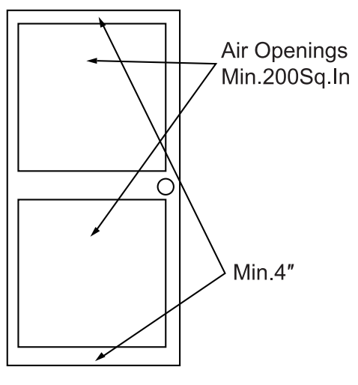
COMBUSTION AND VENTILATION AIR
А confined space is one having а volume of less than 50 cubic feet per 1,000 BTU/Hr of the aggregate input of all appliances within that space.
The air must be supplied through two permanent openings of equal area. One is to be located within 12" inches above the floor and the other is to be located within 12" inches below the ceiling.
The minimum net free area of each opening must not be less than one square inch per 1,000 BTU/Hr of the total input rating of all the appliances in the enclosure (but not less than 100 square inches) if each opening communicates with other unconfined areas inside the building.
Buildings of unusually tight construction shall have combustion and ventilation air supplied from outdoors, or а freely ventilated attic or crawl space.
If air is supplied from outdoors, directly, or through vertical ducts, there must be two openings located as specified above and each must have а minimum net free area of not less than one square inch per 4,000 BTU/Hr of the total input rating of all the appliances in the enclosure.
If horizontal ducts are used to communicate with the outdoors, each opening must have а minimum net free area of not less than one square inch per 2,000 BTU/Hr of the total input rating of all the appliances in the enclosure. If ducts are used, the minimum dimensions of rectangular air ducts shall not be less than four (4") inches.
NOТICE
If the water heater is installed in an unconfined space within а building of conventional frame, masonry, or metal construction, infiltration air is normally adequate for proper combustion and ventilation. If the water heater is installed in а confined space, provisions for combustion and ventilation air must be made.
NOТICE
If the duct openings which supply combustion and ventilation air are to be covered with а protective screen or grill, the net free area (openings in the material) of the covering material must be used in determining the size of the openings. Protective screening for the openings MUST NOT be smaller than 1/4"inch to prevent clogging by lint or other debris.
CORROSIVE ATMOSPHERES
The air in beauty shops, dry cleaning establishments, photo processing labs, and storage areas for liquid and powdered bleaches or swimming pool chemicals often contain halogenated hydrocarbons.
An air supply containing halogenated hydrocarbons may be safe to breathe, but when it passes through а gas flame, corrosive elements are released that will shorten the life of any gas burning appliance.
Propellants from common spray cans or gas leaks from А/С and refrigeration equipment are highly corrosive after passing through а flame.
The water heater warranty is voided when failure of the water heater is due to operation in а corrosive atmosphere.
NOТICE
The water heater should not be installed near any air supply containing halogenated hydrocarbons.

INSPECT THE WATER HEATER AND PACKAGING
Inspect the water heater for possible damage during shipment. Check the markings on the rating plate of the water heater to be certain the type of gas supplied corresponds to the water heater requirements. Verify that all included parts are present (see below).
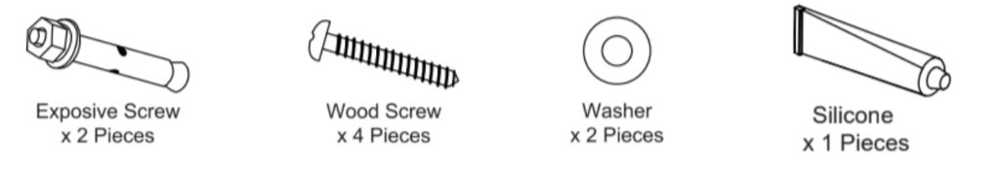
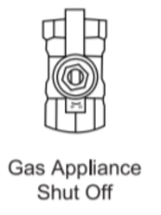
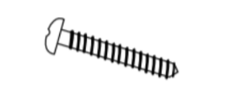
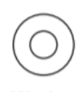

Silicone
x1 Piece
Wood Screw + Plastic Anchor Inserts
x4 Pieces
Exhaust Vent Rubber Gasket
x1 Piece
Water Inlet + Outlet Rubber Gaskets
x2 Pieces
Metal
Washer
x2 Pieces
Expansion Screw
x2 Pieces
Manual Gas Appliance Shut-off
x1 Piece

INSTALLING THE WATER HEATER

Typical Installation*

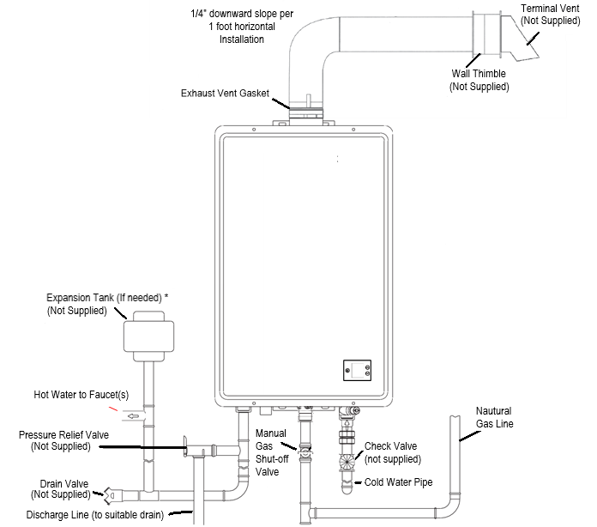

*Some Items may not apply

WATER SUPPLY CONNECTIONS
Plumbing should be carried out by а qualified plumber in accordance with local codes. Use approved plumbing materials and tools only.

Install а check valve between the water heater and the water shutoff valve. (See illustration below).
То conserve energy and to prevent freezing, insulate both cold and hot water supply lines. DO NOT cover the drain valves.

Install а water shutoff valve near the inlet of the water heater for service and draining purposes. Before connecting the water supply pipe to the water heater, open the shutoff valve, and clean out sand, debris, air, caulking material, etc. inside the pipe. Connect to the water inlet, then check water flow. Close the shutoff valve and clean the water filter.

If а water heater is installed in а closed water supply system, such as one having а backflow preventer in the cold-water supply line, means shall be provided to control thermal expansion. Contact the water supplier or local plumbing inspector on how to control this situation.
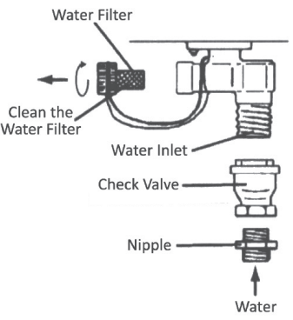
⚠️CAUTION
This water heater must only be used with the following water supply system conditions:
- With clean, potable water, free of corrosive chemicals, sand, dirt, or other contaminates.
- Inlet water temperatures above 32° F, but not to exceed 90° F.
- Free of lime and scale deposits. See Page 29 for acceptable Water Quality guidelines.
- Water quality conditions outside of these parameters may void product warranty.
- DO NOT reverse the hot and cold-water connections. The water heater will not operate.
То ensure proper operation of the water heater, the following water pressure guidelines should be followed:
- Operation of the water heater requires the minimum water pressure of 14 PSI and а minimum water flow rate of 0.8 GPM .
- Additional water pressure is required for long pipe runs and outlet fitting(s) water pressure drops.
- То maintain proper performance, ensure sufficient water supply pressure. The Required Water Pressure = Min. Operating Water Pressure (14 PSI) + Pipe Pressure Loss + Faucet and Shower Pressure Loss + Safety Margin (more than 5 PSI).
- То supply hot water to upper floors, additional water pressure (0.44 PSl/ft) must be ensured. The measurement should be calculated by the distance between the water inlet of the water heater (ground level) to the hot water faucet (upper floor level).
- Well water systems should be set at а range of 50-60 PSI.
- When the water is supplied from а water supply tank, the height of the tank and the diameter of the pipes and their relation to water pressure should be taken into consideration. Gravity water pressure is not recommended.

IMPORTANT
Do not apply heat to the НОТ or COLD water connections. Any heat applied to the water supply fittings will permanently damage the internal components of the water heater.
NOТICE
If the water flow resistance of а shower head is too high, the burner in the water heater will fail to ignite. Keep shower heads clean from debris that could cause additional pressure drop.
NOТICE
If using mixing valves on the outlet, choose one which prevents cold water pressure from overcoming hot water line pressure.
DO NOT use pipes with smaller diameters than the water supply connection of the water heater.
Be sure to connect the water inlet and the hot water outlet as shown on the water heater. If reversed, the water heater will not function.
Installation of unions or flexible copper connections are recommended on the НОТ and COLD water lines so that the water heater may disconnect easily for servicing if necessary.
REGARDING THE HOT WATER OUTLET
- Connections between the water heater and point(s) of use should be as short and direct as possible.
- DO NOT use lead or non-approved plastic pipe.
- То conserve energy and minimize heat loss, insulation of the hot water piping is recommended.
NOТICE
The flow rate of hot water may vary when more than two outlets (faucets, appliances, fixtures, etc) are being used simultaneously.
NOТICE
The pipes MUST be completely drainable. If the hot water faucets are located at а point higher than the water heater, place а drain valve at the lowest point (see diagram to the below).


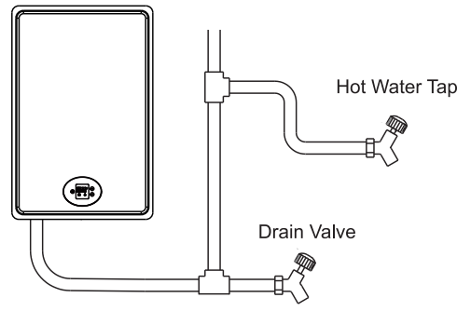

RELIEF VALVE
А new pressure relief valve (not supplied), complying with the Standard for relief Valves and Automatic Gas Shut-Off Devices for Hot Water Supply Systems, ANSI Z21.22, must be installed at the hot water outlet connection of the water heater at the time of installation. Local codes shall govern the installation of relief valves.
For safe operation of the water heater, be sure that:
- The pressure rating of the relief valve must not exceed 150 PSI, the maximum working pressure of the water heater as marked on the rating plate.
- The BTU/Hr rating of the relief valve must equal or exceed the BTU/Hr input of the water heater as marked on its rating plate.
- No valve of any type should be installed between the relief valve and the water heater.
- Discharge from the relief valve should be piped to а suitable drain to eliminate potential water damage. Piping used should be of а type approved for the distribution of hot water.
- HOT and COLD water lines should be insulated up to the water heater, but not covering any connections.
- The discharge line must be NO SMALLER than the outlet of the valve and must pitch downward to allow complete drainage (by gravity) of the relief valve and discharge line.
- The end of the discharge line should not be threaded or concealed and should be protected from freezing.
- No valve of any type, restriction, or reducer coupling should be installed in discharge line.

NOТICE
The diagram below illustrates а pressure only relief valve. If local codes require а combination temperature and pressure relief valve be installed, an extension piece may be needed.
Local codes govern the installation of relief valves. If local codes require that а temperature and pressure relief valve should be installed the manufacturer recommends a type 40XL Watts Т&Р relief valve or an equivalent model be used.
Manual operation of relief valves should be performed at least once а year. Turn off the electrical power and manual gas appliance shutoff valve. Lift and release lever on the relief valve and check the manual operation of the relief valve.
You should take precautions to avoid contact with the hot water coming out of the relief valve and to prevent water damage.
If the relief valve on the system discharges periodically, this may be due to thermal expansion in а closed water supply system. Contact the water supplier or local plumbing inspector on how to correct this situation. Do not plug the relief valve.

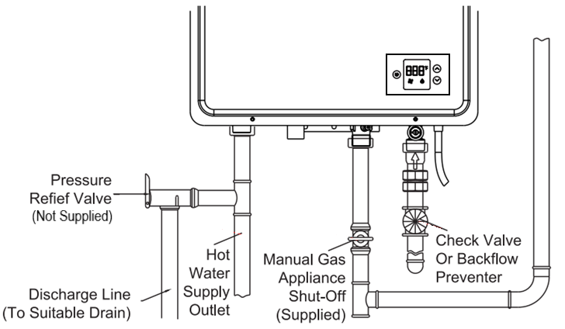
Cold Water
GAS SUPPLY
⚠️WARNING
Do not attempt to convert this water heater for use with а different type of gas other than the type shown on the rating plate. Such conversion could result in hazardous operating conditions.
Only have а professional connect the gas pipe.
The supplied manual gas appliance shut-off valve must be installed at the gas connection of the water heater at the time of installation.
The branch gas supply line to the water heater should be a clean black steel pipe or other approved gas piping material.
А ground joint union or ANSI design certified semi-rigid or flexible gas appliance connector should be installed in the gas line close to the water heater.
The National Fuel Gas Code (NFGC) mandates а manual gas shut-off valve: See NFGC for complete instructions.
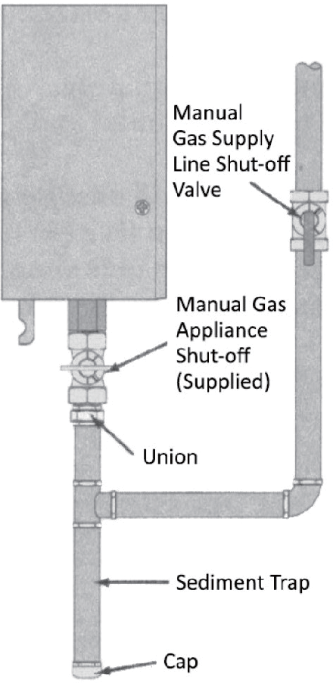
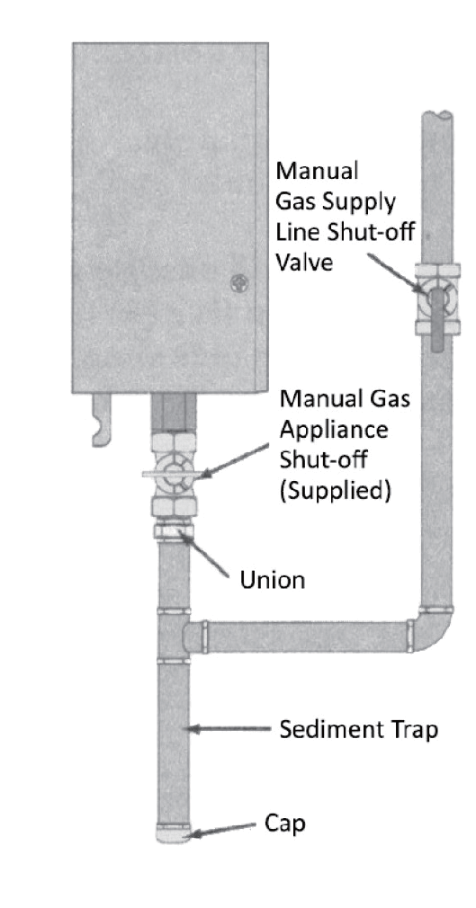
А sediment trap should be installed at the bottom of the gas line.
The inlet gas pressure to the water heater must not exceed 10.5" wc.
For purposes of input adjustment, the minimum inlet gas pressure (with main burner on) is shown on the water heater rating plate. If high or low gas pressures are present, contact your gas supplier for correction.
The water heater and its individual manual gas appliance shut-off valve must be disconnected from the gas supply piping system during any pressure testing of that system at test pressures in excess of ½ PSI (14” wc or 3.5 kPa). The water heater must be isolated from the gas supply piping system by closing its individual manual shut-off valve during any pressure testing of the gas supply piping system at test pressures equal to or less than ½ PSI (14” wc or 3.5 kPa).
DO NOT use excessive force (over 31.5 ft lbs.) in tightening the pipe, particularly if pipe compound is used, as the unit may be damaged.
The compound used on the threaded joints of the gas piping must be of the type resistant to the action of natural gas. Use compound sparingly and use on male threads only.
Leak Testing
⚠️WARNING
Never use an open flame to test for gas leaks, as property damage, personal injury, or death could result.
The water heater and its gas connections must be leak tested at normal operating pressures before it is placed into operation.
- Turn on the gas shut-off valve(s) to the water heater.
- Use а commercial leak detector or soapy water solution to test for leaks at all connections and fittings. Bubbles indicate а gas leak that must be corrected.
AII connections should also be leak tested after the water heater is placed into operation.
PRESSURE TESTING THE GAS SUPPLY SYSTEM
⚠️WARNING
Install а gas pressure regulator in the gas supply line which does not exceed the maximum supply pressure. DO NOT use an industrial type gas regulator.
The water heater must be isolated from the gas piping system by closing the manual gas shut-off valve during any pressure testing of the gas supply piping at pressures equal to or less than 1/2 PSI (14” wc).

VENTING
⚠️DANGER
Failure to install the vent adapter and properly vent the water heater to the outdoors as outlined in the VENTING section of this manual will result in unsafe operation of the water heater causing death, serious injury, explosion, and/or fire. То avoid the risk of fire, explosion, or asphyxiation from carbon monoxide, NEVER operate the water heater unless it is properly vented and has adequate air supply for proper operation as outlined in the VENTING section of this manual.
⚠️WARNING
Use UL approved Category III Stainless Steel vent material only. No other vent material is permitted. Installer must refer to vent manufacturer's instructions and specifications. Information on Z-Flex™, an approved venting material, can be found at www.novaflex.com
The installation of venting must comply with national codes, local codes, and the vent manufacturer's instructions. Installer must refer to vent manufacturer's instructions and specifications. Please visit а local hardware store or online marketplaces to purchase З" Category III Stainless Steel Venting for certified installation, such as Z-Flex™ referenced above.
The water heater must be vented to the outdoors as described in these instructions. DO NOT connect this water heater to an existing Vent or Chimney, it must be vented separately from all other appliances.
AII vent components (adapters, pipe, elbows, terminals, etc.) should be UL 1738 Certified Stainless Steel Venting Material (e.g. AL29-4C).
The specified vent termination must be used. The termination should be а 90° elbow type with screen.
Use а vent pipe with an antidisconnection structure.
The use of а High Temperature Silicone (500°F) тау be required to seal vent connections. Insert the pipe onto the exhaust vent rubber gasket to start the vent run. Make sure to completely slide the vent into the collar until make sure the tube contact with the bottom of gasket. The vent pipe will be sealed by the rubber gasket with the addition of the silicon provided on both side of rubber gasket to make it fixed well. To prevent accidental gas exhaust leakage, apply а 1/4" wide bead approximately 1/4" from the end and another bead against the joint side of the stop bead.

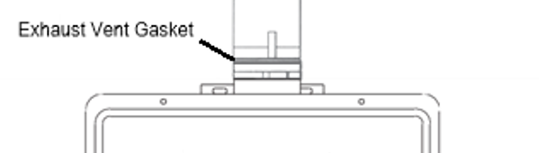
Exhaust Vent Gasket

Follow vent manufacturer's installation instructions. The unit сап be vented either horizontally or vertically.
Vent pipe runs must be adequately supported along both horizontal and vertical runs.

VENTING (CON’T.)
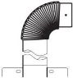
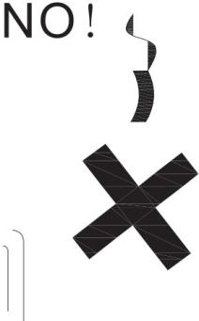
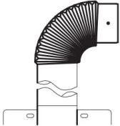
The maximum recommended unsupported span is по more than four (4’) feet. Support isolation hanging bands should be used. DO NOT use wire.
о
о
о
YES!
о

VENTING THROUGH CLOSED SPACES
If the vent piping passes through а closed space, wrap the vent pipe with nonflammable insulation material that is at least 3/4" thick. DO NOT let the insulation material contact flammable materials. А minimum clearance of six (6") inches between the vent pipe and ceiling should be maintained. Follow all local codes.
For maintenance and inspection purposes, the following holes are required to be made:
- Two (2) inspection openings that allow access to venting. One of these openings should be close to where the vent pipe enters the ceiling. The other opening should be near the vent termination.
- А ventilation hole with а 16 sq. in. opening should be made at least every ten (10’) feet.

NOТICE
Vent pipes must be completely insulated with nonflammable material when installed in alcoves, closets, and garages and must not touch any flammable material.

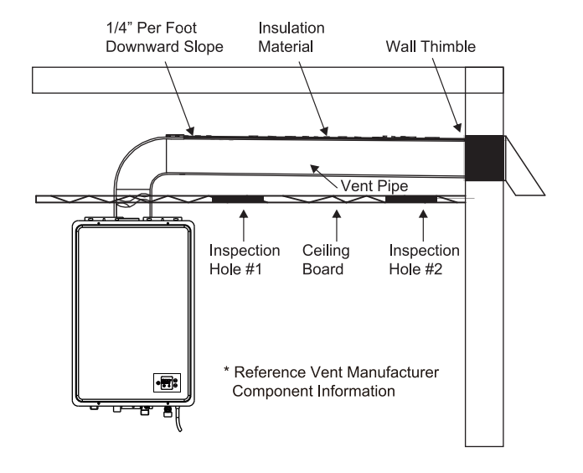
Terminal Vent
VENTING LENGTHS
MAXIMUM VENT LENGTH
The installer must refer to vent manufacturer's instructions and specifications.
The system will not operate if there is excessive restriction (pressure drop) in the venting system. А maximum of 32’ feet of vent pipe may be used provided there is only one 90° elbow in the system. If additional elbows are required: two elbows сап be used with 27 feet of vent pipe, and three elbows сап be used with 22 feet of vent pipe.
А 90° elbow is equivalent to 5 feet of straight pipe. А 45° elbow is equivalent to 2’ feet 6" inches of straight pipe. The termination elbow does not count as an elbow when determining total vent lengths.
The vent pipe must be installed with а slight downward slope of 1/4" inch per foot of horizontal run toward the vent terminal (see diagram below). This ensures that any condensate formed during operation of the unit is evacuated from the water heater.
А 1/4" per foot upward slope is acceptable when it is not possible to vent with а downward slope; however, а UL approved Category III Stainless Steel condensate trap MUST be installed at the beginning of the horizontal run.
Number of 90° elbows (Bends) | Maximum length of straight pipe
1 | 32’
2 | 27’
3 | 22’
One (1) 90° elbow is equivalent to 5’ feet (60”) of straight pipe
One (1) 45° elbow is equivalent to 2.5’ feet (30”) of straight pipe

MINIMUM VENT LENGTH
The venting may be as short as 35", provided one vent termination is installed to the outdoors through а sidewall, one 90° elbow is included in the installation, and the wall thimble is installed.
NOТICE
Make sure that the seam of the vent pipe in horizontal runs is toward the top of the installation (see illustration below on the left).
¼ Inch per Foot Downward Slope
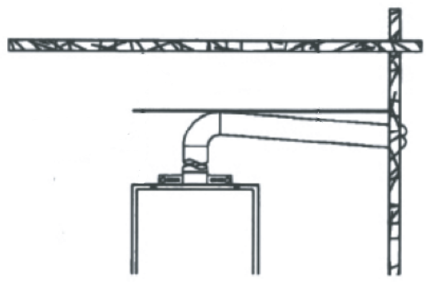
Vent Seam
Minimum one (1’) foot

Maximum two (2’) feet
Maximum two (2’) feet
Minimum of six (6”) inches
Condensate trap and drain (if needed)
DRAINING THE CONDENSATE
In certain conditions, installations in unconditioned space or having long horizontal or vertical runs may accumulate condensate.
Condensate is known to be acidic; refer to local, state, or federal codes for proper handling methods.
To prevent condensate from draining back into the water heater, we recommend а condensate trap and drain to be installed in а horizontal vent section as close as practical to the water heater vent connection.
Not following proper condensate procedures will void this product’s warranty.

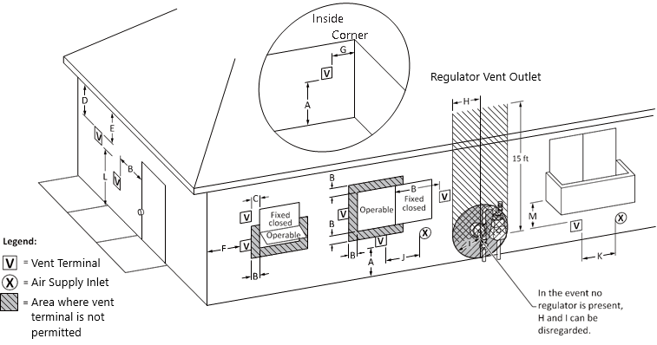
VENT TERMINATION CLEARANCES FOR NON-DIRECT VENT INSTALLATIONS

US installations (minimum distances specified in the National Fuel Gas Code, ANSI Z223.1/NFPA 54, and/or the Natural Gas and Propane Installation Code, CSA B149.1)
A = | Clearance above grade, veranda, porch, deck, or balcony | 12” inches
B = | Clearance to window or door that may be opened | 4 ft (48”) below or to side of opening.  1 ft (12”) above opening
C = | Clearance to permanently closed window | *
D = | Vertical clearance to ventilated soffit located above the terminal within a horizontal distance of 2 ft (24” inches) from the center line of the terminal | *
E = | Clearance to unventilated soffit | *
F = | Clearance to outside corner | *
G = | Clearance to inside corner | *
H = | Clearance to each side of center line extended above meter/ regulator assembly | *
I = | Clearance to service regulator vent outlet | *
J = | Clearance to nonmechanical air supply inlet to building or the combustion air inlet to any other appliance | 4 ft (48”) below or to side of opening; 1 ft (12”) above opening
K = | Clearance to a mechanical air supply inlet | 3 ft (36”) above if within 10 ft (120”) horizontally
L = | Clearance above paved sidewalk or paved driveway located on public property | 7 ft (84”) for mechanical draft systems (Category I appliances). Vents for Category II and IV appliances cannot be located above public walkways or other areas where condensate or vapor can cause a nuisance or hazard
M = | Clearance under veranda, porch deck, or balcony | *

* Clearance in accordance with local installation codes and the requirements of the gas supplier

VENT TERMINATION CLEARANCES FOR NON-DIRECT VENT INSTALLATIONS (CONT’D.)
The minimum distance from adjacent public walkways, adjacent buildings, openable windows, and building openings shall not be less than those values specified in the National Fuel Gas Code, ANSI Z223.1/NFPA 54, and/or the Natural Gas and Propane Installation Code, CSA B149.1;
- Information on preventing blockage by snow; and
- Information on protecting building materials from degradation by flue gases.
  - A vent shall not terminate directly above a sidewalk or paved driveway that is located between two single family dwellings and serves both dwellings.
- A vent termination is permitted only if veranda, porch, deck, or balcony is fully open on a minimum of two sides beneath the floor.
Vent termination clearances are in accordance with:
- current CSA B149.1 Natural Gas and Propane Installation Code.
- current ANSI Z223.1 / NFPA 54 National Fuel Gas Code.
If locally adopted installation codes specify clearances different than those illustrated on page 20, then the most stringent clearance shall prevail.

INSTALLING THE WATER HEATER ILLUSTRATION
TYPICAL HORIZONTAL TERMINATION
¼ INCH PER FOOT DOWNWARD SLOPE ILLUSTRATED




Wall Thimble (detailed on next page)

Six (6”) inch Clearance

Minimum one (1’) foot

Maximum two (2’) feet

Support Hangers

Adaptor
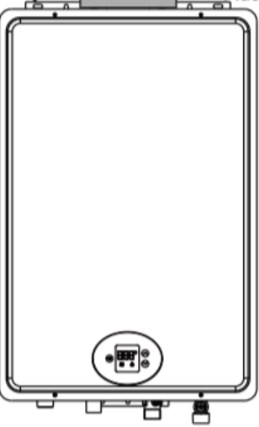
To drain, dispose of the condensate in accordance with local codes

10” inch space gap
10” inch space gap

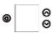

TYPICAL WALL THIMBLE INSTALLATION ILLUSTRATION

Inner Thimble
Section
Towards Water Heater
Outer Thimble
Section Towards Outside Terminal Vent

Side View

⚠️WARNING
Use UL approved Category III vent material only. No other vent material is permitted. Installer must refer to vent manufacturer's instructions and specifications.
Please visit а local hardware store or online marketplaces to purchase UL approved Category III Stainless Steel Venting for certified installation.
⚠️CAUTION
Follow the vent manufacturer’s installation instructions as design might vary from manufacturer to manufacturer.

ELECTRICAL CONNECTIONS
POWERCORD
- The electric power supply requirement for this water heater is 120 VAC/60Hz, 2 Amps.
- The water heater comes with а three (3) pin power supply cord. Use only а power outlet with а ground terminal.
- The installation of an electric leakage breaker (GFCI) is recommended.
- Keep any excess of the power supply cord on the outside of the water heater.
- If local codes require hardwiring, see instructions for "HARDWIRING THE ELECTRICAL CONNECTIONS" below.
⚠️WARNING
Shock hazard line voltage is present. Before servicing the water heater, turn off the electrical power to the water heater at the main disconnect or circuit breaker. Failure to do so could result in severe personal injury or death. Additionally, it is recommended to unplug the power cord from the outlet serving the unit and wait at least ten (10) seconds after disconnecting before servicing the unit.
HARD WIRING THE ELECTRICAL CONNECTIONS
⚠️WARNING
Field wiring connections and electrical grounding must comply with local codes, or in the absence of local codes with the latest edition of the National Electrical Code ANSI/NFPA 70.
- Wiring should be carried out by a qualified electrician in accordance with local codes.
- The water heater requires 120 VAC/60Hz and should be properly grounded.
- DO NOT connect grounding wire to water pipes, gas pipes, telephone cables, lightning conductor circuits and to grounding circuits of other equipment that carry a ground-fault interrupter.
- An ON/OFF switch must be provided and installed for incoming 120 VAC power.
- Wire the water heater exactly as shown below. A wiring diagram is also found inside the cover panel.
- A green screw is provided in the junction box for grounding connection.
- Connect the live wire to black leg wire and neutral wire to the white neutral wire.
⚠️CAUTION
Label all wires prior to disconnection when servicing controls. Wiring errors can cause improper and dangerous operation. Verify correct operation after servicing.

ELECTRIC WIRING DIAGRAM

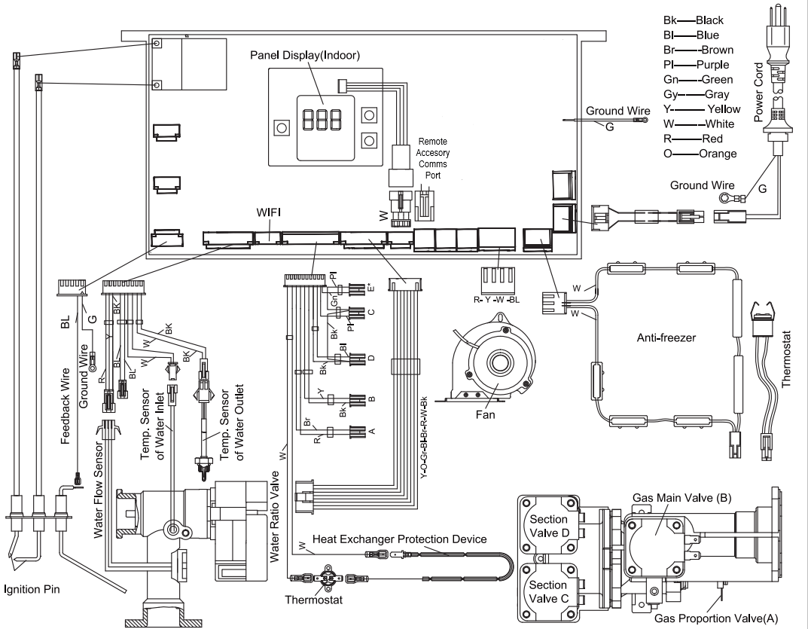

INSULATION BLANKETS
⚠️WARNING
Do not use an insulation blanket with this product.
Utilizing an external insulation blanket will void this product’s warranty.
For increased energy efficiency, please use pipe insulation.

PIPE INSTALLATION
INLET PIPE AND OUTLET PIPE INSTALLATION
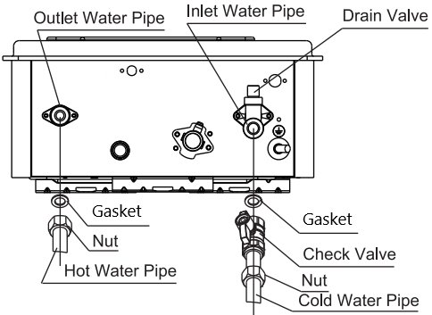
Use pressure resistant pipe to connect the inlet and outlet water pipes of the water heater and the local water pipe (Make sure to place a rubber gasket (supplied) when connecting). Before connecting the inlet water pipe, flush the inside of the pipe.

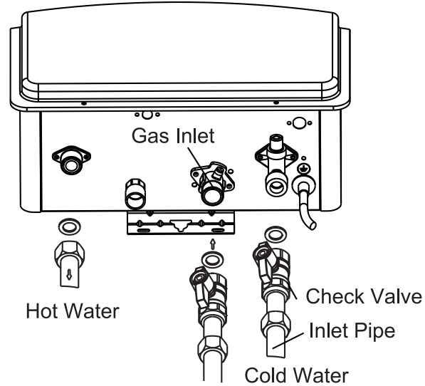

HOT AND COLD PIPE INSULATION
When installing pipe insulation, please install the insulation according to the manufacturer’s instructions making sure to insulate all the way to the top of the pipe to the nut. Do not cover any drain or pressure valve(s).

DURING INSTALLATION OF THIS WATER HEATER
MUST DO
- DO check inlet gas pressure to ensure that it is within the range specified on the rating plate.
- DO provide adequate air for combustion and ventilation as discussed in this Manual and the National Gas Code.
- DO maintain proper clearances to combustibles as specified by applicable code.
- DO ensure that the flue terminal location complies with the guidelines found in this Manual and National Fuel Gas Code.

DO NOT
- DO NOT blосk or restrict Air Intake Opening located on the back side of the water heater.
- DO NOT remove the front cover unless necessary and mandatory.
- DO NOT install this product where standing water may occur.

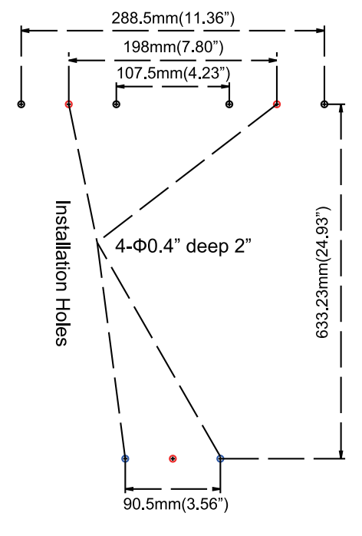
MOUNTING ТНЕ WATER HEATER
Make sure the location of the water heater allows for easy access and operation. In case of dry wall or concrete wall, use dry wall anchors or lag bolts.
The water heater requires 120 VAC/ 60Нz. Have а receptacle with ground terminal near the water heater. The length of the power supply cord is five (5’) feet.
Drill the holes as per the sizes in the figure to the right, put two (2) expansion screws into the top holes, and two (2) plastic expansion inserts into the bottom holes.
Hang up the water heater unit, tighten the expansion screws, and put two (2) wood thread screws into the bottom holes.

⚠️CAUTION
Reinforcement of the wall is required in case the wall is not strong enough to hold the water heater.
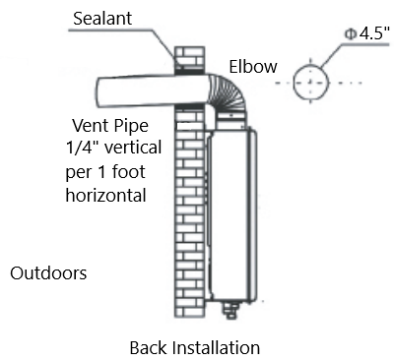
А. ВАСК INSTALLATION
- Insert the vent pipe through the installation hole in the wall with the terminal sticking out.
- Connect the elbow to the vent pipe and water heater, moving straight backwards until the expansion screws go into the holes of the water heater. Screw the nuts tight (pay attention to the direction of the elbow).

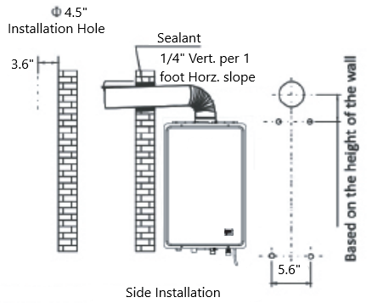

B. SIDE INSTALLATION
- Aim the holes in the water heater onto the expansion screws, hang it up, and screw the nuts tightly.
- Put the vent pipe through the holes in the wall and connect the elbow with the water heater and vent pipe.

VERITCAL INSTALLATION
Not recommended

INSTALLATION CHECK LIST

А. Water Heater Location
- Installed indoors.
- Close to area of mostly used outlet.
- Protected from freezing temperatures.
- Proper clearance from combustible surfaces observed.
- Sufficient fresh air supply for proper operation of water heater.
- Air supply free of corrosive elements and flammable vapors.
- Provisions made to protect area from water damage.
- Sufficient room to service heater.
- Combustible materials, such as clothing, cleaning materials, rags, etc. clear of the heater and vent piping.
- Water heater is properly attached to the wall.

В. Water Supply
- Water supply has sufficient pressure.
- Water quality is within operating parameters as outlined on Page 29.
- Air purged from water heater and piping.
- Water connections tight and free of leaks.
- Water filter is clean and in place.
- Materials used are as instructed in this manual.
- Water pipes are insulated.

C. Relief Valve
- Pressure Relief Valve properly installed and discharge line run to open drain.
- Discharge line protected from freezing.

D. Gas Supply
- Gas type matches rating plate.
- Gas supply pressure is sufficient for the water heater.
- Gas line equipped with shut-off valve, union, and sediment trap.
- Approved pipe joint compound used.
- Commercial leak detector or soap and water solution used to check all connections and fittings for possible gas leak.
- Gas company inspected installation (if required).

Е. Electrical Wiring
- Voltage matches rating plate.
- Water heater is properly grounded.
- Wiring meets all local codes.
- GFCI Protection where required.

LIGHTING THE WATER HEATER
Before operating this water heater, be sure to read and follow the instructions on the label pictured on the following page and all other labels on the water heater, as well as the warnings printed in this manual. Failure to do so сап result in unsafe operation of the water heater resulting in property damage, personal injury, or death. Should you have any problems reading or following the instructions in this manual, STOP and get help from а qualified service technician.


FOR YOUR SAFETY BEFORE USING THE WATER HEATER

⚠️WARNING If you do not follow these instructions exactly, а fire or explosion may result in causing property damage, personal injury, or loss of life.
А This water heater does not have а pilot. It is equipped with an ignition device which automatically lights the burner. Do not try to light the burner by hand.
В. BEFORE OPERAТING smell all around the water heater area for gas. Be sure to smell next to the floor because some gas is heavier than air and will settle on the floor. Test all connections with а commercial leak detector ог soapy water.
WHAT ТО DO IF YOU SMELL GAS
  - DO NOT try to light any appliance • DO NOT touch any electric switch; DO NOT use any phone in your building. • Immediately call your gas supplier from а neighbor's phone. Follow the gas supplier's instructions. • If you cannot reach your gas supplier or fire department. • DO NOT return to your home until authorized by the gas supplier or fire department.
С. Use only your hand to push in or turn the gas control knob. Never use tools. If the knob will not push in or turn by hand, don't try to repair it, call а qualified service technician. Force or attempted repair may result in а fire or explosion.
- DO NOT use this water heater if any part has been under water. Immediately call а qualified service technician to inspect the water heater and to replace any part of the control system.
OPERATING INSTRUCTIONS

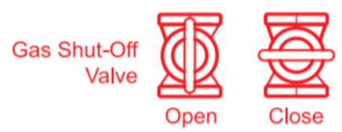
  - STOP! Read the safety information above on this label.
  - Turn off all electric power to the water heater.
  - Set the thermostat to lowest setting.
  - DO NOT attempt to light the burner by hand.
  - Turn the Gas Shut-off Valve located on the outside of the
unit clockwise to the "CLOSE" / “OFF” position.
  - Wait five (5) minutes to clear out any gas. lf you smell gas, STOP! Follow "В" in the safety information above on this label. If you don't smell gas, go to the next step.
  - Turn the Gas Shut-off Valve located on outside of the unit counterclockwise to the "OPEN" position.
  - Turn on all electric power to the water heater.
  - Set thermostat to desired setting.
1О. lf the water heater will not operate, follow the instructions below "ТO TURN OFF GAS TO WATER HEATER" and call your service technician or gas supplier.
TO TURN OFF GAS TO WATER HEATER
- Turn off all electric power to the water heater if service is to be performed.
- Turn the Gas Shut-off Valve located on the outside of the unit clockwise to the "CLOSE" / “OFF” position.

NОТЕ: THIS MANUAL AND ALL KINGS PEAK CONTENT IS SUBJECT ТО CHANGE WIТHOUT NOTICE. PLEASE VISIТ WWW.KINGSPEAKHOME.COM, CALL SERVICE НОТ LINE (855) 855-4647 OR EMAIL ТО HEREFORYOU@KINGSPEAKHOME.COM FOR MORE INFORMATION.

OPERATING ТНЕ WATER HEATER
TURNING ON THE WATER HEATER
- Make sure the gas type you will use is the same as the type on the data plate.
- OPEN the main gas valve, plug in the power cord (be sure the socket is well grounded), and press the "ON/OFF" button on the control panel. Set temperature to desire temperature (e.g. 120°F).
- Turn on a hot water faucet, and the fan will start working. You will hear the ignition sound for а few seconds and the burner will ignite and hot water will come out. If the burner is not ignited successfully, the ignition click sound will last more than а few seconds. If the burner still fails to ignite, turn off the faucet and wait for 10-20 seconds, and repeat the above procedures.
For first use and/or if the water heater has not been used for а considerable period of time, repeating the above procedures may be required due to accumulated air inside the gas pipe.
SAFETY PRECAUTIONS
If there is any difficulty in understanding or following the “OPERATING THE WATER HEATER” instructions or the “CARE AND CLEANING” Section, it is recommended that а qualified person or serviceperson perform the work.
- DO CLOSE the manual gas shut-off valve if water heater has been subjected to overheating, fire, flood, physical damage, or if the gas supply fails to shut off.
- DO NOT turn on the water heater unless water and gas supplies are fully opened.
- DO NOT turn on the water heater if cold water supply shut-off valve is closed.
- DO NOT allow combustible materials such as newspaper, rags, or mops to accumulate near water heater.
- DO NOT store or use gasoline or other flammable vapors and liquids, such as adhesives or paint thinner, in vicinity of this or any other appliance. If such flammables must be used, open doors and windows for ventilation and all gas burning appliances in the vicinity should be shut off including their pilot lights to avoid vapors lighting.
NOТICE
Flammable vapors сап be drawn by air currents from surrounding areas to the water heater.

WATER TEMPERATURE SETTING
⚠️DANGER
There is а hot water scald potential if the temperature is set too high. Households with small children, disabled, or elderly persons may require а 120°F or lower temperature setting to prevent contact with excessively hot water.
Water Temperature | Time To Produce а Serious Burn
120° F | More than 5 minutes
125° F | 1½ to 2 minutes
130° F | About 30 seconds
135° F | About 10 seconds
140° F | Less than 5 seconds
145° F | Less than 3 seconds
150° F | About 1½ seconds
155° F | About 1 second
Table courtesy of Shriners Burn Institute
Output temperature of water is regulated by setting the temperature on the display. Safety factors should be considered when selecting the water temperature setting of the water heater’s control. The control was set at 110°F before the water heater was shipped from our factory. This is the recommended starting point.
Be sure to read and follow the warnings outlined in this manual and on the label located on the water heater. Mixing valves are available for reducing point of use water temperature by mixing hot and cold water in branch water lines.

WATER TEMPERATURE SETTING (CON’T.)
SET TEMPERATURE MEMORY
- This water heater contains an electronically controlled thermostat. The temperature range can be set between 90° F and 140° F.
- The control is factory preset to 110° F.
- To turn the control ON or OFF, press and hold the POWER button for more than three (3) seconds.
- То adjust the temperature to а desired setting, press the UP or DOWN temperature buttons. Press and hold UP or DOWN to raise or lower the temperature continuously until desired temperature is reached.
- When the unit is on and in use, the set temperature сап only be increased to 122° F, but there is no limit to temperature decrease. То increase the temperature more than 122° F, the water heater will need to be shut off first.
NOТICE
If the inlet water temperature is high, and set temperature is low, the actual temperature might be higher than the set temperature.
- The display will read the set temperature if the water heater is not in use or there is no water flow. If the water heater is in use or has water flow, the display will read the actual temperature. То view the set temperature in this condition, press UP or DOWN and the set temperature will flash for three (3) seconds.
- The hottest temperature water will be at the hot water faucet closest to the water heater.
- Always remember to test the water temperature with your hand before use and remember that hotter water increases the risk of a scalding injury.
- Always supervise young children or others who need special assistance.
- If the water heater has been subjected to fire, flood, or physical damage, CLOSE the manual gas shut-off valve, and do not operate the water heater again until it has been checked by qualified personnel.
⚠️WARNING
Should overheating occur or the gas supply fails to shut off, CLOSE the manual gas shut-off valve to the water heater.

WATER QUALITY
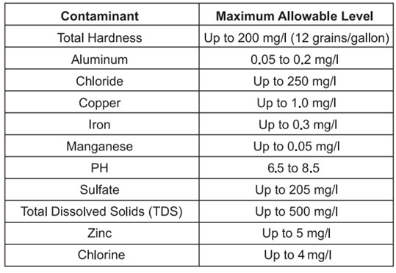
Proper maintenance of the water heater is required to ensure that your water meets ЕРА quality standards.

- The following table shows the maximum contaminant levels allowed based on the ЕРА National Secondary Drinking Water Regulations (40 CFR Part 143.3).
.
- Water quality conditions outside of these parameters may void product warranty and may impact your health.
.

NOТICE
If you suspect that your water is contaminated in any way, discontinue use of the water heater, and contact an authorized technician or licensed professional.

CARE AND CLEANING OF ТНЕ WATER HEATER
ROUTINE PREVENTATIVE MAINTENANCE
⚠️DANGER
Before manually operating the relief valve, make certain no one will be exposed to the danger of the hot water released by the valve. The water may be hot enough to create а scalding hazard. The water should be released into а suitable drain to prevent injury or property damage.
⚠️DANGER
Hotter water increases the potential for hot water scalds.
Properly maintained, your water heater will provide years of dependable trouble-free service. It is recommended that а periodic inspection of the burner, relief valve, water filter, and venting system should be made by service personnel qualified in gas appliance repair.
It is suggested that а routine preventive maintenance program be established and followed by the user.
At least once а year, lift and release the lever handle on the pressure relief valve, located in the hot outlet piping of the water heater, to make certain the valve operates freely. Allow several gallons to flush through the discharge line to an open drain.
Rapid closing of faucets or solenoid valves in automatic water using appliances may cause а banging noise heard in а water pipe. Strategically located risers in the water pipe system or water hammer arrestors сап be used to minimize this problem.
Inspect the area around the water heater to ensure а safe operating environment. Keep the water heater area clear and free from combustible materials, gasoline, and other flammable vapors and liquids. Ensure the unit has not been damaged. If damage or denting to the appliance is present, contact а service personnel to verify proper operation.
Check for any abnormal sounds during normal operation of the water heater.
AII piping should be checked for gas and/or water leaks. Refer to the “LEAK TESTING” section on Page 17 of this manual for instructions on how to test.
The air intake and cold water supply filter should be cleaned monthly. Refer to the "HOW TO CLEAN THE WATER FILTER" section on Page 31 for further information.
DO NOT operate the water heater if you feel something is wrong with the water heater. DO NOT allow children to operate or otherwise handle the water heater.
⚠️DANGER
Failure to perform the recommended routine preventative maintenance сап harm the proper operation of this water heater, which сап cause carbon monoxide dangers, excessive hot water temperatures, and other potentially hazardous conditions.
NOТICE
If the pressure relief valve on the hot water heater discharges periodically, this may be due to a problem in the water system. Contact the water supplier or your plumbing contractor on how to correct this. DO NOT plug the relief valve outlet.
NOТICE
After inspection, maintenance, and/or cleaning, ensure proper operation by turning on а hot water faucet.

HOW ТО CLEAN ТНЕ WATER FILTER
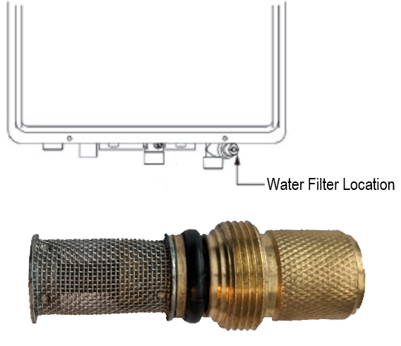
- Make sure the unit is OFF, the power cord is unplugged, and the electrical power supply has been disconnected at the circuit breaker.
- CLOSE the water supply to the heater.
- Unscrew the water filter and slide the filter out.
- DO NOT tap the filter as it may deform and/or damage the filter.
- To remove severe debris, use а soft brush and wash with running water.
- Return the filter to the water heater and screw in the filter.
- Plug in the power cord to the outlet and reconnect the electrical power supply and OPEN the cold water supply to the water heater.
- The water filter should be cleaned on а monthly basis.
Water Filter Unscrewed from Appliance
SIX (6) MONTH CLEANING ROUТINE
То prevent water scale, lime, or rust deposit buildup and ensure your new tankless water heater is running as efficiently as possible, it is highly recommended that you clean your tankless water heater every 6 months. We recommended using a descaling kit, such as the Kings Peak EZ-Descale Kit, available at our website, www.kingspeakhome.com
Before performing any cleaning and maintenance tasks to this water heater, be sure to turn the unit OFF and disconnect the power supply.
Vacuum around the water heater for dust, debris, and lint on а regular basis. Clean the exterior of the water heater by using а damp soft cloth with а few drops of mild detergent and gently wiping the surfaces of the unit. Wipe any remaining moisture with а dry soft cloth.
То ensure sufficient ventilation and combustion air supply, proper clearances must be maintained.

CLEANING ТНЕ EXTERIOR OF THE WATER HEATER
- Make sure the unit is OFF and the electrical power supply has been disconnected.
- DO NOT scrub the appliance with а brush.
- Use only mild soapy water, other cleaners may damage the surface of the water heater.
- DO NOT remove any label including the rating plate while cleaning or servicing.
⚠️DANGER
Shock Hazard. Make sure the electrical power to the water heater is off to avoid potential serious injury or damage to components.
⚠️DANGER
Combustible materials, such as clothing, cleaning materials, or flammable liquids, etc., must not be placed against or next to the water heater.

VACATION AND EXTENDED SHUT-DOWN
If the water heater is to remain idle for an extended period, the power and water to the appliance should be turned off.
The water heater and piping should be drained if they might be subjected to freezing temperatures. After а long shut-down period, the water heater's operation and controls should be checked by qualified service personnel.

ANTI-FREEZING ELECTRIC WARMING SYSTEM
An Anti-Freezing system inside the unit will help to protect from near to slightly below freezing temperatures, it will in no way guarantee protection from water freezing damage. DO NOT rely on the anti-freezing system to fully protect the unit from freezing, especially when exposed to extreme cold environments. Take all precautions to prevent extreme cold damage the unit.
NOТICE
The anti-freezing device works for the water heater unit, and not the inlet nor outlet water pipes.
⚠️WARNING
Freezing at any point within the plumbing system may result in damage to the water heater, such as а rupture in your heat exchanger. AII pipes must be adequately protected from freezing.
This unit is equipped with an automatic heating system that will help to avoid freeze damage, but the power to the unit and the unit itself must remain ON. Freezing will occur with no power or power loss. In colder areas, where the air temperature around the unit is at or under 32° F, freezing will occur if the heating power limit of the anti-freeze system is exceeded. If these conditions take place, please follow the procedures explained below.
DRAINING PROCEDURE
When the temperature falls below 32° F, water in your plumbing system or water heater can turn to ice and then expand, causing damage to the water heater. This damage is not covered under the Limited Product Warranty. If these conditions are anticipated or have been experienced, please drain the water heater as follows to help, but not guarantee, protection from freezing water damage:
DRAINING THE WATER HEATER
- CLOSE the main gas valve and unplug power to the unit. Disconnecting the breaker serving the outlet for this unit at the breaker box is strongly recommended for your safety. For extra precaution, we recommend waiting at least ten seconds after disconnecting power to the unit to move to step 2.
- CLOSE the water Shut-off inlet water valve.
- OPEN all faucets, cold water should be coming out of all hot water faucets, bypassing the hot water heater.
- OPEN the drain valve and allow water to drain for three (3) minutes or until the unit is empty.
- Once you are sure all water is out of the unit, CLOSE the drain valve and shut the faucets.
⚠️WARNING
Failure to follow these instructions while draining the water heater can cause serious damage to the water heater as well as personal injury including scalding.
RESUMING OPERATION OF THE UNIT
- Reattach the water filter, if previously removed for cleaning.
- OPEN a hot water faucet, then close the hot water outlet drain valve from the unit.
- OPEN the water shut-off valve and close again after making sure that water comes out from hot water faucets. (This step is to remove air from the water lines.)
- Reconnect the power plug of the unit to an outlet.
- Reconnect the breaker at the breaker box that serves the outlet for this unit.
- Turn the on/off switch to the ON position, fully OPEN the gas shut-off valve and the water shut-off valve.
- Ensure hot water is now available from the open faucet from step 2 above.
NOТICE
The water heater may not operate unless the above procedure is followed correctly.
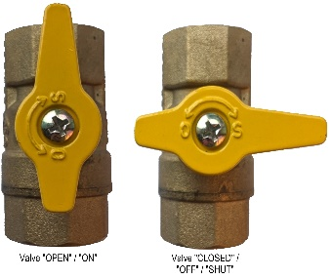
Manual Gas Appliance Shut-Off Valve “CLOSED / OFF / SHUT”
Manual Gas Appliance Shut-Off Valve “OPEN”

BEFORE INQUIRING TO CUSTOMER SERVICE
TROUBLESHOOTING TIPS
Save time and money! Review the charts below first and you may not need to call for service. This water heater incorporates а variety of shut off devices that prevent the operation of the water heater if undesirable combustion conditions occur, such as the presence of а blockage of the combustion air vent, or insufficient gas or gas pressure which сап impact the safe operation of the water heater. Please contact а qualified service technician if this occurs.

Problem | Possible Cause | Potential Solution
Not enough or no hot water | Water shutoff valve is not fully opened | Check shutoff valve and open fully
Not enough or no hot water | Hot water faucet is not fully opened | Open hot water faucet completely  (The main burner goes off when incoming water volume is inadequate)
Not enough or no hot water | Water pipes are frozen | Allow pipes to thaw, DO NOT USE APPLIANCE until pipes are un-frozen
Not enough or no hot water | No electricity or water supply is cut off | Check that proper power is being supplied and/or water supply is adequate
Not enough or no hot water | Unit is not "ON" | Turn the unit "ON"
Not enough or no hot water | The temperature may be set too low | Increase the temperature setting
Not enough or no hot water | Mixing Valve malfunction (if applicable) | Check and replace if necessary
Not enough or no hot water | Error code displayed on the control display panel | See instructions for Error Codes on Page 34
Not enough or no hot water | Water filter is clogged | Clean the filter with а toothbrush
Not enough or no hot water | Water shutoff valve is not fully opened | Check shutoff valve and open fully
Not enough or no hot water | Small amount of water has been heated | Allow more water to flow
Water not | The temperature may be set too low | Increase the temperature setting
hot enough | The gas valve is not fully opened | Check and open the gas valve fully
Water too hot | The temperature is set too high | Decrease the temperature setting
Fan continues to rotate after hot water faucet is closed | This function is to purge unburned gas for 10-15 seconds | Normal operation.  There is no need to call for service
An error code is showing on the display | The unit has detected an abnormal operation | Please see the next page for Error Code Explanations and Potential Solutions

ERROR CODE GUIDE AND POSSIBLE SOLUTIONS
WHEN AN ERROR CODE IS DISPLAYED
- Close the hot water faucet, turn OFF the unit using the power button on the unit.
- Wait for about five (5) minutes before turning the power ON to the unit.
- Open a hot water faucet.
If the Error Code remains displayed on the unit:
- Close the hot water faucet and turn OFF power to the unit using the button on the unit.
- Review the Error Code chart below and try the potential solution for the associated code displayed.
- Resume use of the hot water faucet.
If the Error Code still displays on the unit:
- Close the hot water faucet and turn OFF power to the unit using the button on the unit.
- Call customer service at (855)855-4647 for further assistance.
Error Code | Error Description | Potential Solution
E0 | Water outlet temperature sensor failure | Connect the water outlet temperature sensor
E0 | Water outlet temperature sensor failure | Replace the water outlet temperature sensor
E1 | Accidental flameout failure | Turn off the hot water faucet or turn OFF the power button on the display
E2 | Fake flame failure | Turn off the hot water faucet or turn OFF the power button on the display
E3 | Thermostat failure | Connect the thermostat
E3 | Thermostat failure | Replace the thermostat
E4 | Water outlet sensor recorded an “overtemperature” alert | Connect the water outlet temperature sensor
E4 | Water outlet sensor recorded an “overtemperature” alert | Replace the water outlet temperature sensor
E5 | Fan failure | Connect the fan
E5 | Fan failure | Replace the fan
E6 | Solenoid valve failure | Connect the valve
E6 | Solenoid valve failure | Replace the valve
EE | Timeout fault | Turn off the hot water faucet or turn OFF the power button on the display
C0 | Ignition failure | Turn off the hot water faucet or turn OFF the power button on the display
C1 | Residual flame failure | Turn off the hot water faucet or turn OFF the power button on the display
C4 | Vent blockage | Clean the vent pipe
F2 | Cold water inlet temperature sensor failure | Connect the water inlet temperature sensor
F2 | Cold water inlet temperature sensor failure | Replace the water inlet temperature sensor
NOTICE
If an Error Code other than those listed in the chart below is displayed, immediately close the hot water faucet, take note of the Error Code, turn OFF power to the unit, and call the customer assistance number at (855)855-4647.
⚠️WARNING
For your safety, DO NOT attempt to repair gas piping, the display, burners, vent connectors, or other safety devices. Refer all repairs to qualified service personnel. This product is not serviceable by the end consumer outside of the remedies outlined in the “TROUBLESHOOTING TIPS” and “ERROR CODES” sections of this manual. Failure to defer service to a professional may result in property damage, injury, and/or loss of life.
⚠️DANGER
Make sure the unit is OFF, the power cord fully disconnected from the outlet, and the power to the outlet that services this unit is disconnected at the breaker before removing the protective front panel cover FOR ANY REASON.

Product Diagrams
⚠️WARNING
Label all wires prior to disconnection when servicing controls. Wiring errors can cause improper and dangerous operation. VERIFY PROPER OPERATION AFTER SERVICING.
⚠️WARNING
For Your safety, DO NOT attempt to disassemble this unit for any reason.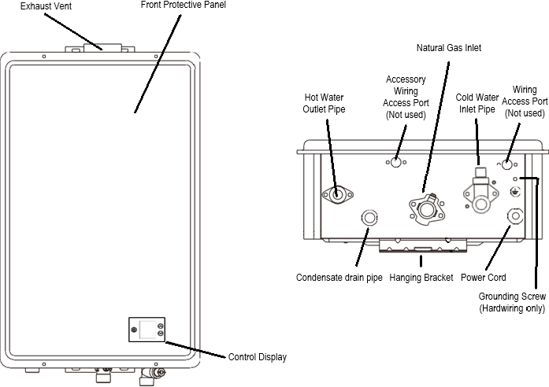
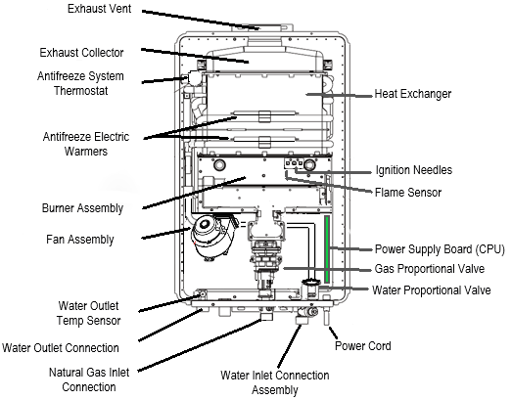
PRODUCT SERIVCE PARTS
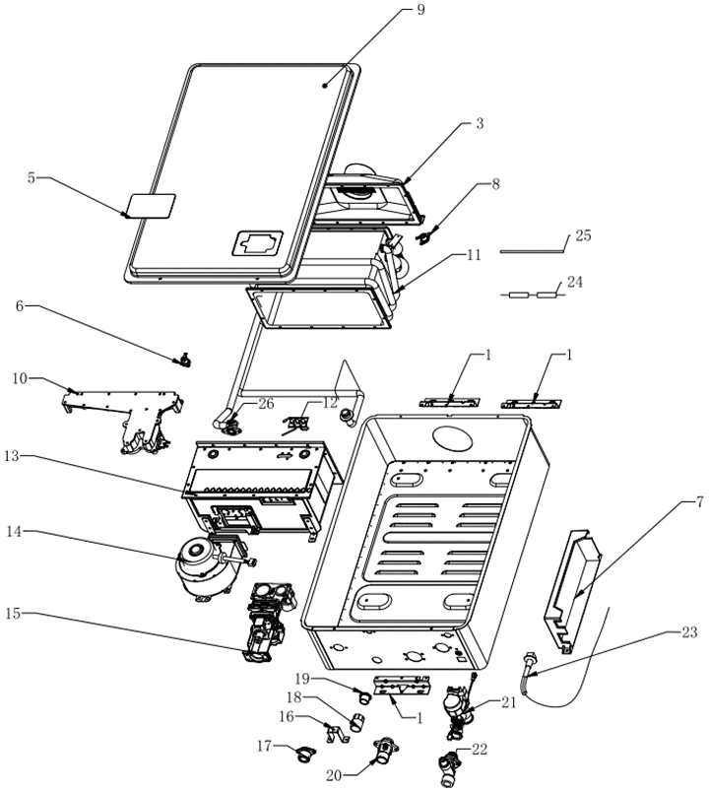
⚠️WARNING
For your safety, DO NOT attempt to disassemble this unit for any reason. Refer all repairs, service, and/or adjustments to a qualified service person.

To place a Service Parts Order:
Visit - SaltLakeIS.com
Record Part number and quantity of units needed before ordering.

KNG Service Part # | KNG Part Name | KNG Service Part # | KNG Part Name | KNG Service Part # | KNG Part Name
KNGINW01 | MOUNTING BRACKETS | KNGINW11 | HEAT EXCHANGER | KNGINW20 | GAS INLET CONNECTION
KNGINW02 | BOTTOM ASSEMBLY | KNGINW12 | IGNITION NEEDLES AND SENSOR | KNGINW21 | WATER PROPORTIONAL VALVE
KNGINW03 | EXHAUST HOOD AND VENT | KNGINW13 | BURNER ASSEMBLY | KNGINW22 | COLD WATER INLET CONNECTION ASSEMBLY
KNGINW05 | DISPLAY PANEL | KNGINW14 | FAN MOTOR | KNGINW23 | POWER CORD
KNGINW06 | LEFT HEAT EXCHANGE THERMOSTAT | KNGINW15 | GAS PROPORTIONAL VALVE | KNGINW24 | ELECTRIC HEATING ANTIFREEZE SYSTEM
KNGINW07 | POWER SUPPLY BOARD | KNGINW16 | THE FIXED SUPPORT OF DRAUGHT FAN | KNGINW25 | THERMAL FUSE
KNGINW08 | RIGHT HEAT EXCHANGE THERMOSTAT | KNGINW17 | HOT WATER OUTLET CONNECTION | KNGINW26 | HOT WATER EXIT TEMPERATURE SENSOR
KNGINW09 | FRONT PANEL ASSEMBLY | KNGINW18 | CONDENSATE OUTLET (FEMALE)
KNGINW10 | GAS DISTRIBUTOR AXIS  ASSEMBLY | KNGINW19 | CONDENSATE OUTLET (MALE)

Kings Peak

PEAK PERFORMANCE, PEAK COMFORT™
LIMITED WARRANTY INFORMATION
Kings Peak brand of Salt Lake Iron & Steel Ltd. Co. hereby warrants this product to be free of material defects in materials and workmanship when installed and operated according to the installation and operating instructions included in this manual. This Limited Warranty extends to the original purchaser and subsequent owners, but only while the product remains at the site of the original installation. This Limited Warranty terminates if moved or reinstalled at а new location. There are no warranties, express or implied made or given other than contained in this Limited Warranty. No agent, employee, or representative of Salt Lake Iron & Steel Ltd. Co. has any authority to bind Salt Lake Iron & Steel Ltd. Co. to any representation or warranty concerning the Product not contained in this Limited Warranty.
Except as expressly set forth herein, THERE ARE NO REPRESENTATIONS OR WARRANТIES, EXPRESS OR IMPLIED, INCLUDING, WIТHOUT LIMIТATION, AS ТО MERCHANTABILIТY OR FIТNESS FOR А PARТICULAR PURPOSE WIТH RESPECТ ТО ANY GOODS SOLD HEREUNDER. BUYER'S EXCLUSIVE REMEDY IS LIMIТED ТО REPAIR OR REPLACEMENT OF ТНЕ GOODS SOLD, АТ SALT LAKE IRON & STEEL LTD. CO. DISCRETION.
SALT LAKE IRON & STEEL LTD. CO. SHALL NOT ВЕ LIABLE FOR INCIDENTAL OR CONSEQUENТIAL DAMAGES.
Item Period of Coverage
1 Year from date of Valid Proof of Purchase
Coverages are void if the unit is used in а hot water circulation loop, in series with а circulation system, or where an on-demand recirculation system is not incorporated.
Owner is responsible for all other costs incidental to repair such as labor, shipping, delivery, and permits. Proof of purchase required. Products repaired will be covered under this Limited Warranty for the remainder of term of the original purchase.
This Limited Warranty becomes null and void if any of the following are determined to be а contributing factor to the failure of the product:
- Abuse, misuse, alteration, neglect, or misapplication;
- Installed not to the specifications as detailed in the installation instructions in this manual;
- Improper or inadequate maintenance;
- Inadequate water quality;
- Installation in а corrosive or otherwise destructive environment;
- Freeze damage;
- Excessive Scale buildup due to water quality;
- Incorrect gas or water pressure;
- Acts of force Majeure.
This Product is not to be used as а pool or spa heater.
Within the first 30 days of purchase, Salt Lake Iron & Steel Ltd. Co. will cover all ground shipping costs for warranty related issues, excluding АК and HI and any location outside of the continental US. After the first 30 days of purchase, Salt Lake Iron & Steel Ltd. Co. will cover all shipping costs to the customer for warranty related issues, excluding АК and HI and any location outside of the continental US. After the first 30 days of purchase, the customer is responsible for all shipping to Salt Lake Iron & Steel Ltd. Co., regardless of reason or circumstance. The method for warranty related shipping will be Ground equivalent with the provider of Salt Lake Iron & Steel Ltd. Co. choosing.
АК and HI and any location outside of the continental US, will be responsible for all shipping costs, regardless of reason or circumstance.
AII shipments of any type of product coming to Salt Lake Iron & Steel Ltd. Co. for any reason must have an Returns Goods Authorization (RGA) number from our customer service team for any repairs to be made . Please contact Salt Lake Iron & Steel Ltd. Co. to obtain an RGA number prior to shipping anything to Salt Lake Iron & Steel Ltd. Co. Failure to do so could result in loss of product. Salt Lake Iron & Steel Ltd. Co. will not be responsible for replacement due to loss or damage if these steps are not properly followed.

HOW TO MAKE A CLAIM
All warranty service is provided exclusively by our authorized Kings Peak Service Providers. For service, contact the Kings Peak Customer Experience Center. In the U.S.A., call 1-855-855-4647. If outside the 50 United States, contact your authorized Kings Peak dealer to determine whether another warranty applies.
WHAT IS NOT COVERED
1. Commercial, non-residential, or multiple family use or use inconsistent with the product instructions and manuals.
2. In-home instruction on how to use your product.
3. Repair to correct improper maintenance, installation not in accordance with installation instructions or electrical or plumbing codes, or repair of household electrical or plumbing systems.
4. Consumable parts (e.g., light bulbs, batteries, air or water filters, etc).
5. Defects or damage resulting from accident, misuse, abuse, alteration, fire, floods, acts of God or improper installation.
6. Damages, defects, or repairs caused by unauthorized servicers or use of non-genuine or third-party parts; however, use of unauthorized service providers or non-genuine or third-party parts will not void this warranty.
7. Cosmetic damage (e.g., scratches, dents, chips, and other damage to appliance finishes), unless such damage results from defects in materials and workmanship and is reported to Kings Peak within 30 days from date of delivery.
8. Discoloration, rust or oxidation of surfaces resulting from caustic or corrosive environments (e.g., high salt concentrations, high moisture or humidity or exposure to chemicals).
9. Product pick-up or delivery. This product is intended for in-home repair or replacement.
10. Travel or transportation expenses for service in remote locations where an authorized Kings Peak servicer is not available.
11. Repair, removal, or reinstallation of inaccessible appliances or built-in fixtures (e.g., trim, decorative panels, flooring, cabinetry, islands, countertops, drywall) that interfere with servicing, removal, or replacement of the product.
12. Appliances with original, factory installed model/serial numbers removed, altered or not easily determined.
13. Conversion of your product from natural gas or propane gas.
14. Incidental or consequential damages (e.g., loss of food or medicine) resulting from appliance breakdown.
HOW STATE LAW APPLIES
This warranty gives you specific legal rights, and you may also have other rights that vary from state to state or province to province. Some states and provinces, such as California, do not allow for limitations on the date your warranty coverage begins, so this limitation may not apply to you.

Kings Peak™

Electrician and/or HVAC Technician: License #:
Installation Date: Installation location: Serial number:

Manufactured for:
Salt Lake Iron & Steel Ltd. Co.
Salt Lake City, Utah
United States of America

®™ ©All Rights Reserved, 2024

