Installation, Use, and Care Manual


™
Peak Performance. Peak Comfort.™

Model – KNG199ICW
Tankless Water Heater

WARNING: If the information in these instructions is not followed exactly a fire or explosion may result causing property damage, personal injury, or death.
- Do not store or use gasoline or other flammable vapors and liquids in the vicinity of this or any other appliance.
WHAT TO DO IF YOU SMELL GAS:
·Do not try to light any appliance.
·Do not touch any electrical switch; do not use any phone in your building.
·Immediately call your gas supplier from a neighbor's phone.
·Follow the gas supplier’s instructions.
·If you cannot reach your gas supplier, call the fire department.
Installation and service must be performed by a qualified installer, service agency, or the gas supplier.

Due to updates and constantly improving performance, the information and instructions within this manual are subject to change without notice.
Version Date: Jan 2024

Table of Contents
- - Safety Precautions 2 ­ 5

­ Product Speciﬁcations 6

­ Product Overview 7 ­ 8

­ Physical Dimensions & Components 9

­ Display Panel Overview 10

­ Installation 11 ­ 15

­ Connecting the Gas Supply 16 - 17

­ Gas Pipe Sizing Tables 18

­ Measuring the Inlet Gas Pressure 19 ­ 20

­ Connecting the Water Supply 21 ­ 22

­ Connecting a Pressure Relief Valve 23

­ Connecting the Condensate Drain 24 ­ 26

­ Venting the Water Heater ­ Overview 27 ­ 28

­ Selecting a Vent Type 29 ­ 30

­ Selecting Vent Pipe Materials 31

­ Measuring Vent Length 32

­ Terminating the Vent 33 ­ 36

­ Connecting the Power Supply 37
19­ Operation 38 ­ 40
20 ­ Required Routine Maintenance 41 ­ 42
- ­ Troubleshooting 43 ­ 46
- ­ Appliance Servicing* 47 ­ 52
- ­ Installation Checklist 53 ­ 54
- ­ Service Parts List 55 ­ 57
- ­ Product Limited Warranty ___________________________________ 58 - 59

*Appliance Servicing by authorized Kings Peak representatives only

1 ©2024 Salt Lake Iron & Steel Ltd. Co.

Safety Precautions

Read Before Installation!
Incorrect installation may cause serious damage or injury!
1
The seriousness of potential damage or injuries is classiﬁed as either a WARNING! or CAUTION!
WARNING!  CAUTION!


WARNING!
INSTALLATION & SERVICE MUST BE PERFORMED BY A QUALIFIED INSTALLER, SERVICE AGENCY, OR GAS SUPPLIER!
Please read the manual in its entirety before installing, operating, or repairing.
NOTE: The installation must conform to local codes or, in the absence of local codes, the National Fuel Gas Code, ANSIZ223.1/NFPA 54.
California Proposition 65 Warning:
The product referred to in this manual contains chemicals which are known to the State of California to cause cancer, birth defects, or other reproductive harm.
BEFORE OPERATING, smell all around the area near the appliance for the scent of gas. Be sure to
smell next to the ﬂoor as some gas is heavier than air and will settle there.
DO NOT try to light the burner by hand. This appliance does NOT have a pilot light. It is equipped with an ignition device which automatically lights the burner.
DO NOT store or use gasoline or other ﬂammable substances (vapors or liquids) in the vicinity of
this water heater or any other appliance. This could create a hazard that may result in personal
injury, ﬁre, and/or an explosion.
DO NOT place newspapers or laundry near the water heater or venting system (including the vent termination outlet), as these could create a ﬁre hazard, which could result in personal injury and property damage.
DO NOT use or store aerosol products (such as hair sprays, spray paints etc.) or any other compressed gases near the water heater or venting system (including the vent termination outlet), as this could result in personal injury, ﬁre, and/or an explosion.
DO NOT use this appliance if any part has been submerged in water. Immediately call a qualiﬁed service technician to inspect the appliance and to replace any parts which have been under water.
DO NOT use tools to push in or turn the manual gas appliance shut-off valve. Use only your hand to perform this action. In the event the valve will not turn, DO NOT attempt to repair it. Using too much force or attempting to repair the manual gas shut-off valve could result in personal injury, ﬁre, and/or an explosion. Call a qualiﬁed service technician to perform any repairs.
- Have your installer or plumber show the location of the manual gas shut-oﬀ valve and demonstrate how to properly use it.

2 ©2024 Salt Lake Iron & Steel Ltd. Co.

Safety Precautions

WARNING!
OPERATIONAL WARNINGS:
DO NOT operate the water heater with the front cover open. Doing so could cause a ﬁre or carbon monoxide (CO) poisoning, which could result in property damage, personal injury, death, and/or an explosion.
DO NOT operate the water heater without a proper venting system. Operating the unit without a vent could cause ﬁre and/or carbon monoxide poisoning, which could result in property damage, personal injury, or death. Inspect the vent termination and air intake supply annually to ensure proper operation of the water heater. If any of the vent pipes, vent elbows, or intake pipes are damaged in any way (separated at a joint or show signs corrosion, rusting, or melting), turn OFF the water heater and discontinue use until piping is repaired.
DO NOT touch the power cord or internal components of the water heater with wet hands. Doing so could result in electric shock and personal injury. Always disconnect the power supply before servicing.
- If the water heater is damaged for any reason, immediately shut oﬀ the gas supply to the appliance.
- If the water heater is damaged as a result of overheating, ﬁre, ﬂood, or any other reason, close the manual shut-oﬀ valve and DO NOT operate the unit again until it has been repaired and inspected by a qualiﬁed technician.
WHAT TO DO IF YOU SMELL GAS:
DO NOT try to start, ignite/light, or operate any nearby appliance.
DO NOT touch any electrical switch.
DO NOT use any phone within the building where you smell gas.
- EXIT the building IMMEDIATELY and CALL your GAS SUPPLIER. Follow the gas supplier’s instructions. If you CANNOT reach the gas supplier, CALL the FIRE DEPARTMENT.
TO PREVENT BURNS:
DO NOT change or adjust the temperature setting of the water heater before reading all of the instructions in this manual carefully.
- Use the lowest operating temperature setting to provide comfortably hot water.
- If your household has children, elderly, or disabled residents, consider using a lower temperature setting.
- Feel the temperature of the hot water before allowing children, the elderly, or disabled to be exposed to it.
Time/Temperature Relationship in Scalds
Water Temperature | Time to Produce а  Serious Burn
120° F | More than 5 minutes
125° F | 1½ to 2 minutes
130° F | About 30 seconds
135° F | About 10 seconds
140° F | Less than 5 seconds
145° F | Less than 3 seconds
150° F | About 1½ seconds
155° F | About 1 second

IMPORTANT: This water heater is set to a default temperature setting of 116°F at the factory for your safety and comfort. Increasing the temperature above this increases the risk of accidental scalding. Water temperatures at or above 125°F can cause instant scalding, severe burns, or death. If it is necessary to set the temperature of the water heater 125°F, have a temperature-limiting valve or mixing valve installed on the water heater. Before changing the temperature setting, read & review the chart to the right carefully.
Table courtesy of Shriners Burn Institute

WARNING!
FREEZE PROTECTION:
The water heater is equipped with an anti-freeze protection system that activates based on internal water temperature in the appliance. If the system detects the water temperature is 41°F or below, it will activate internal electric heaters to ensure the water meets the target temperature and maintains the set temperature level.

NOTE: If a power failure occurs during cold weather, the anti-freeze protection system of the water heater will not operate and may allow freezing within the heat exchanger and waterway to occur.
Please note the following information and guidelines regarding the anti-freeze protection function:
- If the water heater is not going to be used and the indoor environment is expected to be near or below freezing temperatures, please drain the water within the appliance.
- The freeze protection function will only operate when the temperature of the inlet water of the water heater is 41°F or lower. However, it cannot be guaranteed that it will provide protection to water pipes connected to the appliance and they could be damaged by freezing.
- The anti-freeze protection of the water heater only applies to the internal water tubing of the appliance. Damage of electrical components caused by a low ambient temperature is not covered by the warranty.
- In the event the water heater is not operating for extended periods of time, be sure to drain any condensate water completely. If this is not done, when the ambient temperature is near or drops below 32°F, the condensate will freeze and could cause damage to the internal condensation system of the water heater.

ALTITUDE ADJUSTMENT:
The parameter setting of the water heater may need to be adjusted depending on the altitude of the location it is being installed. Being from the West ourselves, we already adjusted the initial altitude setting to operate between 2,000 – 6,500 feet above sea level, since being out West is best. Please refer to the table below for the proper setting based on your altitude. This adjustment can be made through the water heater control panel.
Instructions on how to perform this adjustment can be found in the Appliance Servicing section of this manual. However, this adjustment should only be performed by a qualiﬁed technician at the time of installation. If this adjustment is not made, or performed incorrectly, it could cause improper operation of the unit. Improper operation could cause gas leakage, ﬁre, and/or an explosion that can put you at risk of personal injury or death.

Program data | Altitude setting
Altitude above Sea  Level | 2,000 – 6,500 feet | 6,500 – 9,800 feet
L2 | 05 (Factory Default Setting) | 06

Safety Precautions

CAUTION!
Safety Precautions
For service or repair, contact an authorized Kings Peak technician or licensed professional. Improper installation, adjustment, alteration, service, or maintenance can cause unit failure or damage, property damage, personal injury, or death, and will void the product’s warranty. If you need assistance or further information, please consult the manufacturer or a qualiﬁed professional.
- DO NOT attempt to repair or replace any part of the water heater unless it is speciﬁcally recommended in this manual.
- DO NOT operate the water heater if it shows any signs of damage or any part of it has been submerged in water. Doing so could result in personal injury, product failure, and/or property damage. If any part of the unit has been damaged or has been submerged in water, immediately contact a qualiﬁed service technician to inspect the unit and replace any parts that are damaged or have been under water.
- DO NOT allow children to operate or access the water heater. Doing so could result in personal injury, product failure, and/or property damage.
- DO NOT attempt to adjust or change the temperature setting while the water heater is in use, as this could result in personal injury.
- DO NOT turn on the water heater unless the water and gas supplies are properly connected and fully opened. Operating the unit without the water and gas connected and ﬂowing could cause damage to the water heater.
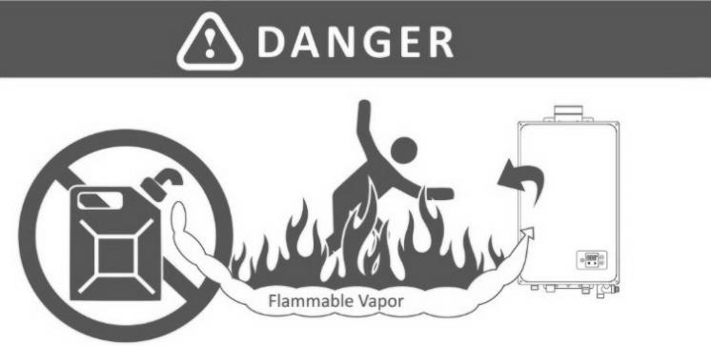
Vapors from ﬂammable liquids The water heater has a
will explode and catch ﬁre, causing main burner.
death or severe burns. The main burner ﬂame can: DO NOT use or store ﬂammable 1. Come on at any time. products such as gasoline, 2. Will ignite ﬂammable solvents, or adhesives in the same
room or any area near the water vapors.
heater.
Keep ﬂammable products: Vapors:
- Far away from the unit. 1. Cannot be seen.
- In approved containers. 2. Are heavier than air.
- Tightly closed. 3. Can travel a long
- Away from children distance.
DO NOT install the water heater where ﬂammable products will be stored or used unless the main burner is at least 18 inches above the ﬂoor. This will reduce, but not eliminate, the risk of vapors being ignited by the main burner.
Read and follow all water heater warnings and instructions. If the owner’s
manual is missing, contact the retailer or manufacturer.

- DO NOT turn on the water heater if the cold water supply shut-oﬀ valve is closed, as this could cause damage to the unit.
- DO NOT use this water heater for anything other than its intended purpose, as described within this manual.
- DO NOT remove the front cover unless the power to the water heater is turned oﬀ and the appliance is disconnected from the outlet. Failure to follow this warning could result in electric shock.
- DO NOT use unapproved replacement parts or accessories, as this could cause the unit to operate improperly or fail and void the product’s warranty.
- DO NOT place anything in or around the vent terminals that could obstruct airﬂow in or out of the water heater (e.g. clothesline).
- Should overheating occur, or the gas supply fails to shut oﬀ, turn oﬀ the manual gas valve to the appliance.

IMPORTANT: This water heater has been approved for use in the USA. Installing and operating this water heater in any other country will void the product’s warranty.


Product Speciﬁcations
2

Input Rate |  | 199,000 BTU/hr
Min. rating |  | 20,000 BTU/hr
Heat exchanger |  | Primary and secondary stainless steel heat exchanger
Max. temperature setting |  | 140°F
Min. temperature setting |  | 95°F
Factory temperature setting |  | 116°F
Min. actuation water ﬂow |  | 0.5 GPM
Eﬃciency | UEF | >0.95
Max. Flow Rate | 34°F rise | 11.1 GPM
Max. Flow Rate | 45°F rise | 8.5 GPM
Max. Flow Rate | 67°F rise | 5.7 GPM
Max. Inlet Gas Pressure |  | 10.5” in. WC (2610 Pa)
Min. Inlet Gas Pressure |  | 3.5” in. WC (870 Pa)
Manifold pressure |  | -0.9” in. WC (-0.218 kPa)
Max. water pressure |  | 150 psi (1.0 MPa)
Min. water pressure |  | 15 psi (0.1 MPa)
Appliance Dimension (L x W x H) |  | 31.3” in. x 17.3” in. x 10.6” in.
Net weight |  | 66.1 lbs.
Water inlet connection |  | ¾” in. NPT
Water outlet connection |  | ¾” in. NPT
Gas connection |  | ¾” in. NPT
Condensate drain connection |  | ½” in. NPT
Venting pipe |  | 2” in. or 3” in. concentric PVC, CPVC, or approved Polypropylene
Venting type |  | Direct Vent
Installation type |  | Indoor
Ignition |  | Direct Electric Ignition
Power supply |  | 120V, 60Hz
Power consumption |  | 150W (264W when anti-freeze module is on)
General Operating Conditions |  | Ambient Temperature Range: 33°F to 120°F
 |  | Operating Relative Humidity: Up to 90% at 120°F
Shipping & Storage Temperature Range:
-4°F to 176°F
Safety Devices |  | - Flue High Limit Switch (158°F)  - Water Temperature High Limit Switch (185°F)  - Freeze Protection Ceramic Heater (Turns on at 41°F & Turns oﬀ at 59°F)


Product Overview
3

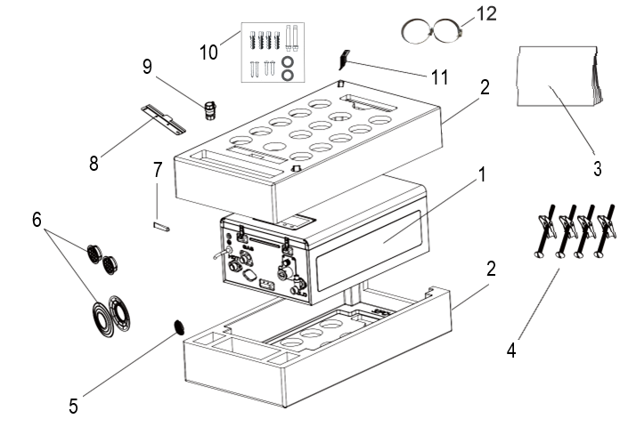

KNG199ICW PACKAGING CONTENTS


Product Overview

No | Name | Figure | Quantity
1 | Tankless Gas Water Heater | 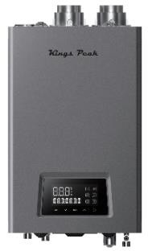 | 1
2 | Styrofoam Packing Materials |  | 2
3 | Installation & User Manual |  | 1
4 | Toggle Bolts | 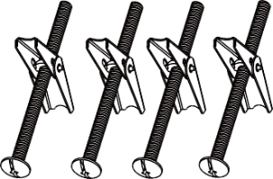 | 4
5 | Three (3”) in. Exhaust Pipe Flow Restrictor |  | 1  (3” inch pipe only)
6 | Bird Screens |  | 2 x 2  pieces each
7 | Silicone | 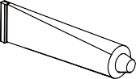 | 1
8 | Wall-Mounting Bracket (upper) | 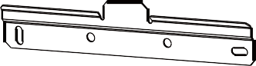 | 1
9 | Manual Gas Shut-Oﬀ Valve | 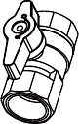 | 1
10 | Fastener Packet  4 Wood Screws  4 Plastic Anchors  2 Expansion Bolts  2 Water Pipe Rubber Gaskets | 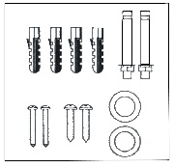 | 1
11 | Wall-Mounting Bracket (lower/bottom) | 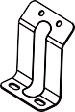 | 1
12 | Hose/Pipe Clamps | 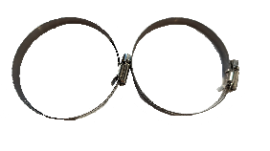 | 2

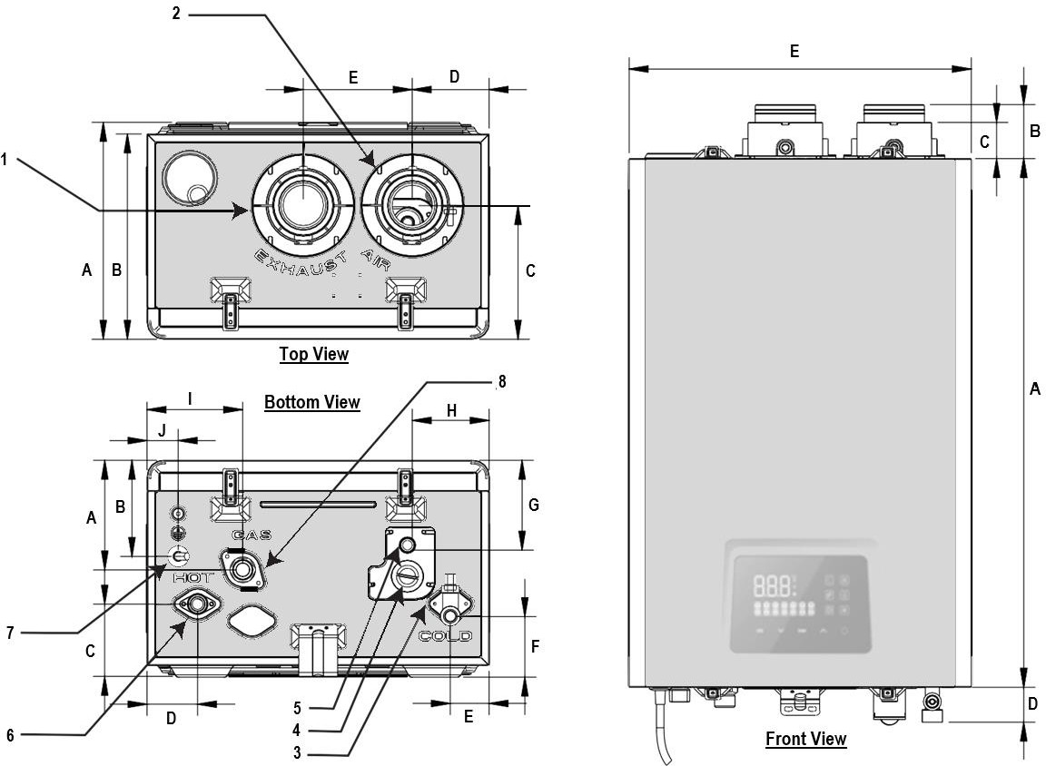
Physical Dimensions & Components 4

Appliance Components Appliance Dimensions
No. | Description | Size
1 | Exhaust Vent | 2” inches (in.)
2 | Air Intake | 2” in.
3 | Cold Water Inlet | ¾” in.
4 | Condensate Clean | N/A
5 | Condensate Drain | ½” in.
6 | Hot Water Outlet | ¾” in.
7 | Power Cable | 120V/60Hz
8 | Gas Inlet | ¾” in.

 | Item | Top View | Front View | Bottom View
 | A | 10 7/8 in. | 26 3/4 in. | 5 5/8 in.
 | B | 10 3/8 in. | 2 3/4 in. | 4 7/8 in.
 | C | 6 3/4 in. | 1 3/4 in. | 3 1/8 in.
 | D | 3 7/8 in. | 1 3/4 in. | 2 5/8 in.
 | E | 5 1/2 in. | 17 1/4 in. | 2 in.
 | F |  |  | 2 1/2 in.
 | G |  |  | 4 3/8 in.
 | H |  |  | 4 1/8 in.
 | I |  |  | 4 7/8in.
 | J |  |  | 1 5/8 in.
9 ©2024 Salt Lake Iron & Steel Ltd. Co.


Display Panel Overview
8
9
10
11
12
7

6
5
4
3
2
1
5

No. | Symbol |  |  |  |  | Description | Function
1 |  |  |  |  |  | Power | Power ON/OFF
2 |  |  |  |  |  | Up | - Increase temperature setting.  - Switch the information displayed when Info button is pressed.
3 |  |  |  |  |  | Enter
4 |  |  |  |  |  | Down | - Decrease temperature setting.  - Switch the information displayed when Info button is pressed.
5 |  |  |  |  |  | Information | Display more operation information.
6 |  |  |  |  |  | Error Display | Show error description.
7 |  |  |  |  |  | Temperature | Displays temperature of the water.
8 |  |  |  |  |  | Anti-Freeze | Indicates anti-freeze function is on.
9 |  |  |  |  |  | Temperature | Displays the temperature in Fahrenheit.
10 |  |  |  |  |  | Water Flow | Indicates water ﬂow signal is detected.
11 |  |  |  |  |  | Flame | Indicates ﬂame signal is detected.
12 |  |  |  |  |  | Blower | Indicates blower is operating.

© 2024 Salt Lake Iron & Steel Ltd. Co. 10

Installation

When choosing an installation location, the site must provide adequate clearance for the water heater, adequate options for venting and drainage, and suﬃcient access to gas, water, and electrical supplies.
6


- Review all of the installation information in this manual before starting installation. Consider all the requirements for venting, piping, condensate removal, and wiring.
- The installation location of the water heater should have a minimum clearance of eight (8’) feet from any high heat sources (producing temperatures greater than 158°F), as these will cause deformation of plastic parts or plastic pipe ﬁttings of the unit.
Example : boiler ventilation pipe, space heater, etc.
- The unit must be installed in a ﬁre retardant area away from all combustible materials. The minimum clearances from combustible construction are six (6”) in. on the sides, zero (0”) in. from the back, and twelve (12”) in. from the top.
- The location chosen and installation MUST comply with the Uniform Plumbing Code (latest version).
CAUTION!

Water Quality
Proper maintenance of the water heater is required to ensure compliance to EPA water quality standards. Damage caused by poor water quality IS NOT covered under the product warranty. The following table shows the maximum contaminant levels allowed, based in part on the EPA National Secondary Drinking Water Regulations (40 CFR Part 143.3). If you suspect that your water is contaminated in any way, discontinue use of the water heater and contact an authorized technician or licensed professional to investigate further.

Contaminant | Max. Allowable Level | Contaminant | Max. Allowable Level
Total Hardness | Up to 300 mg/l* | Iron | Up to 0.3 mg/l
Aluminum | 0.05 to 0.2 mg/l | Manganese | Up to 0.05 mg/l
Chloride | Up to 250 mg/l | pH | 6.5 to 8.5 mg/l
Copper | Up to 1.0 mg/l | Sulfate | Up to 250 mg/l
Total Dissolved Solids | Up to 500 mg/l | Zinc | Up to 5 mg/l
Chlorine | Up to 4 mg/l
*18 grains/gallon
If your local water is hard, please review the following treatment and ﬂushing guidelines. However, ﬁrst check your local
codes for any restrictions on the use of softeners before choosing and purchasing a softener.

Hardness Level : EPA 2018 Water Quality Parameters |  | Treatment Method | Flush Frequency
Soft | 0-4 grains/gallon (0-75mg/l) | None | None
Moderately Hard | 4-9 grains/gallon (75-150 mg/l) | None | Annually
Hard | 9-18 grains/gallon (150-300 mg/l) | Water Softener is Strongly Recommended for  Optimal Performance | Every 6 months
Very Hard | >18 grains/gallon (300 mg/l) | Water Softener REQUIRED for Product  Warranty | Threshold exceeds operational capability  of the Product

Installation

Access to Utilities
The installation location should be near where there is easy access to the cold water supply, natural gas supply, and a GFCI 120V 60Hz 20-Amp electrical outlet, preferably near where these utilities enter the building.

Adequate Drainage
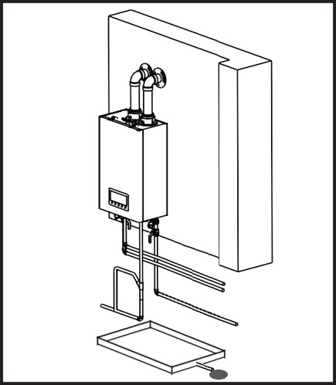
The water heater produces a signiﬁcant amount of condensate during operation due to its increased natural gas efficiency. The water heater should be located near a suitable drain and where potential water damage from this condensate will be minimal. Installation of the water heater in a location without a suitable drain will void the warranty and Kings Peak™ will not be liable or responsible for any damages that occur as a result. For further information about condensate drainage, please refer to Chapter 12.
The water heater must be located in an area where condensate drainage from the unit or its connections will not result in damage to the area adjacent to the unit, or to lower ﬂoors of the building or structure. When such a location cannot be found, it is highly recommended that a condensate drain pan that can drain adequately be installed beneath the unit. When installing the drain pan, ensure that it will not restrict combustion airﬂow in any way.

Adequate Venting and Ventilation
Select an installation location that will also require minimal venting. Consider venting restrictions caused by windows, doors, air intakes, gas meters, foliage, and other buildings. For more information regarding venting, please refer to Chapters 13-17.
To ensure adequate venting and ventilation, follow these guidelines and restrictions:
DO NOT install the water heater in bathrooms, bedrooms, or any other occupied rooms that are normally kept closed or are not adequately ventilated.
DO NOT install the water heater where moisture from the vented exhaust could discolor or damage exterior walls.
DO NOT enclose the vent termination.
- Maintain proper clearances from any openings in the building.
- Install the water heater with a minimum clearance of twelve (12”) in. above an exterior grade or as required by local codes.
- Maintain a minimum clearance of four (4’) feet from heating and cooling vents.
- Install the exhaust vent in an area that is free from obstructions and does not allow the exiting exhaust to accumulate.

Installation

Proximity to Fixtures and Appliances
Install the water heater near ﬁxtures that deliver or use hot water, such as near the bathroom, kitchen, and laundry room fixtures. Select a location that will minimize the amount of water piping required between major ﬁxtures. Insulate as much of the hot water pipes as possible. For more information regarding the water supply, refer to Chapter 10.
Install the water heater in an area that will allow for front panel removal for service & maintenance as well as access to the utility connections, piping, ﬁlters, and traps. Based on the installation location, ensure the clearances listed in the table below are maintained.

Minimum Clearance | Top | Bottom | Front | Back | Sides
Inches | 9” in. | 12” in. | 4” in. | 0” in. | 6” in.

Install in an Area Free from Debris + Chemical-Free Air for Optimal Combustion
Follow the installation guidelines listed below regarding the air surrounding the unit and storage of potentially dangerous items in the vicinity of the unit.
DO NOT install the water heater in areas where dust and debris may accumulate.
DO NOT install the unit where hair sprays, spray detergents, chlorine, or similar chemicals are used or stored.
DO NOT install the water heater in areas where gasoline or other ﬂammables are used or stored.
DO NOT allow hanging laundry or any similar items to obstruct access to the water heater or its venting system.
- Ensure that any combustible materials are properly and securely stored away from the water heater.
The combustion air must be free of ﬂammable vapors or corrosive chemical fumes. Common corrosive chemical fumes to avoid include: ﬂuorocarbons, other halogenated compounds such as freon, trichloroethylene, perchloroethylene, and chlorine, all of which can be found in refrigerants or solvents. When these chemicals burn, they produce acids that can corrode the stainless-steel heat exchanger, gaskets, the ﬂue, and venting system.
NOTE

Coastal Installations
For installations around salt water marine environments, the salt in the air can cause corrosion to the water heater. The water heater should be protected and enclosed to minimize exposure to this corrosive atmosphere. Damage caused by a corrosive environment is not covered under the warranty.

Operating Temperature
The ambient temperature at the installation location must be above freezing. Steps should be taken to ensure the water inlet and outlet pipes will not freeze. Frozen pipes should be allowed to fully thaw, and the appliance should be drained, fully thawed, and inspected by a professional before use after a freezing event. Operation of the appliance after it has been frozen without the procedure above or the water pipes have frozen without proper thawing will void the product warranty.
The ambient air temperature for operation of the appliance is between 33° to 120°F.
The anti-freeze system activates when the inlet water temperature of the appliance is below 41°F.
NOTE

Installation

Mounting the Water Heater to the Wall
The water heater referenced in this manual comes with an upper mounting bracket that is pre-drilled for easy installation. If the strength of the wall is insuﬃcient or if the framing is uneven, reinforce the area before installing the water heater. Avoid installation on common walls as the unit will make some operational noises while operating.
To mount the water heater to the wall:
Upper Bracket secured with Expansion Bolts
- Make two (2) 5/16” (8mm) holes in the wall with the drill that align with the outer holes on the upper bracket. If additional support is required, utilize the supplied 1¼” wood screws and plastic anchors or toggle bolts in the middle holes of the upper bracket. Place the expansion bolts with washers inside of drilled hole, ensuring bolt extends from wall. Aﬃx the upper bracket to the protruding bolts, ensuring that the bracket is level, the center tab on the bracket is facing upwards, and that the area where the bolts insert into the bracket is flush with the wall. Add the lock washers and nuts to secure bracket to the wall. Tighten the nuts until the lock washers engage. Do not over tighten the nuts on the expansion bolts to prevent stripping bolt threads.
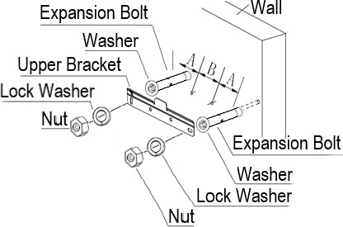
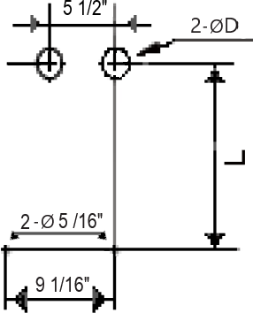
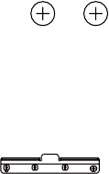
Measurements
A: 2 15/16”
B: 3 1/8”
D: ≥ 2 9/16”
L: ≥ 14 3/8” to
≤ 26 3/8”
Ø 5/16" in. (8mm) with a minimum depth of 2.5"

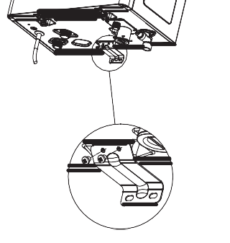
Bottom Bracket Installation
- Use the two (2) pre-installed screws (illustration on the right) on the bottom of the unit to fasten the lower bracket to the bottom of the water heater.

Installation

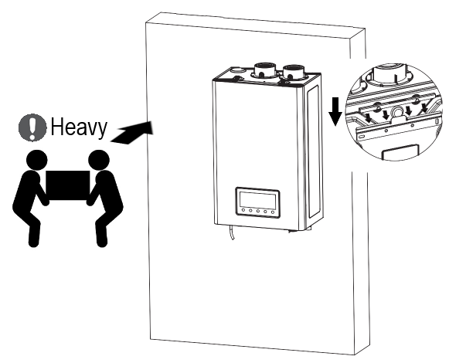
- Lift the unit with two people. Align the lip of the pre-installed hanging bracket on the back of the water heater with the lip of the upper bracket. The tab on the upper bracket should insert into the slot of the pre-installed bracket on the water heater.
- Gently hang the unit on the upper bracket attached to the wall.

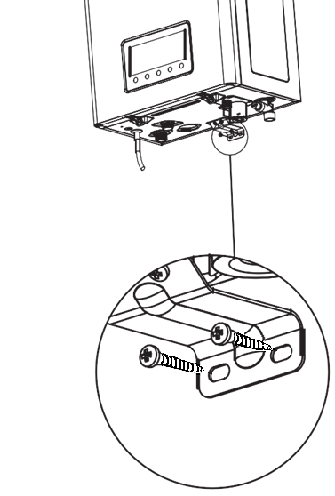

- Secure the lower bracket to the wall with the smaller 1" wood screws and plastic anchors supplied.

15 © 2024 Salt Lake Iron & Steel Ltd. Co.

Connecting the Gas Line

If possible, we recommend connecting the water heater as the ﬁrst gas appliance to the meter to ensure a suﬃcient gas supply.
7

WARNING!
Before connecting the gas supply, determine the gas type and pressure for the water heater by referring to the appliance rating plate. Only use the same gas type indicated on the rating plate. Using a diﬀerent gas type will result in abnormal combustion and water heater malfunction which will void the product warranty. Gas supplies should be connected by a licensed professional only.
DO NOT use a ﬂame to check for a gas leakage. Perform a bubble test and/or utilize a commercial combustible gas detector around the joints to check for gas leaks. If a leak exists, bubbles from the bubble test will form at the leaking joint. A gas leak could result in substantial property damage, severe personal injury, or death.
DO NOT attempt a ﬁeld conversion of this water heater from natural gas to propane. This water heater CANNOT be converted from one type to another. Doing so will result in dangerous operating conditions and will void the warranty.
DO NOT allow the piping to be supported by the water heater or its accessories. Properly support the piping with hanging bands.
  - To avoid damaging the connectors on the water heater, use two wrenches when tightening piping to the water heater. Use one wrench to prevent the connector at the water heater from turning, and the other wrench to tighten the connection. Damaged connectors may result in system leaks.
  - Ensure that the gas piping is protected from physical damage. Failure to follow these instructions could result in gas leakage, which can result in ﬁre, explosion, property damage, severe personal injury, or death.
  - The appliance and its gas connection must be leak tested before initial operation of the appliance.
  - The inlet gas pressure must be within the range speciﬁed in Chapter 2: Product Speciﬁcations of this
manual (Refer to Max. Inlet Gas Pressure & Min. Inlet Gas Pressure).

To connect the gas supply:
- Determine the gas type and pressure for the water heater by referring to the appliance’s rating plate.
- Perform a pressure test on the main gas supply line.
- Purge the gas line of any debris.
- Determine the proper size and type of piping for the gas line. Refer to the diagrams and tables on the following pages.
- Install the full port manual gas shut-off valve on the gas supply line and water heater.
- Connect the gas supply line.
- Test the supply line, all connection points, and the water heater for gas leaks.

Connecting the Gas Supply

Illustration of typical rigid pipe installation
  - The connection ﬁtting on the water heater is ¾” in.

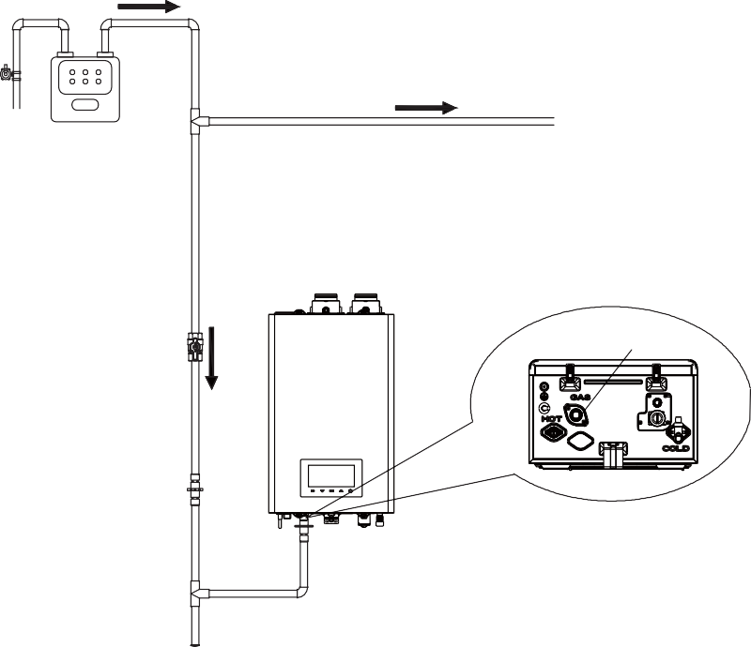
- ½” in. rigid pipe may be used. (Refer to the Gas Pipe Sizing Tables on the adjacent page for limitations.)
To additional gas appliances
•
Gas Supply
•
Gas Shut-Oﬀ Valve
Gas Inlet
Union
•
•
Check with the local jurisdiction to verify the use of ½” in. gas pipe is allowed/approved in the area where the water heater is being installed.
DO NOT use ½” in. corrugated tubing or connectors as these could cause excessive noise during appliance operation.
When using ﬂexible gas lines, ensure that the inner diameter of the pipe and connector are suﬃcient to supply the required amount of BTUs. Also, ensure the ﬂexible line has no crimps or tight bends in it, as these will restrict gas ﬂow.
When using rigid pipe, installation of a union on the gas supply line close to the water heater is recommended. This will facilitate any future maintenance or service required.
Tighten the water heater connection valves with care to avoid damaging them.

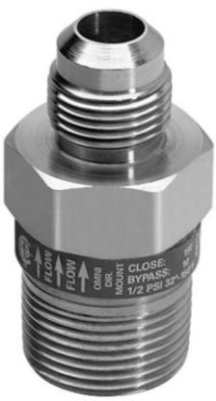
Prior to using an Excess Flow Valve (EFV) in the gas line, check the manufacturer’s minimum and maximum ﬂow capacity rating. An improperly sized EFV will not allow for full gas ﬂow to the water heater. If this occurs, it could cause improper operation of the water heater.
CAUTION!

Gas Pipe Sizing Tables

NOTE: The tables below are for reference only. Please consult the gas pipe manufacturer for actual pipe capacities. The tables below are referenced from the 2012 National Fuel Gas Code.
8

Maximum Natural Gas Delivery Capacity
In Cubic Feet (ft3) per hour (0.60 Speciﬁc Gravity; 0.5 in. WC Pressure Drop). Contact your gas supplier for BTU/ft3 ratings. Use 1,000 BTU/ft3 for simpliﬁed calculations. This table is recommended for supply pressures less than 6 in. WC.

Pipe Size | Length (including ﬁttings)
Pipe Size | 10 ft | 20 ft | 30 ft | 40 ft | 50 ft | 60 ft | 70 ft | 80 ft | 90 ft | 100 ft | 125 ft
3/4 in. | 360 | 247 | 199 | 170 | 151 | 137 | 126 | 117 | 110 | 104 | 92
1 in. | 678 | 466 | 374 | 320 | 284 | 257 | 237 | 220 | 207 | 195 | 173
1 ¼” in. | 1,390 | 957 | 768 | 657 | 583 | 528 | 486 | 452 | 424 | 400 | 355
1 ½” in. | 2,090 | 1,430 | 1,150 | 985 | 873 | 791 | 728 | 677 | 635 | 600 | 532
2 in. | 4,020 | 2,760 | 2,220 | 1,900 | 1,680 | 1,520 | 1,400 | 1,300 | 1,220 | 1,160 | 1,020
2 ½” in. | 6,400 | 4,400 | 3,530 | 3,020 | 2,680 | 2,430 | 2,230 | 2,080 | 1,950 | 1,840 | 1,630
3 in. | 11,300 | 7,780 | 6,250 | 5,350 | 4,740 | 4,290 | 3,950 | 3,670 | 3,450 | 3,260 | 2,890
4 in. | 23,100 | 15,900 | 12,700 | 10,900 | 9,660 | 8,760 | 8,050 | 7,490 | 7,030 | 6,640 | 5,890

In Cubic Feet (ft3) per hour (0.60 Speciﬁc Gravity; 3.0 in. WC Pressure Drop). Contact your gas supplier for BTU/ft3 ratings. Use 1,000 BTU/ft3 for simpliﬁed calculations. This table is recommended for supply pressures less than 6 in. WC.

Pipe Size | Length (including ﬁttings)
Pipe Size | 10 ft | 20 ft | 30 ft | 40 ft | 50 ft | 60 ft | 70 ft | 80 ft | 90 ft | 100 ft | 125 ft
1/2 in. | 454 | 312 | 250 | 214 | 190 | 172 | 158 | 147 | 138 | 131 | 116
3/4 in. | 949 | 652 | 524 | 448 | 397 | 360 | 331 | 308 | 289 | 273 | 242
1 in. | 1,790 | 1,230 | 986 | 844 | 748 | 678 | 624 | 580 | 544 | 514 | 456
1 ¼” in. | 3,670 | 2,520 | 2,030 | 1,730 | 1,540 | 1,390 | 1,280 | 1,190 | 1,120 | 1,060 | 936
1 ½” in. | 5,500 | 3,780 | 3,030 | 2,600 | 2,300 | 2,090 | 1,920 | 1,790 | 1,670 | 1,580 | 1,400
2 in. | 10,600 | 7,280 | 5,840 | 5,000 | 4,430 | 4,020 | 3,690 | 3,440 | 3,230 | 3,050 | 2,700
2 ½” in. | 16,900 | 11,600 | 9,310 | 7,970 | 7,060 | 6,400 | 5,890 | 5,480 | 5,140 | 4,860 | 4,300
3 in. | 29,800 | 20,500 | 16,500 | 14,100 | 12,500 | 11,300 | 10,400 | 9,690 | 9,090 | 8,580 | 7,610
4 in. | 60,800 | 41,800 | 33,600 | 28,700 | 25,500 | 23,100 | 21,200 | 19,800 | 18,500 | 17,500 | 15,500

Measuring The Inlet Gas Pressure
9
The water heater cannot function properly without suﬃcient inlet gas pressure (refer to the name plate of the unit for gas pressure rating). Measuring the inlet gas pressure should ONLY be performed by a licensed professional.
- The inlet gas pressure must be maintained between 3.5” in. and 10.5” in. WC for natural gas.
- The appliance and its individual shut-oﬀ valve must be disconnected from the gas supply piping system during any pressure testing of that system when test pressures are in excess of 1/2 psi (3.5 kPa). The appliance must be isolated from the gas supply piping system by closing its individual manual shut-oﬀ valve during any pressure testing of the gas supply piping system at test pressures equal to or less than 1/2 psi (3.5 kPa).
WARNING!
If gas pressure is out of the acceptable range or an excessive pressure drop is observed, contact the
gas supplier or a qualiﬁed installer to supply proper gas pressure to the unit.
NOTE

To measure the inlet gas pressure:
- Close the manual gas shut-off valve on the gas supply line. (See Figure 9.1 on the adjacent page)
- Open a hot water faucet. The water heater should turn on and the gas in the gas supply line will be purged.
- Leave the faucet on until the water heater shuts down due to a lack of gas supply, and then turn oﬀ the hot water faucet.
- Loosen the four (4) Phillips head screws that attached the front panel to the casing of the unit (two on the top and two on the bottom).
(Figure 9.2)
- Carefully raise the front cover approximately 2 inches.
- Find the control panel cable and unplug it from the main control board.
Before removing the front cover, you must unplug the control display cable ﬁrst. Failing to do
so will damage the water heater.
NOTE
- Fully remove the front cover. (Figure 9.3)
- Loosen the screw indicated in Figure 9.4 and connect a manometer to the pressure port. Reset the manometer to zero before use.
- Re-open the manual gas valve and check for leaks.
- Open multiple ﬁxtures that have high ﬂow rates, such as bathtub and shower faucets, to ramp the water heater up to its maximum ﬁring rate.
- When the water heater reaches its maximum ﬁring rate, check the inlet gas pressure reading on the manometer. The gas pressure must fall within the ranges speciﬁed in Chapter 2. (Figure 9.5)
- After checking the intake pressure, tighten the screw again.

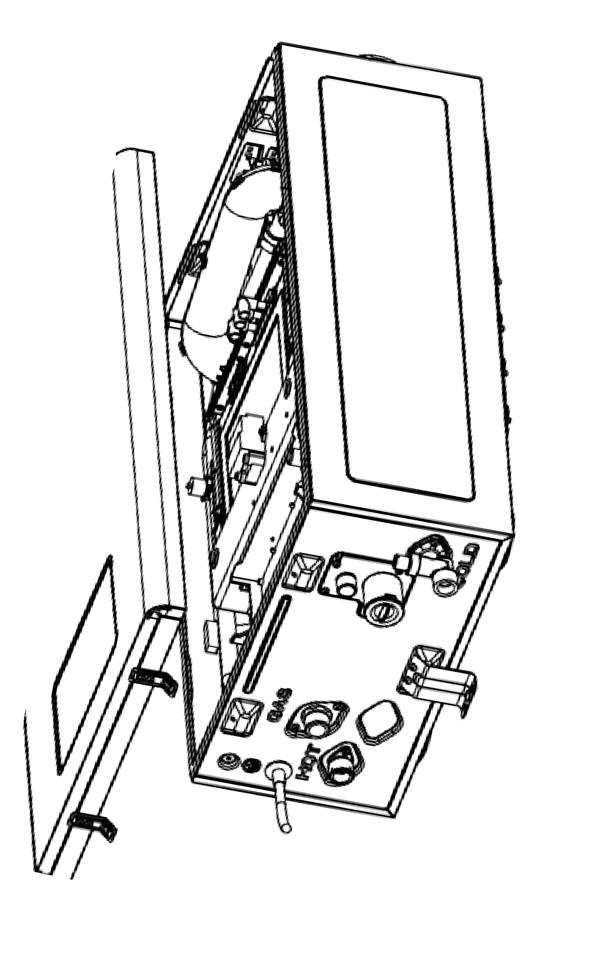
Measuring The Inlet Gas Pressure
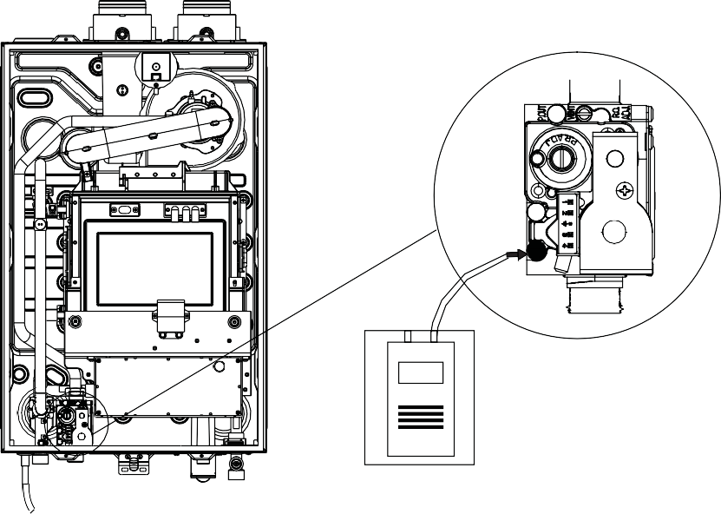
Figure 9.1 Figure 9.2
Figure 9.4
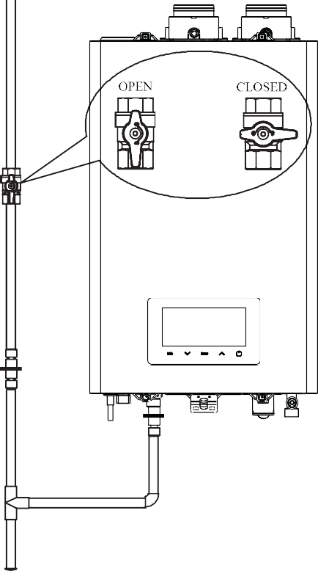
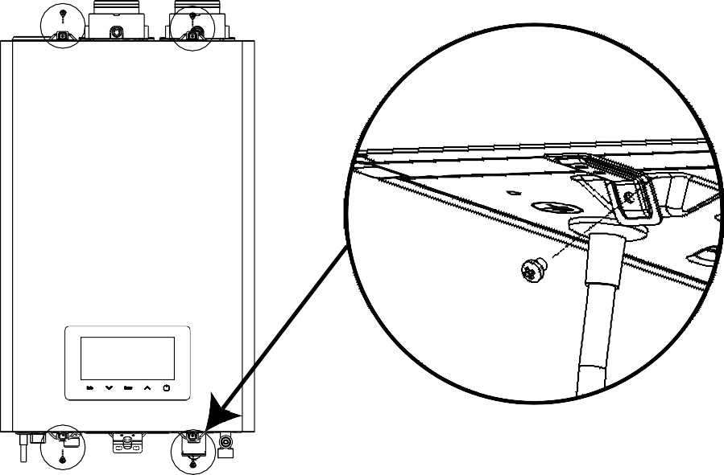
Figure 9.3

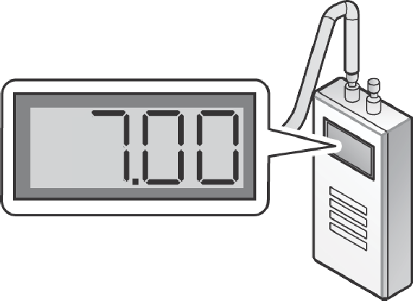
Figure 9.5
20
© 2024 Salt Lake Iron & Steel Ltd. Co.

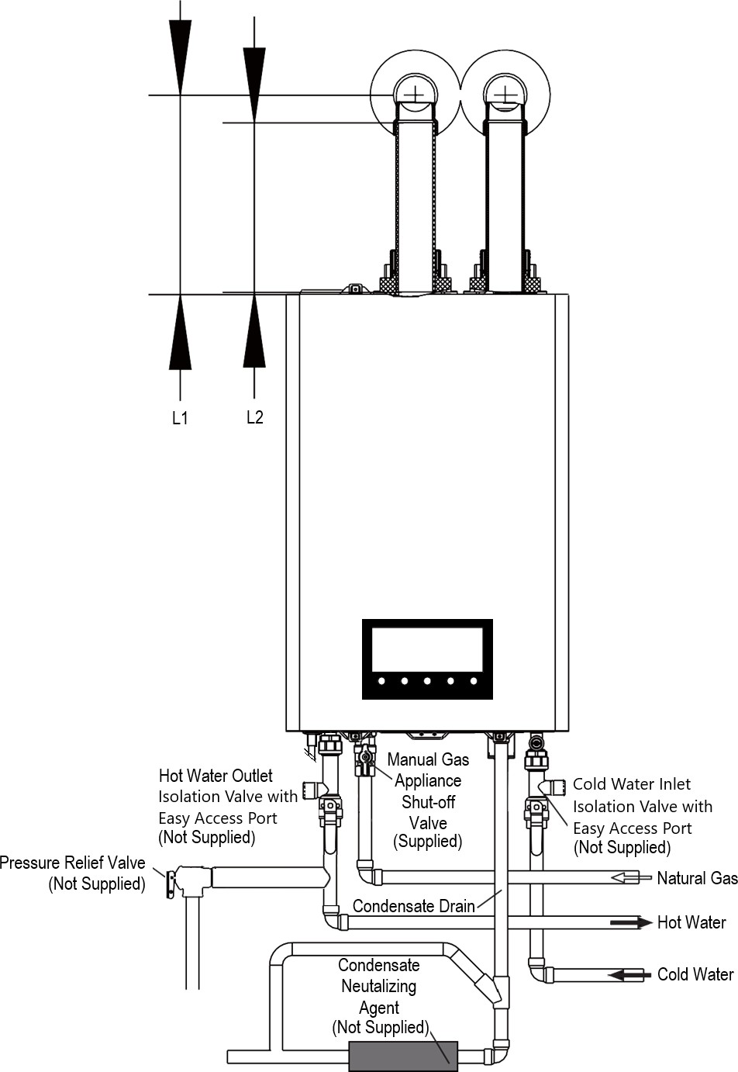
Connecting the Water Supply
10

Example of typical installation
L1 : 24 in. Maximum
L2 = L1 – 1¾ in.

Connecting the Water Supply

Water Supply Guidelines
The water ﬁttings on the water heater are ¾” in. If the installation site only has ½” in. plumbing throughout, it is not necessary to up-size the water lines to ¾” in. if you are installing a single water heater.
When connecting the water supply, follow these guidelines:
- Water quality is tested and is within the acceptable EPA guidelines listed on Page 11 of this manual.
- Water hardness is tested, the hardness level is identified, and a water softening system is added, if required or recommended, before this appliance to ensure this appliance’s proper operation. Failure to achieve the appropriate water hardness level will void this product’s warranty.
- Use only pipes, ﬁttings, valves, and components (e.g. solder) that are approved for use in potable water systems.
- Tighten the water heater connection valves with care to avoid damage.
- It is recommended to use unions on the cold water inlet and hot water outlet.
- Use the supplied rubber gaskets for inlet and outlet connections to the water heater.
- It is mandatory to use isolation valves with easy access ports on the cold water inlet and hot water outlet assemblies from the appliance for required routine maintenance purposes.
- Make the hot water piping system as short as possible to deliver hot water to the ﬁxtures quickly.
- To conserve water and energy, insulate all water piping, especially the hot water lines. DO NOT cover the drain or pressure relief valve.
- After installing the water heater, clean the inlet water ﬁlter that is located inside the cold water inlet, and then test the water heater for proper ﬂow and inspect for leaks. Instruct the water heater owner that the ﬁlter must be cleaned initially every six (6) months to maintain proper water ﬂow. If debris is often present more frequent cleanings should occur.
Failure to follow the instructions in this section and the warnings listed below will not only void the warranty but could also result in property damage, severe personal injury, or death.
DO NOT pipe the water heater with black iron, steel, galvanized steel, lead, or aluminum water pipe, as it could result in premature product failure.
DO NOT apply a torch within twelve (12”) in. of the water heater. If sweat connections are used, sweat
tubing to the adapter before ﬁtting the adapter to the water connections of the heater.
DO NOT use dielectric unions or galvanized steel ﬁttings in a system with this unit. Use only copper, brass, or stainless steel ﬁttings. Teﬂon thread sealant must be used on all connections.
WARNING!

Isolation Valves with Easy Access Ports
- For flushing and draining the appliance, isolation valves with easy access ports must be installed on the cold water inlet and hot water outlet assemblies from the appliance. These are not supplied. Ensure that the easy access port is usable when the valve is closed to the water inlet and outlet pipes, as these will be used to drain water from the internals of the appliance.
To appliance
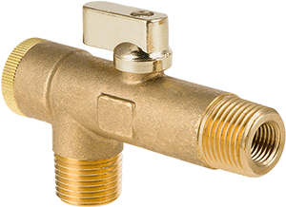
To water pipe

Easy access port

Connecting a Pressure Relief Valve
11

Connecting a Pressure Relief Valve
To complete the installation of the water heater, you must install an approved ¾” in. maximum 150 PSI pressure relief valve on the hot water outlet. The water heater has a
built-in, high temperature shut-oﬀ switch, so install a “pressure only” relief valve. This valve is not supplied; however, it is required. The pressure relief valve should be placed as close to the water heater as possible. No other valve outside of the isolation valve with easy access port should be placed between the pressure relief valve and the water heater. See illustration on Page 21 for reference.
Improper installation of the pressure relief valve may result in property damage, personal injury, or death.
Follow all instructions and guidelines when installing the pressure relief valve.
- The valve should ONLY be installed by a licensed professional.
- To avoid water damage or scalding direct the discharge line to a safe place for disposal.
WARNING!
When installing the pressure relief valve, follow these guidelines:
DO NOT plug the relief valve. If the relief valve discharges periodically, this may be due to thermal expansion in a closed water supply system. Contact the water supplier or local plumbing inspector on how to correct this situation.
DO NOT direct the discharge line to a location where freezing could occur.
DO NOT install a reducing coupling or other restriction on the discharge line.
- Ensure that the discharge capacity of the pressure relief valve is equal to or greater than the maximum pressure rating of the water heater.
- Ensure that the maximum BTU/hr rating on the pressure relief valve is equal to or greater than the maximum input BTU/hr rating of the water heater.
- Direct the discharge piping of the pressure relief valve so that hot water will not splash on anyone or any nearby equipment.
- Attach the discharge line to the pressure relief valve and run the end of the line to within 6-12” in. of the ﬂoor
drain, making discharge clearly visible.
- Ensure that the discharge line will allow free and complete drainage without restriction.
- Ensure that the discharge line is not plugged or obstructed.
- After ﬁlling and pressurizing the system, test the relief valve operation by lifting the lever. If the valve fails to operate correctly, immediately replace the relief valve.

- To avoid potential property damage or personal injury, check the pressure relief valve at least once every three years by manually operating the valve to ensure proper operation.
- Before manually operating the valve, check the discharge line and make sure that the hot discharge water will not cause personal injury or property damages. Contact with the discharge water may result in severe personal injury.
CAUTION!


Connecting the Condensate Drain
12

Connecting the Condensate Drain - Overview
This water heater creates condensation as part of its normal operation. The condensation produced is acidic and generally ranges from 3-5 on the pH scale. Be sure to follow all local
codes and regulations when disposing of condensate from the water heater. Check local codes for suitable waste drain locations, if applicable.

DO NOT cap or plug the integrated condensate line. If the condensate line is obstructed and impeding its ability to drain, it could damage the water heater.
DO NOT allow people or animals to drink the condensate water.
- The condensate line must have a negative slope to drain properly.
- Once the condensate drainpipe has been installed, ﬁll the condensate trap with water to ensure it ﬂows
through the drainpipe freely.
CAUTION!

Condensate Drainage Options:
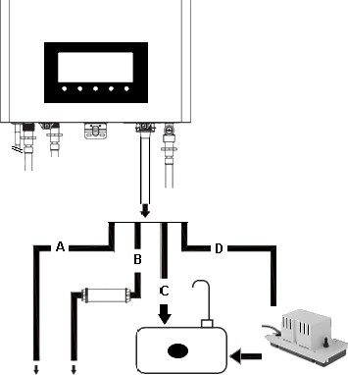

From the water heater directly into an external drain.
A
From the water heater, through a neutralizing agent, and then into an external drain.
B
From the water heater into a laundry tub.
C

From the water heater into a water heater condensate pump, and then into a laundry tub.
D

To External Drain To Laundry Tub
Figure 12.1
- If you choose option B, the neutralizing agent must be replaced periodically. Depletion of the neutralizing agent will vary, based on the usage rate of the water heater. During the ﬁrst year of operation, the neutralizer should be checked every few months for depletion and replaced as needed.
- If you choose option C, the bottom of the water heater must be higher than the top of the laundry tub. The condensate line must have a negative slope to drain properly.
- If you choose option D, a pump can be used when there is a long distance between the water heater and the laundry tub, or when the bottom of the water heater is lower than the top of the laundry tub.
NOTE

Connecting the Condensate Drain

Connecting the Condensate Drain
- Locate the condensate drain on the bottom of the water heater and remove the drain cap. (See Figure 12.2)
- Connect a drain line to the ½” in. ﬁtting at the bottom of the unit. NOTE: Use only corrosion-resistant material for the drain line, such as PVC or CPVC.
- Place the free end of the drain line into an appropriate drain.
- Fill the condensate trap inside the water heater by pouring water through the exhaust vent on top of the unit until water ﬂows through the condensate drain. Ensure the water ﬂows through the condensate drain line smoothly. (Figure 12.3)
- If you are using a condensate pump, ensure that the pump allows for up to 2 GPH of drainage for each water heater in the system.
- If you are not using a condensate pump, ensure that the drain line is pitched downward at a minimum slope of ¼” in. per foot.
NOTE
DO NOT reduce the size of this fitting or the drain to less than ½” in.

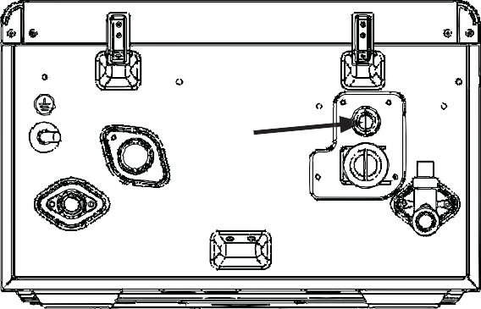

Condensate Drain

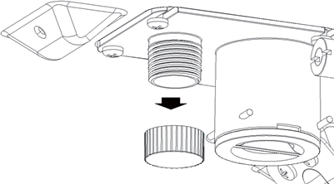
Figure 12.2

The condensate line must remain unobstructed,
allowing for the free ﬂow of condensate. If condensate freezes in the line, or if the line is obstructed in any other manner, condensate can exit the appliance in other areas due to an overflow of the condensate trap, resulting in potential water damage.
CAUTION!

Condensate Neutralizer Kit
DO NOT allow exhaust ﬂue gases to vent through the neutralizer. Leakage can cause injury or death from carbon monoxide.
DO NOT connect more than one appliance to the neutralizer.
- To avoid damaging the appliance, the neutralizer inlet and discharge must be lower than the condensate drain.
- The connection between the appliance and the neutralizer must be installed to prevent the back ﬂow of condensate into the appliance.
WARNING!

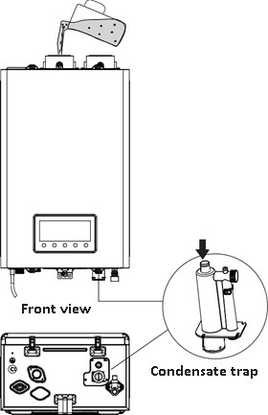
Figure 12.3

Connecting the Condensate Drain

If option B from Page 24 is selected for condensate disposal (condensate ﬂows through the neutralizer and directly into an external drain), the condensate will ﬂow through the neutralizing media and its pH level will increase. An increased pH level will help prevent corrosion of the installation’s drainage system and the public sewer system.
Figure 12.4

Neutralizer Installation Guidelines:
  - The inlet of the neutralizer has a center connection point and the outlet will have an oﬀset connection point.
  - Install the neutralizer on the wall or the ﬂoor and secure it using the brackets.
  - If the neutralizer is installed horizontally, rotate the neutralizer to position the outlet at the highest point. (Refer to Figure 12.4)
  - If the neutralizer is mounted vertically, ensure that the outlet is higher than the inlet. (Refer to Figure 12.5)
  - Ensure that the condensate runs freely to the drain.
  - Ensure all connections are made to prevent the back-ﬂow of condensate.
  - Use corrosion resistant piping and secure it to prevent movement.
  - For increased safety, in the event there is a blockage in the condensate drain, install a Y ﬁtting. Connect the Y ﬁtting (as shown in the diagrams to the right) and ensure condensate can run freely to the drain.
  - Ensure that the discharge connection is accessible, as access is required for maintenance and pH testing.
  - If there is an insuﬃcient gradient for drainage, install a drainage pump designed for water heater & boiler condensate removal.

Maintenance of Neutralizer
Periodically monitor the level of media in the neutralizer and test the pH level at the condensate drain outlet. We recommend an annual pH test using recognized test strips or an electronic pH meter to obtain precise measurements.

Figure 12.4
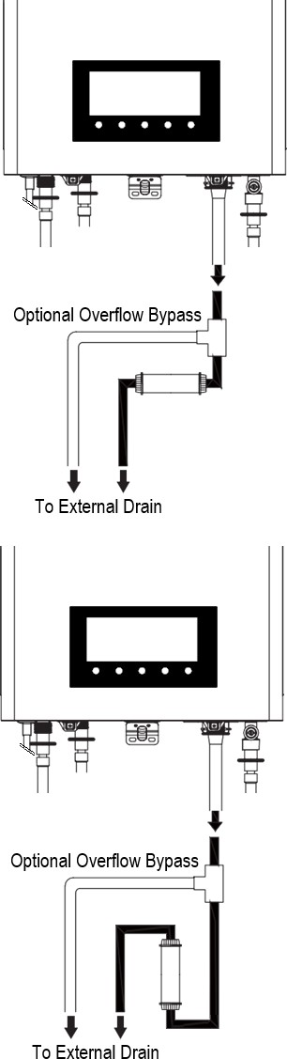

Figure 12.5

Replace the neutralizing media when the pH drops below the minimum level required by the local water authority. If the pH level is not speciﬁed, replace the neutralizing media when the pH is below 6.0.


NOTE
DO NOT install condensate piping in areas where the temperature drops below the freezing point.
- Protect piping in high pedestrian areas from damage and vibration.

Venting the Water Heater - Overview

Venting the Water Heater
13

WARNING!
This appliance is certiﬁed as a “Category IV” appliance and requires a special venting system. The vent system will operate with a positive pressure in the pipe. Exhaust gases must be piped directly outdoors using the vent materials and rules outlined in these instructions. Follow the venting instructions carefully. Failure to follow these instructions will result in substantial property damage, severe personal injury, or death.
DO NOT connect vent connectors serving appliances vented by natural draft into any portion of mechanical draft systems operating under positive pressure.
  - Improper venting of the water heater can result in excessive levels of carbon monoxide, which can lead to severe personal injury or death. This water heater must be vented in accordance with the “Venting of Equipment” section of the latest edition of the ANSI Z223.1/NFPA 54 Natural Fuel Gas Code in the USA, as well as all applicable local building codes and regulations. Follow all instructions and guidelines when venting the water heater. Installation of a venting system should ONLY be performed by a licensed professional.
  - The venting system must be sealed airtight to prevent ﬂue gas spillage and carbon monoxide emissions; both spillage and emissions will result in severe personal injury or death.
  - The end user is responsible for keeping the air intake and exhaust termination free of snow, ice, or other potential obstructions, as well as scheduling routine maintenance. Blocked or obstructed vent piping terminations could result in property damage, severe personal injury, or death.

The water heater must be properly vented to ensure a constant supply of clean intake air and to ensure that exhaust air is properly removed from living areas. When venting the water heater, follow these guidelines:
DO NOT install the water heater in areas with contaminated air (high levels of sawdust, dust, sand, ﬂour, aerosols, halogenated compounds, or any other airborne contaminants), as this could cause the unit to have operational issues. Please refer to Pages 12 and 13 for more information. Damage that is caused as a result of the unit being operated and installed in an area with contaminated air WILL NOT be covered by the warranty. If you must install the water heater in an area with contaminated air, use direct venting to supply air from outside of the building. It is recommended that more frequent intervals of maintenance
and ﬁlter cleaning be performed when installed in these areas.
DO NOT connect the water heater vent to a vent for any other gas water heater or vent stack.
DO NOT obstruct heater air intake or exhaust. Support all vent piping per the vent pipe manufacturer’s
installation instructions.
DO NOT place chemical vapor emitting products near the unit.
DO NOT operate the heater unless it is vented to the outdoors.
  - Install the water heater as close as possible to the vent termination.
  - For horizontal runs, slope the horizontal section upward toward the vent termination at a rate of 1/4 in. per foot (2% slope).
  - Create an airtight seal at each joint in the exhaust and intake air pipes from the water heater collar to the vent termination connecting the pipe to the vent collar by using the supplied Hose/Pipe Clamps. Please refer to Page 31 for more information.
  - Analyze the entire vent system to make sure that condensate in the vent pipe will not become trapped in a section of vent pipe and reduce the open cross-sectional area of the vent. Condensate in the vent pipe should be disposed via a condensate trap.
  - According to NFPA 720, carbon monoxide detectors should be installed outside each sleeping area.

Venting the Water Heater - Overview

Connecting the Pipe to the Vent Collar
Ensure the ends of the vent pipe are properly beveled to 90° prior to installation. Also ensure the pipe is fully connected to the exhaust gas vent ﬁtting. Failure to properly bevel and install the pipe correctly could lead to gasket failure and ﬂue gas leakage, which could result in serious injury or death.
WARNING!
DO NOT use primer or cement on the appliance connection.
- The products covered in this manual are designed for two (2”) in. vent pipes. Both vent pipes can be installed without an external adapter. When installing the vent pipe, please refer to the following pages for selection & installation of the correct vent piping for your application.
- Three (3” in.) vent pipe may be used, however the supplied Flue Gas Flow Limiting ring must be used in the exhaust pipe to help increasing the resistance for the outlet.
- Covering non-metallic vent pipe and ﬁttings with thermal insulation is prohibited.
NOTE

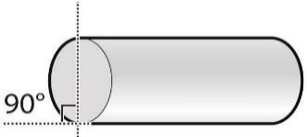
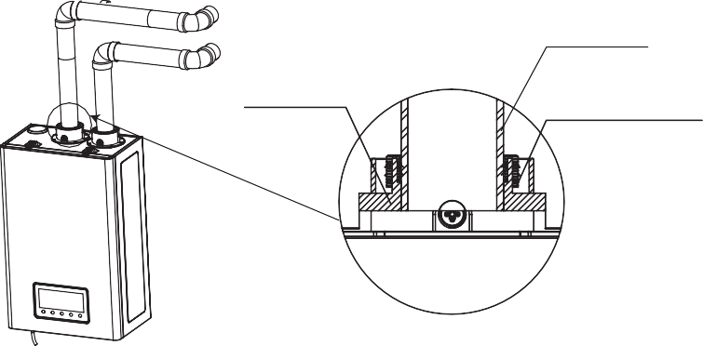
Vent Pipe Installation
Flue pipe
Vent collar
Rubber gasket
- Measure 1 ¾” in. from the end of the vent pipe and then draw a mark at that distance.
- Insert the pipe into the vent collar to start the vent run. Make sure to completely slide the vent into the collar until the end makes contact with the bottom of the socket.
- Verify that over 1 ¾” in. of the pipe has been completely inserted into the collar and that the mark is no longer visible. The pipe will be tightened and sealed by the rubber gasket.
DO NOT start the vent run with a street elbow at the vent collar.
- Using an elbow directly at the collar will not allow for a tight seal between the appliance and the vent pipe. A section of straight pipe must be used when starting the vent run.
CAUTION!
- If the connections leak, harmful gas could cause severe personal injury or death.
- After completing the installation, and the unit is ﬁlled with water, turn on the water heater and test it for leaks using a bubble test kit. After applying the soap solution, bubbles will form on the connections if leaks exist.
WARNING!

Selecting a Vent Type
14

The water heater referenced in this manual is classiﬁed as Category IV appliances and are prepared at the factory to be direct vent (sealed combustion) appliances that draw all of the required combustion air directly from the outdoors. Direct air vent installations are
recommended whenever possible to avoid the back-drafting of cold air through the water heater. If you cannot use a direct vent, ensure that there is an ample supply of usable air available in the installation location.
Installation of a new vent system with this appliance is also recommended. In the event an existing vent system is reused, ensure it is thoroughly inspected for punctures, cracks, or blockages before it is connected to the water heater.

Vent Termination Guidelines:
 DO NOT store hazardous material or ﬂammable substances near the vent termination.
- To avoid moisture and frost build-up and to maintain clearances on adjacent homes, 45° & 90° elbows and tees may be attached to the end of the termination vent pipe to direct the exhaust plumes away from buildings. However, the total allowable vent lengths, maximum number of elbows, and distances to air intake restrictions must be observed.
- If this water heater will be installed in areas where snow is known to accumulate, protect the vent termination from blockage.
- Ensure that the vent termination is at least 12” in. above the highest anticipated snow line, or as required by local codes, whichever is greater.
- Support the vent pipe with hangers at regular intervals, or as required by local codes.
- Exhaust and intake air pipes must be supported at least every four (4’) feet.
- The vent for this appliance shall not terminate over public walkways, near soﬃt vents or crawlspace vents, where condensate or vapor could create a nuisance, hazard, or cause property damage, nor where condensate or vapor could cause damage or could be detrimental to the operation of regulators, relief valves, or other equipment.

Direct Venting
The water heater uses two (2”) in. diameter exhaust and two (2”) in. diameter intake air ducts. To ensure the draw of air directly from and exhaust of air directly to the outside of the building, create an airtight seal from the water heater collar to the vent termination. Do not install the restrictor in the exhaust pipe for two (2”) inch vent pipes.
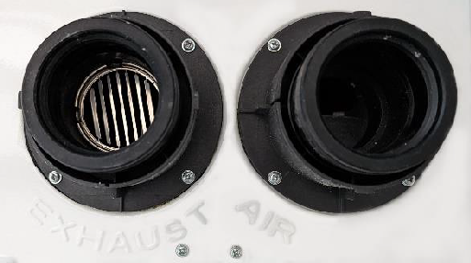
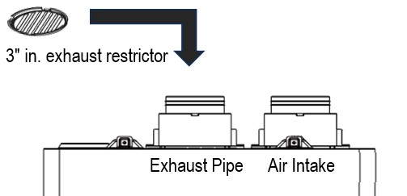
Three (3”) inch vent pipe option:
If installation of three (3”) inch diameter pipes for venting is desired, install the supplied exhaust pipe restrictor according to the placement shown below. The restrictor should be placed fully inside the exhaust pipe, level, until resting firmly in the pipe.
NOTE

Selecting a Vent Type
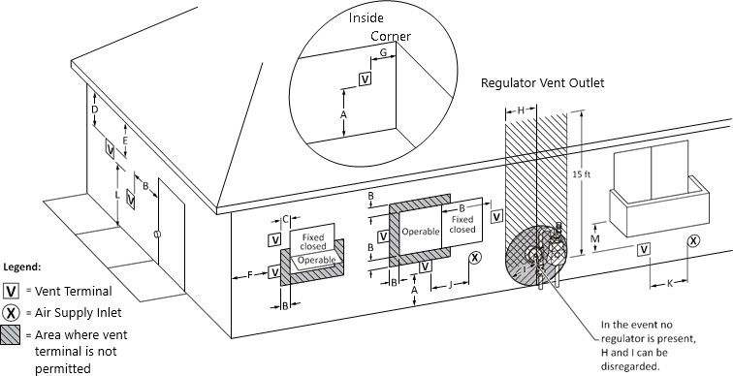

 | Description | US Direct Vent
A | Clearance above grade, veranda, porch, deck, or balcony. | 12” in.
B | Clearance to window or door that may be opened. | 12” in.
C | Clearance to permanently closed window. | *
D | Vertical clearance to ventilated soﬃt located above the terminal within a horizontal distance  of 2 ft (61 cm) from the center line of the terminal. | *
E | Clearance to unventilated soﬃt. | *
F | Clearance to outside corner. | *
G | Clearance to inside corner. | *
H | Clearance to each side of center line extended above meter/regulator assembly. | *
I | Clearance to service regulator vent outlet. | *
J | Clearance to non-mechanical air supply inlet to building or the combustion air inlet to any other appliance. | 12” in.
K | Clearance to a mechanical air supply inlet. | 36” in. above if within 10 ft
L | Clearance above paved sidewalk or paved driveway located on public property. | *
M | Clearance under veranda, porch, deck, or balcony. | *
  - In accordance with the current with the current CSA B149.1 Natural Gas & Propane Installation Code.
  - In accordance with the current ANSI Z223.1/NFPA 54 National Fuel Gas Code.
* Clearance in accordance with local installation codes and the requirements of the gas supplier and the vent
manufacturer’s instructions.

Selecting Vent Pipe Materials 15
Consult the following chart, or the most recent edition of ANSI Z223.1/NFPA 54, as well as all applicable local codes and regulations when selecting vent pipe materials.
DO NOT use cellular core PVC (ASTM F891), cellular core CPVC, or Radel (polyphenol sulfone) for the exhaust vent.
DO NOT mix components from diﬀerent systems. The vent system could fail and harmful elements from the ﬂue could leak into the living space. In the event this occurs, it could cause serious personal injury or death.
- Mixing of vent materials WILL VOID THE WARRANTY and certiﬁcation of the appliance.
WARNING!

Intake materials can be made of ABS, PVC, CPVC, PP, galvanized steel, corrugated aluminum or any other such materials. If you use a corrugated material, ensure that there is not crimping or damage to the intake airpipe.
When using direct venting, maintain the following venting clearances, as required by ANSI Z21.10.3 and the National Fuel Gas Code, ANSI Z223.1/NFPA 54:
Failure to provide a properly installed vent and air system will cause personal injury or death!

Location | Recommended Vent Materials
USA | - PVC/CPVC Schedule 40 or 80 (Solid Core)  - Approved Polypropylene (PP)
These installation instructions reference snow levels in establishing a minimum height for the installation of the exhaust vent or air intake terminations. Snow levels are determined as follows:
- The installation location, by ordinance, designate the calculation of the snow levels in that location.
- In the absence of speciﬁc ordinances, snow levels should be calculated from the average of monthly maximum depth of snow accumulation as indicated by the 10-year statistics for the installation/geographical area by the National Weather Service.
The supplied vent connectors and vent termination methods outlined on Pages 32 through 35 are certiﬁed
as part of the water heater.
NOTE

Measuring Vent Length
16

The maximum vent length when using two (2”) in. exhaust ducts is 60 feet. The intake duct length may be identical to the exhaust duct length. One (1’) foot straight pipe and a 90° elbow are not included in the vent length. The maximum vent length is reduced by the number of elbows used, as shown in the table below:

Vent Size | Max. Length | Equivalent Lengths
2 in | 60 ft | Reduce the maximum vent length accordingly for each elbow used:  - Each 90° elbow equates to five (5’) linear feet of vent length.  - Each 45° elbow equates to two and a half (2.5’) linear feet of vent length.  - The number of 90° elbows cannot exceed seven (7).  - The number of 45° elbows cannot exceed fourteen (14).
NOTE: The use of a PVC or polypropylene concentric termination counts as 5 linear feet of vent.
When the exhaust pipe is too long, the gas load will be reduced due to the inﬂuence of air resistance.
DO NOT exceed the maximum length of the vent. Excessive length may result in heater shutdown and property loss.
DO NOT make the exhaust pipe shorter than the minimum length allowed. If the length of the pipe is too short, the exhaust gas generated by gas combustion could enter into the air inlet of the machine, which could lead to incomplete combustion, and result in heater failure, property loss, personal injury, or death.
NOTE

Terminating the Vent
17

Before installing the water heater, determine what type of vent termination is
appropriate for the installation location and materials. The following sections describe some typical venting conﬁgurations, but do not include all possible options. The examples shown on the following pages are possible venting options.
The following “low profile” PVC terminal listed in the table below has been approved to be adequate for the unit mentioned in this manual.

Brand | UPC | Part # | Type | Note
Diversitech | 095247149612 | HVENT-2 | Low proﬁle | 2 in.
- Only the “low profile” termination model listed in this manual is certified for use with this appliance. IPEX and Centrotherm branded “Low Profile” terminations may be used, however they must be the same dimensions as the SKU listed above. This product is not recommended for use with Centrotherm concentric terminations.
- Only terminations produced by the same manufacturer as the vent system shall be used.
- Refer to the vent manufacturer’s instructions for detailed installation procedures and guidelines.
NOTE

Two-Pipe Sidewall Venting
WARNING!
The vent system must be installed by an authorized technician or licensed professional. Improper installation may cause appliance failure, property damage, severe personal injury, or death.
Improper installation will also void the warranty of the water heater.
If the distance between the air inlet and exhaust vent terminations is less than seven (7”) in., the water heater will draw in exhaust gases through the intake. This creates a risk of inadequate combustion air for the water heater, which can increase the amount of Carbon Monoxide (CO) emissions and noise due to vibration.
Termination elbows must be oriented vertically, ensuring they point directly downward. Attempt to prevent exhaust air from entering the air inlet by angling termination elbows in directions other than directly downward will increase the risk of freezing.
Reversing the air intake and exhaust pipes is not allowed. Carbon Monoxide (CO) emissions and noise due to vibration will increase.
In case of earthquake, tornado, or other natural disasters, have a trained professional check the vent pipe for any damage, that the exhaust ﬂows normally, and the unit functions properly after such extreme event.
NOTE
- Install the bird screen at the end of the terminal elbow when a two-pipe sidewall venting method is applied.
- If glue and other solvent cement are used during the installation, please follow the manufacturer’s
instructions when using.
- Please refer to the illustrations on the following page for the dimension requirements when using this method of venting.

Terminating the Vent
Two-Pipe Sidewall Venting Example 1:

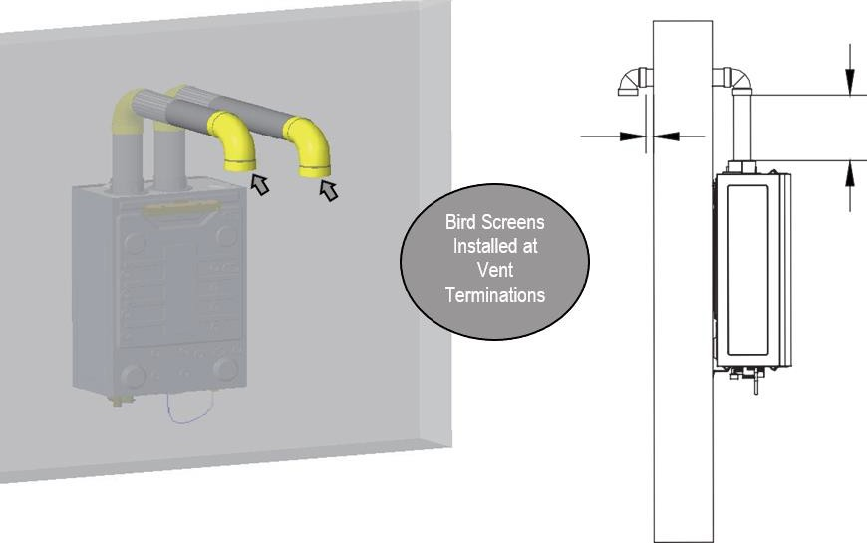
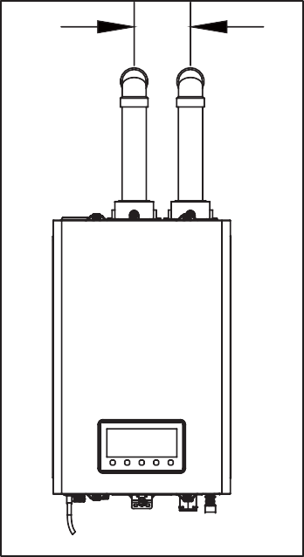

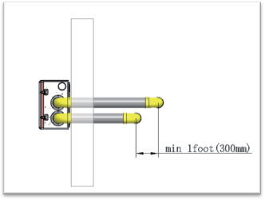
Minimum
two (2”) in. Minimum 12” in.

5 ½” in.

Minimum 12” in.

Terminating the Vent

Two-Pipe Sidewall Venting Example 2:
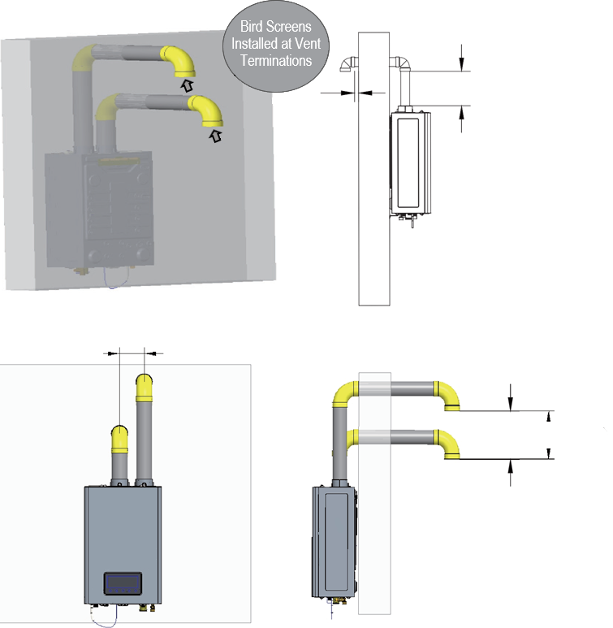

Minimum 12” in.
Minimum
two (2”) in.

5 ½” in.

Minimum 12” in.

Terminating the Vent
Low Proﬁle Two-Pipe Sidewall Venting:

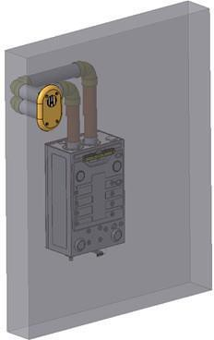
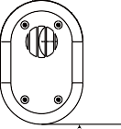
Flue Exhaust

External Wall
Air intake
Minimum 12 In.

Clearance above the highest anticipated snow level or grade, or as required by local codes, whichever is greater.

NOTE
Only the following orientations are allowed for twin pipe low profile terminations.
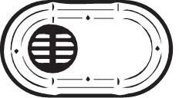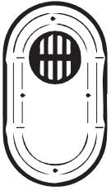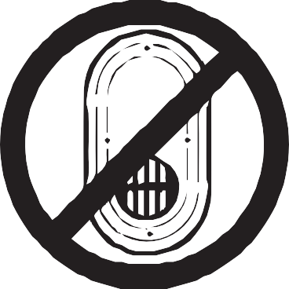
Figure 17.6

Connecting the Power Supply
18
The products referred to in this manual utilize an external electrical source. When installed, the unit must be electrically grounded in accordance with local codes or, in the absence of local codes, with the National Electrical Code ANSI/NFPA 70.
Improperly connecting the power supply could result in personal injury, electrical shock, and/or death!
WARNING!
When connecting the power supply, follow these guidelines:
DO NOT connect the electrical supply until all plumbing and gas piping is complete and the
water heater has been ﬁlled with water.
DO NOT connect the water heater to a 220 - 240V AC power supply. Doing this will damage the water heater and void the warranty.
DO NOT run a dedicated electrical line to the water heater. All water heaters come with a 3 -pronged (grounded) plug. The water heater can be plugged into any grounded electrical outlet nearby to the installation location, as the unit only requires 2-4 Amps to operate.
DO NOT use a broken or modiﬁed power cord.
DO NOT bind, bend, or stretch power cords.
- Keep power cord free of dust.
- If local codes require the water heater to be wired directly, remove and discard the factory-installed plug. Install a power switch between the breaker and the water heater to facilitate any end-user maintenance and servicing. Connect the water heater to a110-120V AC, 60 Hz rated electrical supply that has a maximum of 2 Amps.
- The water heater must be electrically grounded. If using the power plug, ensure the electrical outlet that the water heater will be connected to is properly grounded. If wiring the water heater directly to a power supply, DO NOT attach the ground wire to the gas or water piping, as plastic piping or dielectric unions could prevent proper grounding.
- It is recommended to use a surge protector to protect the water heater from power surges.
- If there is a power failure in cold weather areas, the anti-freeze system in the water heater will not operate and could result in freezing of the heat exchanger. In cold weather areas, where power failures are common, the water heater must be completely drained to prevent damage if the power will be oﬀ for an extended period of time. A battery back-up can be used to supply hot water during power outages. Damage caused by freezing temperatures due to a power loss is NOT covered by the warranty.
If the water heater will not be used for an extended period of time, follow these steps:
  - Disconnect the power supply to the water heater.
  - Completely drain the water out of the water heater.
Label all wires before disconnecting them when you work on the controls. Wiring errors can cause improper and dangerous operation. Verify proper operation after servicing.
CAUTION!

Appliance Operation
19
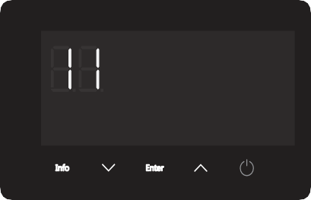









Follow the instructions below to avoid unsafe operating conditions that could cause property damage, severe personal injury, or even death.
- Ensure the water heater is ﬁlled with water before using the water heater. If the water heater’s internal gas valve cannot shut oﬀ the gas supply, use the manual gas shut-off valve and call a qualiﬁed technician.
- If any part of the water heater has been submerged in water, do not use this appliance, immediately cut oﬀ the power supply, and call a qualiﬁed technician.
WARNING!
Power On/Oﬀ
Press the POWER button to turn on/oﬀ. When the unit is turned “ON”, the temperature setting will show on the display and the buzzer will sound once.
Temperature setting
Before adjusting the temperature, pay attention to whether the water heater is properly functioning.
Water temperatures above 122°F can cause skin to scald instantly leading to severe burns or death.
WARNING!

The default temperature setting is 116°F. To adjust the temperature while the power is “ON”, press the
or buttons. Pressing an arrow key quickly will change the set temperature in small increments and the
buzzer will sound with each press. Holding an arrow button down will adjust the set temperature faster.
Decrease Temperature Setting Increase Temperature Setting
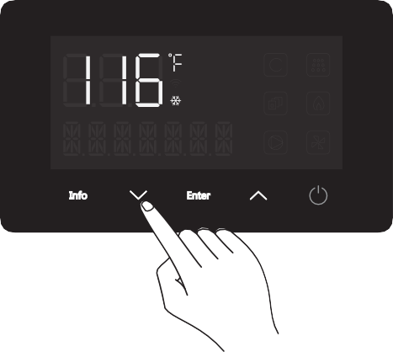
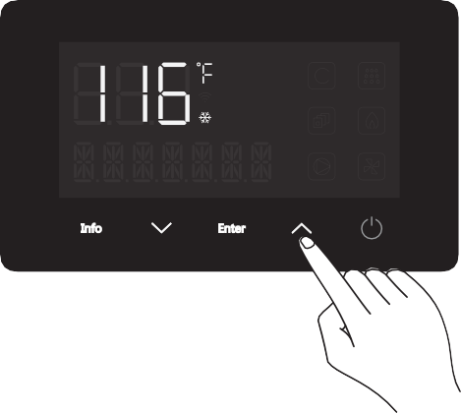
38 © 2024 Salt Lake Iron & Steel Ltd. Co

Appliance Operation

Range of temperature setting | Accuracy
95°F ~ 140°F | 1°F
- The set temperature may be changed from 95 to 140°F while the burner is off but the
appliance is “ON”.
- If the current set temperature is below 122°F and the burner is on, then the temperature setting is locked from 95 to 122°F to help prevent scalding from temperature adjustment.
- If the set temperature is above 122°F, the set temperature can be changed from 95 to 140°F.
- However, if set temperature is adjusted to a value that is lower than 122°F, the range becomes locked between 95-122°F to help prevent accidental scalding.
NOTE

Set or reset temperature setting
To reset the set temperature while the power is “ON”, press the ENTER button for 3 seconds until the set
temperature on the display ﬂashes, then, press the or keys to reset the set temperature.
To switch from current temperature to the set temperature while the burner is on, press the ENTER button. The buzzer will beep and the display will show the set temperature.








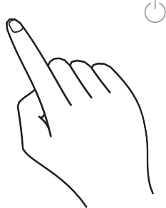
If you try to change the set temperature above 122°F while burner is on and the previous set temperature was below 122°F, the system will not allow this and the buzzer will sound twice.
NOTE

39 © 2024 Salt Lake Iron & Steel Ltd. Co

Appliance Operation

Performance Information
- Press the info button to enter the information query interface while the power is on, IT displays as default.
Menu Item | Description | Units
IT | Inlet Water Temperature | °Fahrenheit
WF | Water Flow Rate | Gallons Per Minute

- Press the or buttons to select the information item.
- Press ENTER to show details.

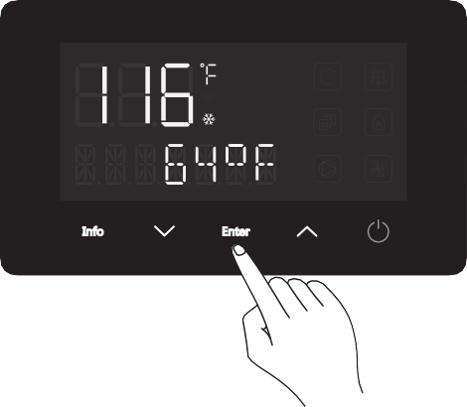
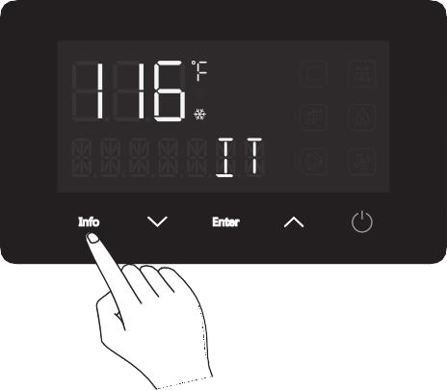
Step 1: Display shows after pressing INFO key

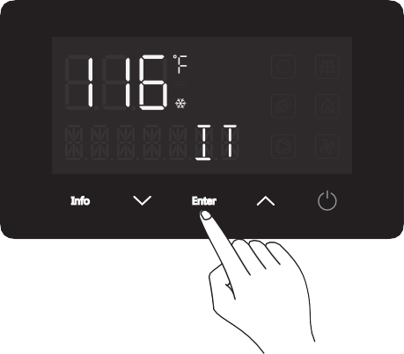
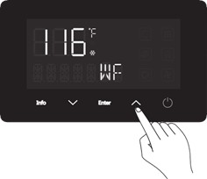
Step 3: Press ENTER again to return to the display Info screen.

Step 5: Press ENTER again to view the actual WF.
Step 2: Then, press ENTER to see the actual IT:

Step 4: Press the key to select WF .

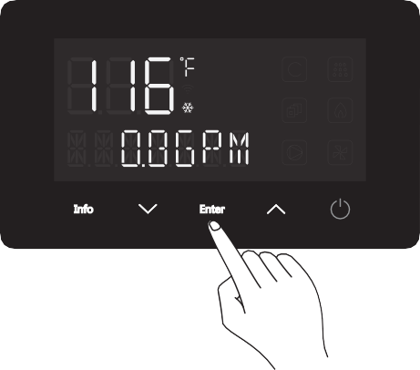
40
© 2024 Salt Lake Iron & Steel Ltd. Co.

Required Routine Maintenance
20

Routine Maintenance
- Check frequently to see if the gas supply pipelines are in good condition without cracks.
- Pay attention to any rubber hoses or gaskets. In order to prevent gas leakage, check the joints
of pipelines frequently by using suds to see if there are bubbles that form. If bubbles form, there is a leak.
- A water heater must be examined and cleaned after it has been used for a period of time (generally about six months to a year) to guarantee normal operation of the heater.
- Clean the external casing of the unit with water and light soap. Use of harsh chemical cleaners or volatile solvents
will cause the paint to fade or lose its luster.
- Clean the inlet water ﬁlter regularly.
Before performing any maintenance, please follow these steps:
- Disconnect the power supply, disconnect power to the outlet that services this unit, and close the gas valve.
- After the power is turned OFF, drain the hot water from a nearby faucet until it runs cold. Then close the water supply isolation valves (cold and hot) of the water heater.
CAUTION!

Flush the Heat Exchanger
Due to the hardness of the water in your area, scale may build up inside the heat exchanger and block efficient water flow. Periodic ﬂushing is mandatory in order to ensure smooth water ﬂow. It is recommended the heat exchanger be ﬂushed on the schedule on the bottom of Page 11 based on your water hardness. Damage to the water heater which results from water scale deposit WILL NOT be covered under the product warranty.
Please follow these steps when the appliance is ﬂushed to descale the heat exchanger. It is recommended that you contact a licensed professional to carry out this procedure.
- Ensure the isolation valves are fully closed before beginning this procedure.
- Connect the empty connection of the isolation valve on the cold water side to the outlet of the circulation pump.
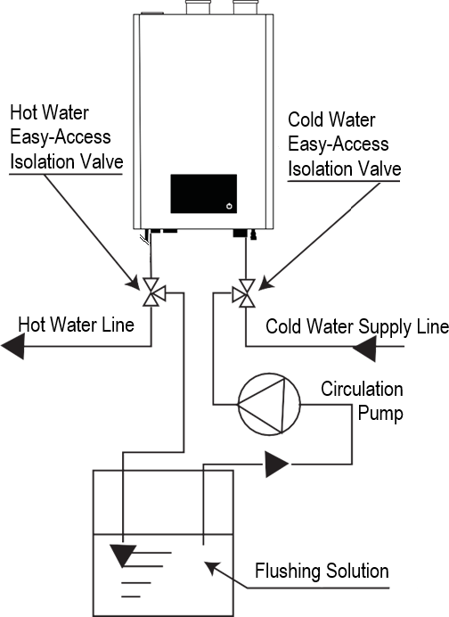
- Connect the empty connection of the isolation valve on the hot water valve to a tube leading to the solution tank.
- Connect the inlet of the circulation pump to a tube that leads to the solution tank.
- Make sure there is no leakage in any of the connectors.
- Fill the solution tank with descaling solution above the tube connected to the circulation pump. If using commercial descaling kit, please properly follow the instructions of the descaling kit.
- Run the circulation pump until solution begins exiting the tubing connected to the hot water isolation valve. Ensure this tubing returns fluid to the flushing solution container.
- Continue running the circulation pump until the solution that comes out from the hot water side is clean.
- Fully drain solution from unit. Disconnect all tubes for ﬂushing and fully close the empty connectors of the isolation valves.
- Open the isolation valves to switch back to normal water ﬂow.
- Restore the power supply, gas supply, and water supply.
- Run the water heater for at least five (5) minutes to make sure there is no solution remaining in the unit.

Required Routine Maintenance

Clean the Inlet Water Filter:
Appliance Operation
Before performing any maintenance, please follow these steps:
- Disconnect the power supply, disconnect power to the outlet that services this unit, and close the manual gas shut­off valve.
- After the power is turned OFF, drain the hot water from a nearby faucet until it runs cold.
Then close the water supply isolation valves (cold and hot) of the water heater.
CAUTION!
  - Drain the water heater.
  - Locate the cold water inlet to the water heater.
  - Unscrew the brass end facing towards you on the cold water inlet assembly by turning it counterclockwise until it becomes loose. Remove the brass end and filter from the water inlet assembly.
  - Rinse the ﬁlter screen with clean water, brush with an unused toothbrush, or wipe it when necessary. Do not tap the screen on a hard surface or with your hand. Tapping the screen might deform the filter, affecting filtering ability.
  - Insert the cleaned ﬁlter and tighten it by turning clockwise until it is securely back in the cold water inlet assembly.
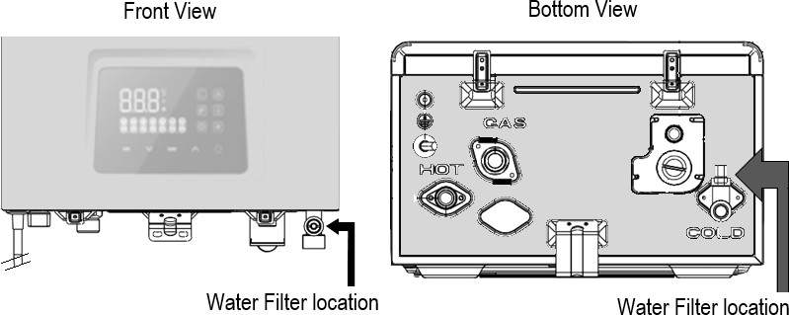

Picture of brass end and clean water filter removed from water heater (Enlarged).
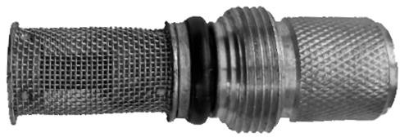

Water Filter
Screen Brass End

Troubleshooting
21

Error Codes and Solutions
Should you experience a problem with the water heater, please refer to the following chart for possible remedies. Error codes that appear on the front panel display are explained in the below section. For minor problems or issues, resetting the water heater may resolve the issue. To reset the water heater, press the POWER button on the front panel, or turn oﬀ the faucet and then back on.
Error Code | Description | Cause | Possible Solution
E0 | E0 Displayed | Outlet water temperature sensor open or has  short-circuited. | Ensure temperature sensor is properly connected. If connection is good, change the sensor.
E0 | E0 Displayed |  | If error still occurs change the MAIN CONTROL BOARD.
E1 | Accidental Flame Lost | Gas has run out during combustion or no pressure in the pipeline. | Increase the gas supply pressure to the required value.
E1 | Accidental Flame Lost | Gas valve operation is unstable. | Replace the gas valve.
E2 | Flame Signal Detected Before Ignition | Open circuit formed between ﬂame sensor and the burner or the heat exchanger before ignition. | Unplug the ﬂame sensor from the  MAIN CONTROL BOARD, with the  power on, but burner oﬀ.  - If E2 persists, change the MAIN CONTROL BOARD.  - If E2 does not persist, change the ﬂame  sensor.
E3 | Thermistor Open Circuit* | Heat exchanger outlet water overheated. | - Check if there’s debris or dirt on the  ﬁlter of the water inlet. If so, clean the ﬁlter (refer to the Clean the Inlet Water Filter section on Page 41).  - Check the BWF value (refer to the Appliance Servicing section), if it exceeds 0.4 GPM, check the HE, if the CB error can be searched from HE, change the bypass water valve.
E3 | Thermistor Open Circuit* | Thermistor failure. | Turn oﬀ the unit, use a multi-meter to check if the thermistor is conducting. If E3 exists while the thermistor is conducting, change the MAIN CONTROL  BOARD.
E4 | Outlet Water Temperature Exceeds 185°F (85°C) For Over 3 Seconds | Outlet hot water overheated. | - Check if there’s debris or dirt on the  ﬁlter of the water inlet. If so, clean the ﬁlter (refer to the Clean the Inlet Water Filter section).  - Check the BWF value (refer to the Appliance Servicing section), if it exceeds  0.4 GPM, check the HE, if the CB error can be searched from HE, change the bypass water valve.
E4 |  | Temperature sensor failure. | Replace the sensor.
* The unit will not automatically restore while this error code is displayed. Press power oﬀ and then on to manually restore the unit.

Troubleshooting
 | E5 | Fan Failure | Cables not connected. | - Connect the cables.  - If E5 persists, replace the fan.
 | E5 | Fan Failure | Fan controller failure. | - Connect the cables.  - If E5 persists, replace the fan.
 | E6 | Gas Valve Failure | Cables not connected. | - Connect the cables.  - If E6 persists, replace the gas valve.
 | E6 | Gas Valve Failure | Solenoid Failure.
 | E9** | Water Valve Failure | Main water valve jam. | Clean the main water valve.
 | E9** | Water Valve Failure | Main water valve failure. | Replace the main water valve.
 | EE | Overtime | Burner time exceeds 40 minutes of continuous operation . | Close & open the faucet to restart combustion operation.
 | F2 | Inlet Water Temperature Sensor Failure | Inlet water temperature sensor open or has short-circuited. | - Ensure the sensor is connected.  - If the sensor is connected & F2 persists, change the sensor.  - If F2 persists with a new sensor, change the MAIN CONTROL BOARD.
 | C0 | Ignition Failure | Gas valve not open. | Replace the gas valve.
 | C0 | Ignition Failure | Air in the gas supply line. | Attempt to ignite several times to discharge the air.
 | C0 | Ignition Failure | Gas supply pressure too low. | Ensure gas supply pressure is within range.
 | C0 | Ignition Failure | Nozzle blockage. | Clean the nozzle.
 | C0 | Ignition Failure | No signal from ﬂame sensor. | Change the ﬂame sensor, if C0 persists,  change the MAIN CONTROL BOARD.
 | C1 | Residual Flame | Gas valve leakage. | Replace the gas valve.
 | C4 | Vent Blockage | Vent pipe blockage. | Clean & remove debris from the vent pipe.
 | C4 | Vent Blockage | Ambient wind pressure too high. | Change the terminal to resist higher wind pressure.
 | C4 | Vent Blockage | Air pressure sensor failure. | Replace air pressure sensor module.
 | C4 | Vent Blockage | Fan failure. | Replace the fan.
 | C9 | Exhaust Gas Temperature Sensor Failure | Exhaust gas temperature sensor is open or has short-circuited. | - Ensure the sensor is connected.  - If the sensor is connected & C9 persists, change the sensor.  - If C9 persists with a new sensor, change the MAIN CONTROL BOARD.
 | CA | Exhaust Gas Temperature Too High | Heat exchanger failure. | Change the heat exchanger.
 | CA | Exhaust Gas Temperature Too High | Exhaust gas temperature failure. | Refer to C9 above.
 | CB | Bypass Water Valve Failure | Bypass water valve jam. | Clean the bypass water valve.
 | CB | Bypass Water Valve Failure | Bypass water valve failure. | Replace the bypass water valve.
 | CF | Heat Exchanger Outlet Temperature Sensor Failure | Heat exchanger outlet temperature sensor is open or has short-circuited. | - Ensure the sensor is connected.  - If the sensor is connected & CF persists, change the sensor.  - If CF persists with a new sensor, change the MAIN CONTROL BOARD.
** These error codes will not display on the screen but can be accessed through the Appliance Servicing mode.
This water heater is equipped with a blocked vent shut -oﬀ system. Should error codes E5 or C4 occur, CLOSE the gas valve at the manual shut-oﬀ point. Then, check the vent terminations for obstructions. If none are found, press the power button to reset the water heater. If the error code persists, call a qualiﬁed service technician or the gas supplier to check the water heater.
Failure to follow these instructions could result in property damage, personal injury, or death.
WARNING

Troubleshooting

A0 | Watch Dog Circuit Failure | MCU internal failure. | Change the controller.
A1 | MCU PC Command Failure | MCU internal failure. | Change the controller.
A2 | Instruction Compilation & Execution Failure | MCU internal failure. | Change the controller.
A3 | MCU RAM Failure | MCU internal failure. | Change the controller.
A4 | MCU ROM Failure | MCU internal failure. | Change the controller.
A5 | MCU Register DC | MCU internal failure. | Change the controller.

Corrective Action Recommendations
Issue | Possible Causes | Possible Remedies
No electrical power to the water heater. | Is the plug on the power supply cord unplugged from the electrical outlet? | Reset the plug.
No electrical power to the water heater. | Has the electrical panel’s 10 Amp circuit breaker  been tripped? | Reset the circuit breaker.
No electrical power to the water heater. | Is the fuse on the circuit board good? | If the display panel is blank, unplug the unit & contact a qualiﬁed installer or service technician.
No electrical power to the water heater. | Is there a power outage? | Contact the power company.
No water is available when the faucet is turned on or opened. | Is the water supply valve shut o ﬀ at the meter (are the cold water faucets still working)? | Open the closed supply valve.
 | Is the water supply valve near the unit opened? | Open the water valve.
 | Is the water pipe frozen? | Turn OFF the unit, close all water valves and the gas valve. Then, contact a qualiﬁed installer or service technician.
 | Is the main water valve jammed? | Check to see if an E9 code has been triggered in the error code history of the Appliance Servicing mode. If the water supply is OK,  and there is no water ﬂow at the  hot water outlet, change the main  water valve.
Hot water is not available when the faucet is turned on or opened. | Does the water heater have power (is it plugged in)? | Restore electrical power to the unit.
 | Is the water heater turned on? | Press & hold the power button to turn the unit on.
 | Is an error code ﬂashing on the  display panel? | Refer to the error codes & solutions section on the previous pages.
 | Is the gas supply valve shut o ﬀ at the meter (are other gas devices operating)? | Open the gas supply valve.

Troubleshooting

Issue | Possible Causes | Possible Remedies
The water temperature is not hot enough or turns cold during operation. | Is the faucet open enough to draw at least a 1/2 gallon per minute through the water heater? | Open the faucet to allow more  water ﬂow.
 | Is an error code ﬂashing on the  display panel? | Refer to the error codes & solutions section on the previous pages.
 | Is the outlet water temperature set too low? | Adjust the outlet water temperature.
The water is not hot enough. | Is the water temperature set too low? | Adjust the temperature setting.
The water at the faucet is too hot. | Is the water temperature set too high? | Adjust the temperature setting.
A fan can be heard even when the unit is not operating. | The fan continues to operate after the burner shuts oﬀ to clear the exhaust vent of combustion gases. | This is a normal pre-purge or post- purge operation; no action is required.
White smoke can be seen coming out of the exterior exhaust gas vent. | Depending on the outside temperature, water vapor can be produced as the exhaust is vented. | This is a normal operation; no action is required.

Appliance Servicing*
*This operation MUST ONLY be performed by licensed professionals or with the specific guidance of an authorized Kings Peak representative.
CAUTION!
Diagnostics and Suggested Corrective Actions
The water heater control panel is able to record information about the water heater’s operating condition at the time of the ten most recent faults or errors. This information is available to view in the error code history when accessed in the Appliance Servicing Mode. The following screens will be displayed when reviewing the water heater history. The table below also includes diagnostic information and possible corrective actions.

Display | Condition | Diagnostic | Possible Corrective Actions
Nothing appears on the display panel but the unit beeps. | Main control board is not receiving commands. | Check the wiring to ensure it is correct and there are no  short-circuits. | Correct wiring per wiring diagram, including the connection of the transformer to the control.
Nothing appears on the display panel and no other components are operating. | No 120V power supply is being received. | Ensure the power button on the display panel is turned ON. | Turn on the power button on the display panel.
 | No 120V power supply is being received. | Is there 120V at the distribution box? | Troubleshoot and correct  the power supply to the distribution box.
 | No 120V power supply is being received. | Is the power connector on the MAIN CONTROL BOARD disconnected? | Properly connect the power cable to the MAIN CONTROL BOARD.
 | No 120V power supply is being received. | Inspect the fuse. | Replace the MAIN CONTROL BOARD.
Display repeatedly goes through initialization sequence. | Occurs when power supply is abnormal. | Power supply voltage too low. | Turn on the power button on the display panel.
Display repeatedly goes through initialization sequence. | Occurs when power supply is abnormal. | Switching power is malfunctioning. | Replace the MAIN CONTROL BOARD.
Nothing appears on the display control panel, but the water heater is operating. | This occurs when communications are lost from the control to the display. | Check for loose connections and proper pin alignment/engagement on the control’s connector. | Correct wiring per wiring diagram, including the connection of the transformer to the control.
 |  | Power the water heater oﬀ and on using the power button on the display board and check for  operation. | Replace the display module.

*This operation MUST ONLY be performed by licensed professionals or with the specific guidance of an authorized Kings Peak representative.
CAUTION!
Appliance Servicing*

Adjusting Parameters for High-Altitude Performance
To change program data:
Step 1: Connect the unit to a power supply.
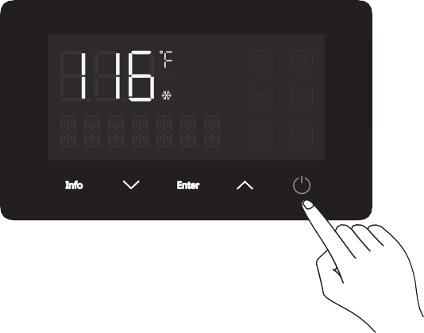
Step 2: Turn “OFF” the water heater by pressing the POWER button.
Step 3: Disconnect the unit from the power supply.
Step 4: Reconnect the power supply, however, do not turn “ON” the unit, instead press and hold the button for at least 5 seconds until PP is displayed on the screen.
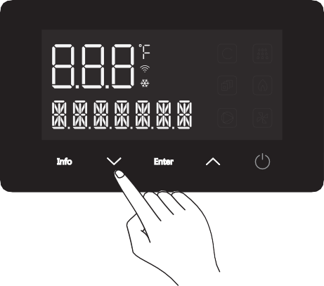
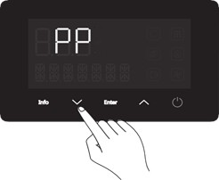
Step 5: Press the ENTER button and FA will display on the screen.
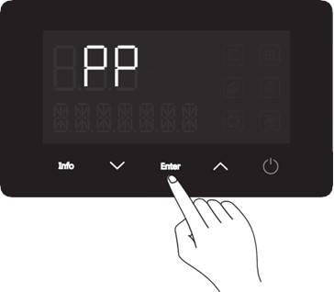
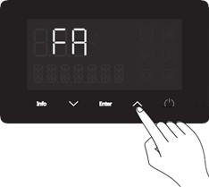

Appliance Servicing*
Step 6: Use the button to scroll through the parameter codes until L2 is displayed on the screen.
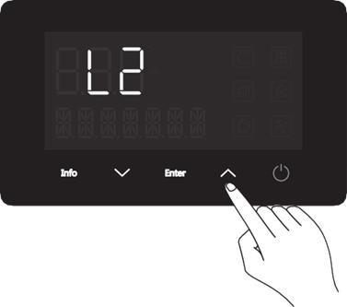

Step 7: Press the ENTER button, and then press the & buttons to adjust the L2 value according to the table below and the appliance’s operating elevation.
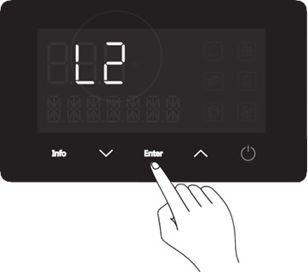
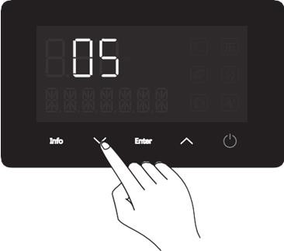

Program data | Altitude setting
Altitude | 2000 ft - 6500 ft | 6500 ft - 9800 ft
L2 | 05 | 06

Step 8: Press the ENTER button again to exit the parameter code adjustment mode.
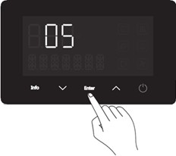
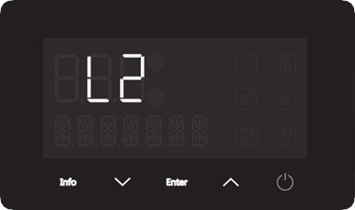

Appliance Servicing *
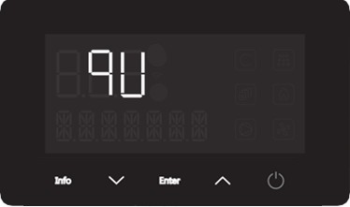
Step 9: Use the button until “ qU” is displayed on the screen.

Step 10: Press the ENTER button to save the L2 code and exit the adjustment mode. Several beeps will sound.
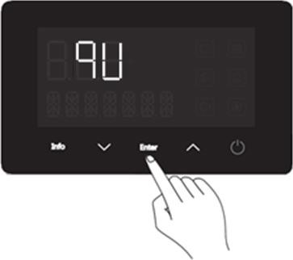
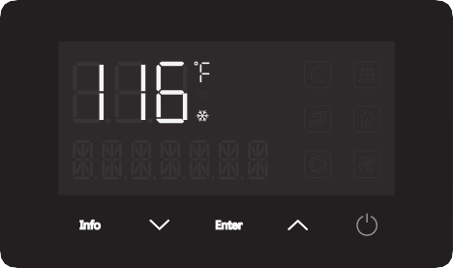

Service Screen Information – Authorized Personnel Only
- This operation MUST be performed by licensed professionals or with the guidance of an authorized Kings Peak representative.
CAUTION!
Press and hold the ENTER & INFO buttons together for 3 seconds to enter the servicing information interface (OT shows as default). Press the & to scroll through the information ﬁelds listed below. Once the desired ﬁeld is selected, press ENTER to show more details.
Contents | Description | Units
OT | Outlet Temperature | °F
EGT | Exhaust Gas Temperature | °F
HET | Heat Exchanger Temperature | °F
FS | Fan Speed | RPM
BWF | Bypass Water Flow Rate | GPM
AP | Air Pressure | PA
HE* | Historical Error | N/A
TUW** | Total Water Consumption | HG
IS*** | Ignition Success Times | H
UA | Version Number of Main Board | N/A
UB | Version Number of Display Board | N/A

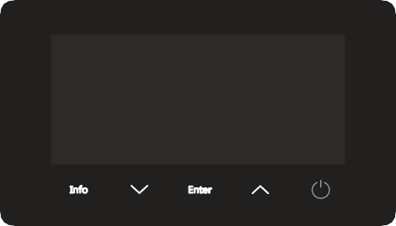








*HE: The most recent 10 error codes can be selected from the list.
**TUW: Total water consumption, displayed in Gallons (e.g. 0 HG means less than 100 L/G, 1 HG means 100G-200G).
***IS: Number of times of Ignition success (e.g., 0H means less than 100 times, 1H means 100-200 times).

Appliance Servicing *

 | ERROR | CODE | DISPLAY | DISPLAY CONTENT
A. | Hot water outlet Temperature Sensor Failure | E0 | E0 Flash | OT SENSOR ERROR
B. | Accidental Flame Lost | E1 | E1 Flash | FLAME LOST ERROR
C. | Fake Flame | E2 | E2 Flash | FAKE FLAME ERROR
D. | Thermistor Failure | E3 | E3 Flash | THERMOSTAT ERROR
E. | Outlet Temperature Too High | E4 | E4 Flash | OT OVERHEAT ERROR
F. | Fan Failure | E5 | E5 Flash | FAN ERROR
G. | Gas Valve Failure | E6 | E6 Flash | GAS VALVE ERROR
H. | Main Water Valve Failure* | E9 | N/A | MAIN WATER VALVE ERROR
I. | Overtime Failure | EE | EE Flash | HEATING OVERTIME ERROR
J. | Inlet Temperature Failure | F2 | F2 Flash | IT SENSOR ERROR
K. | Ignition Fail | C0 | C0 Flash | IGNITION FAILURE ERROR
L. | Residual Flame | C1 | C1 Flash | FLAME LEFT ERROR
M. | Vent Blockage | C4 | C4 Flash | VENT BLOCK ERROR
N. | Exhaust gas Temperature Sensor Failure | C9 | C9 Flash | EGT SENSOR ERROR
O. | Exhaust Gas Temperature Too High | CA | CA Flash | EXHAUST GAS OVERHEAT ERROR
P. | Bypass Water Valve Failure* | CB | N/A | BYPASS WATER VALVE ERROR
Q. | Heat Exchanger Outlet Temperature Sensor Failure | CF | CF Flash | HEAT SENSOR ERROR
R. | Watch Dog Circuit Failure | A0 | A0 Flash | WATCH DOG ERROR
S. | MCU PC Command Failure | A1 | A1 Flash | MCU CMD ERROR
T. | Instruction Compilation & Execution Failure | A2 | A2 Flash | CMD RUN ERROR
U. | MCU RAM DC Failure | A3 | A3 Flash | MCU RAM DC ERROR
V. | MCU ROM Failure | A4 | A4 Flash | MCU ROM ERROR
W. | MCU Register DC | A5 | A5 Flash | MCU REGISTER ERROR
* These error codes will not display on the screen; however, they can be accessed in the Service mode. Please refer to the previous page for more information.

Appliance Servicing*
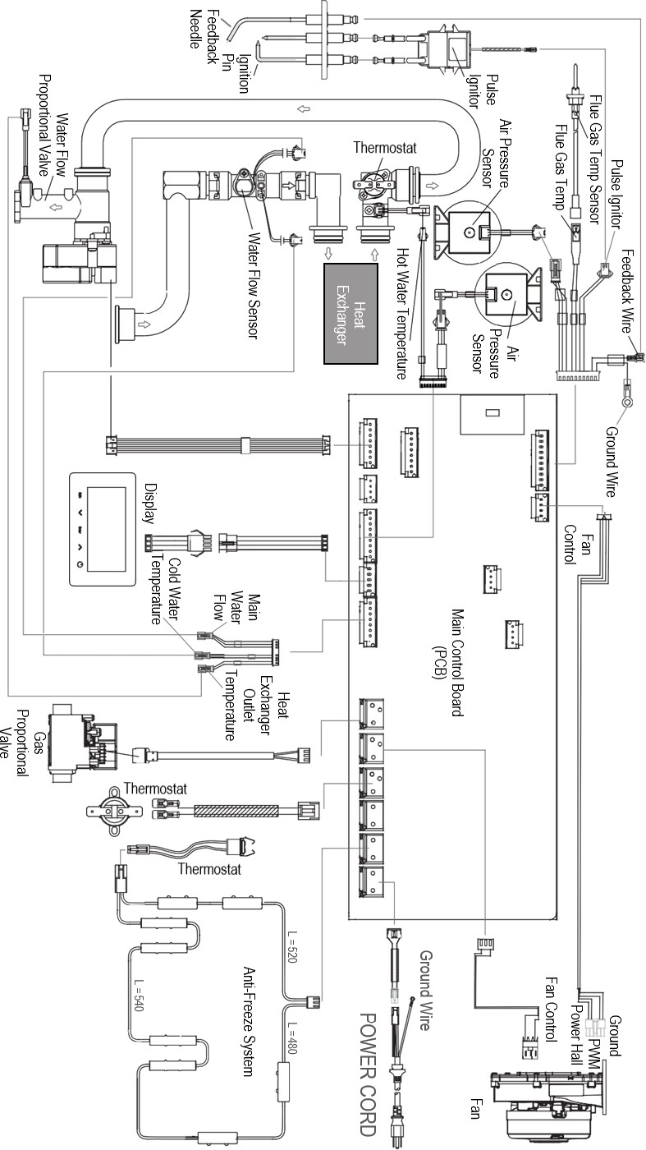
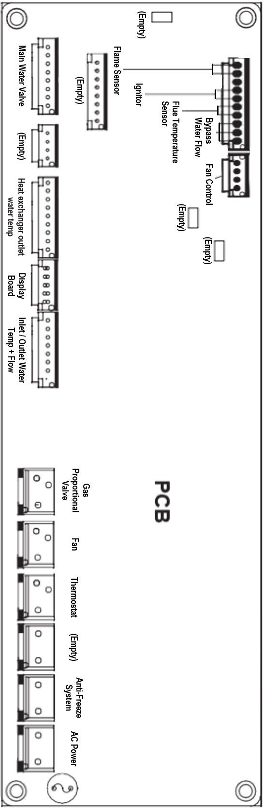

Installation Checklist
22
No. | Items | Check box
Water Heater Installation
1. | Have you maintained the required clearances from building openings and intake air vents?
2. | Have you minimized the distance between the water heater and the vent termination?
3. | Have you minimized the distance between the water heater and major ﬁxtures?
4. | Have you maintained the proper service and maintenance clearances?
5. | Is the water heater and vent piping clear of combustible materials, including clothing, cleaning materials, and rags?
Gas Supply Connection
6. | Does the gas supply match what is speciﬁed on the water heater rating plate?
7. | Is the gas line at least ½” or ¾” in. inner diameter?
8. | Is the gas supply line suﬃcient in length and diameter to deliver the required BTUs?
9. | Have you measured the pressure of the gas supply line?
10. | Is the gas supply pressure within the recommended ranges speciﬁed in this manual?
11. | Is the gas supply line equipped with a manual full port valve?
12. | Have you tested the gas line pressure and all ﬁttings for leaks?
13. | Has the gas company inspected the installation, if required?
Water Supply Connection
14. | Is the water supply pressure suﬃcient (greater than 15-40 PSI)?
15. | Have you installed shut oﬀ valves on the inlet and outlet to facilitate cleaning of the  inlet water ﬁlter?
16. | Have you bled the air out at each ﬁxture?
17. | Have you checked each ﬁxture to ensure hot water is being supplied?
18. | Have you cleaned the inlet water ﬁlter?
Pressure Relief Valve Connection
19. | Have you installed an approved pressure relief valve on the water heater?
20. | Does the rating of the pressure relief valve match or exceed the maximum BTU rating of the water heater?
21. | Is the pressure relief valve at least ¾” in. inner diameter?
22. | Have you installed the pressure relief valve on the hot water outlet pipe near the water heater?
23. | Have you installed a discharge drain tube from the pressure relief valve to within 6-12” in. of the ﬂoor?
Condensate Drain Connection
24. | Have you installed a condensate drain line from the water heater to a drain or laundry tub?

Appliance Servicing *
Installation Checklist

Venting the Water Heater (Checklist continued)
25. | Have you vented the water heater with 2 ” in. or 3” in. PVC, CPVC, Polypropylene, Type BH Special Gas Vent (ULC -S636) for this water heater, or in accordance with all local codes and the guidelines in this manual?
26. | Have you ensured that PVC solid core pipe has not been used as venting for the water heater?
27. | Is the vent sloped upward toward the vent termination at a rate of ¼” inch per foot (2% grade)?
28. | Are all vent runs properly supported?
29. | Have you properly supported the vent termination?
30. | Have you properly sealed all air intake and exhaust joints, from the ﬂue collar to the to the vent termination?
31. | Have you installed bird screens on the exhaust and intake Terminations?
32. | Have you checked the venting for leaks?
33. | Is the vent termination at least 12 ” in. above the exterior grade?
34. | Is the total vent length within the maximum vent length restriction?
Power Supply
35. | Is the supplied voltage 110 -120 VAC?
36. | Is the water heater plugged into a properly grounded outlet?
37. | Have you checked the polarity of the electrical connection?
Water Heater in Operation
38. | Have you shown the owner how to clean the inlet water ﬁlter?
39. | Have you given the Manuals to the owner for future reference?
40. | Have you shown the owner how to shut off the gas in case of an emergency?

54
© 2024 Salt Lake Iron & Steel Ltd. Co.

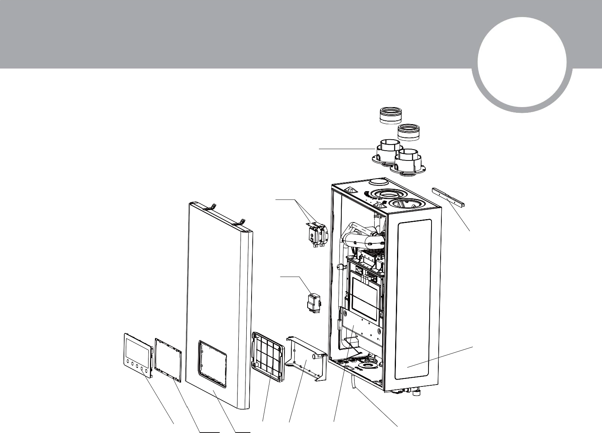
Parts List
Appliance Servicing *
23

Casing Parts Overview
10

11

12

9

14

8

1 2 3 4 5 6 7

No. | Description | Service Part #
1. | Screen Assembly | KNGICW55
2. | Sealing Washer
3. | Front Cover
4. | Cover Plate
5. | Control Board Assembly | KNGICW43
6. | Controller Support
7. | Power Cable
8. | Case
9. | Mounting Bracket
10. | Vent Seal
11. | Vent Collar
12. | Pressure Sensor (APS) | KNGICW20
14. | Ignition Transformer | KNGICW40


Parts List

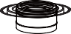
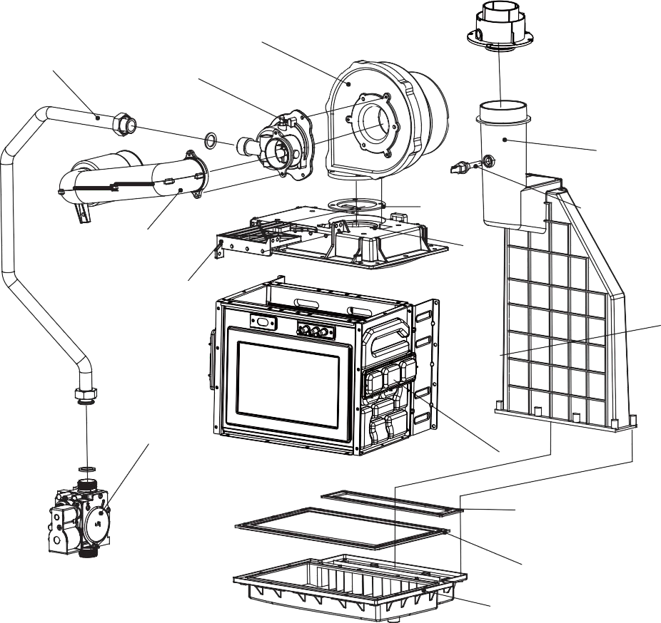
Gas Loop Parts Overview
Appliance Servicing *
14
7
9
5
10
13
6
11
12
15
1
2

3
4

8

No. | Description | Service Part #
1. | Heat exchanger assembly
2. | Vent gasket
3. | Condensate collector gasket
4. | Condensate collector
5. | Flue Vent
6. | Flue temperature sensor | KNGICW19
7. | Blower | KNGICW31
8. | Igniter assembly | KNGICW47
9. | Mixer assembly
10. | Blower gasket
11. | Burner assembly
12. | Blower bracket
13. | Muﬄer
14. | Gas pipe
15. | Gas valve | KNGICW42


57 ©2024 Salt Lake Iron & Steel Ltd. Co.

Parts List

Water Loop Parts Overview
Appliance Servicing *

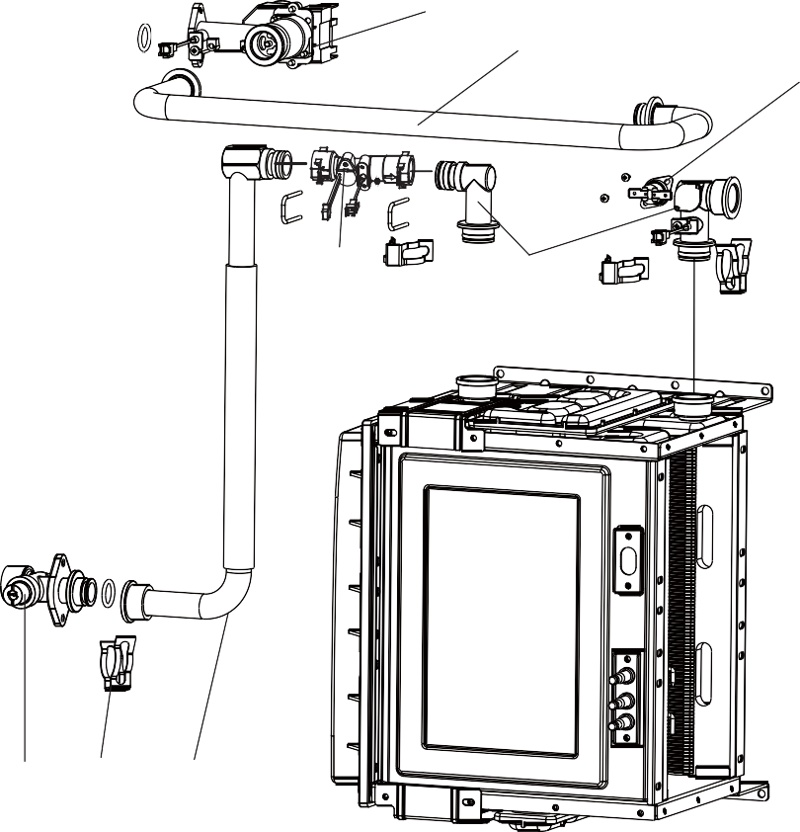

4

No. | Description | Comments
1. | Cold water inlet connector
2. | Clip
3. | Cold water pipe
4. | Thermistor
5. | Connector of water inlet
6. | Connecting pipe component
7. | Water ﬂow sensor | KNGICW51
8. | Water Ratio Valve | KNGICW52
9. | Water outlet connection

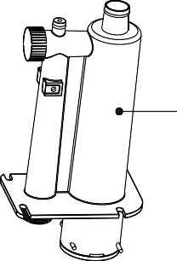
Accessories

No. | Description | Service Part #
1. | Condensate trap assembly
2. | Anti-Freeze Thermostat | KNGICW44
3. | Overheat Thermostat | KNGICW50

Kings Peak hereforyou@kingspeakhome.com

LIMITED WARRANTY INFORMATION
Kings Peak brand of Salt Lake Iron & Steel Ltd. Co. hereby warrants this product to be free of material defects in materials and workmanship when installed and operated according to the installation and operating instructions included in this manual. This Limited Warranty extends to the original purchaser and subsequent owners, but only while the product remains at the site of the original installation. This Limited Warranty terminates if moved or
reinstalled at а new location. There are no warranties, express or implied made or given other than contained in this Limited Warranty. No agent, employee, or representative of Salt Lake Iron & Steel Ltd. Co. has any authority to bind Salt Lake Iron & Steel Ltd. Co. to any representation or warranty concerning the Product not contained in this Limited Warranty.
Except as expressly set forth herein, THERE ARE NO REPRESENTATIONS OR WARRANТIES, EXPRESS OR IMPLIED, INCLUDING, WIТHOUT LIMIТATION, AS ТО MERCHANTABILIТY OR FIТNESS FOR А PARТICULAR PURPOSE WIТH
RESPECТ ТО ANY GOODS SOLD HEREUNDER. BUYER'S EXCLUSIVE REMEDY IS LIMIТED ТО REPAIR OR REPLACEMENT OF ТНЕ GOODS SOLD, АТ SALT LAKE IRON & STEEL LTD. CO. DISCRETION.
SALT LAKE IRON & STEEL LTD. CO. SHALL NOT ВЕ LIABLE FOR INCIDENTAL OR CONSEQUENТIAL DAMAGES.
Item Period of Coverage
1 Year from date of Valid Proof of Purchase
Coverages are void if the unit is used in а hot water circulation loop, in series with а circulation system, or where an on- demand recirculation system is not incorporated.
Owner is responsible for all other costs incidental to repair such as labor, shipping, delivery, and permits. Proof of purchase required. Products repaired will be covered under this Limited Warranty for the remainder of term of the original purchase.
This Limited Warranty becomes null and void if any of the following are determined to be а contributing factor to the
failure of the product:
- Abuse, misuse, alteration, neglect, or misapplication;
- Installed not to the specifications as detailed in the installation instructions in this manual;
- Improper or inadequate maintenance;
- Inadequate water quality;
- Installation in а corrosive or otherwise destructive environment;
- Freeze damage;
- Excessive Scale buildup due to water quality;
- Incorrect gas or water pressure;
- Acts of force Majeure.
This Product is not to be used as а pool or spa heater.
Within the first 30 days of purchase, Salt Lake Iron & Steel Ltd. Co. will cover all ground shipping costs for warranty
related issues, excluding АК and HI and any location outside of the continental US. After the first 30 days of purchase, Salt Lake Iron & Steel Ltd. Co. will cover all shipping costs to the customer for warranty related issues, excluding АК and HI and any location outside of the continental US. After the first 30 days of purchase, the customer is responsible for all shipping to Salt Lake Iron & Steel Ltd. Co., regardless of reason or circumstance. The method for warranty related shipping will be Ground equivalent with the provider of Salt Lake Iron & Steel Ltd. Co. choosing.
АК and HI and any location outside of the continental US, will be responsible for all shipping costs, regardless of
reason or circumstance.
AII shipments of any type of product coming to Salt Lake Iron & Steel Ltd. Co. for any reason must have a Returns Goods Authorization (RGA) number from our customer service team for any repairs to be made. Please contact Salt Lake Iron & Steel Ltd. Co. to obtain an RGA number prior to shipping anything to Salt Lake Iron & Steel Ltd. Co. Failure to do so could result in loss of product. Salt Lake Iron & Steel Ltd. Co. will not be responsible for replacement due to loss or damage if these steps are not properly followed.

Kings Peak hereforyou@kingspeakhome.com
HOW TO MAKE A CLAIM
All warranty service is provided exclusively by our authorized Kings Peak Service Providers. For service, contact the Kings Peak Customer Experience Center. In the U.S.A., call 1-855-855-4647. If outside the 50 United States, contact your authorized Kings Peak dealer to determine whether another warranty applies.
WHAT IS NOT COVERED
  - Commercial, non-residential, or multiple family use or use inconsistent with the product instructions and manuals.
  - In-home instruction on how to use your product.
  - Repair to correct improper maintenance, installation not in accordance with installation instructions or electrical or plumbing codes, or repair of household electrical or plumbing systems.
  - Consumable parts (e.g., light bulbs, batteries, air or water filters, etc.).
  - Defects or damage resulting from accident, misuse, abuse, alteration, fire, floods, acts of God or improper installation.
  - Damages, defects, or repairs caused by unauthorized servicers or use of non-genuine or third-party parts; however, use of unauthorized service providers or non-genuine or third-party parts will not void this warranty.
  - Cosmetic damage (e.g., scratches, dents, chips, and other damage to appliance finishes), unless such damage results from defects in materials and workmanship and is reported to Kings Peak within 30 days from date of delivery.
  - Discoloration, rust, or oxidation of surfaces resulting from caustic or corrosive environments (e.g., high salt concentrations, high moisture or humidity or exposure to chemicals).
  - Product pick-up or delivery. This product is intended for in-home repair or replacement.
  - Travel or transportation expenses for service in remote locations where an authorized Kings Peak servicer is not available.
  - Repair, removal, or reinstallation of inaccessible appliances or built-in fixtures (e.g., trim, decorative panels, flooring, cabinetry, islands, countertops, drywall) that interfere with servicing, removal, or replacement of the product.
  - Appliances with original, factory installed model/serial numbers removed, altered, or not easily determined.
  - Conversion of your product from natural gas or propane gas.
  - Incidental or consequential damages (e.g., loss of food or medicine) resulting from appliance breakdown.

HOW STATE LAW APPLIES
This warranty gives you specific legal rights, and you may also have other rights that vary from state to state. Some states, such as California, do not allow for limitations on the date your warranty coverage begins, so this limitation may not apply to you.


™

PEAK PERFORMANCE, PEAK COMFORT™

Electrician and/or HVAC Technician: License #:
Installation Date:

Installation location:

Serial number:

Manufactured for:
Salt Lake Iron & Steel Ltd. Co.
Salt Lake City, Utah United States of America

®/™ © 2024 All Rights Reserved

